Product information 01/2018

AUDI R8
AUDI R8 / R8 Spyder, Typ 4S, 5/2015=>
V10 plus 5.2l FSI 449 kW
V10 / V10 RWS 5.2l FSI 397 kW

+ 1,3 HP
+ 8,1 Nm
- 17,8 kg

REMUS RACING-axle-back-system
- 100% stainless steel
- Powerful sound
- Performance and torque increase
- Light weight construction

AUDI R8 Typ 4S
V10 plus 5.2l FSI 449 kW

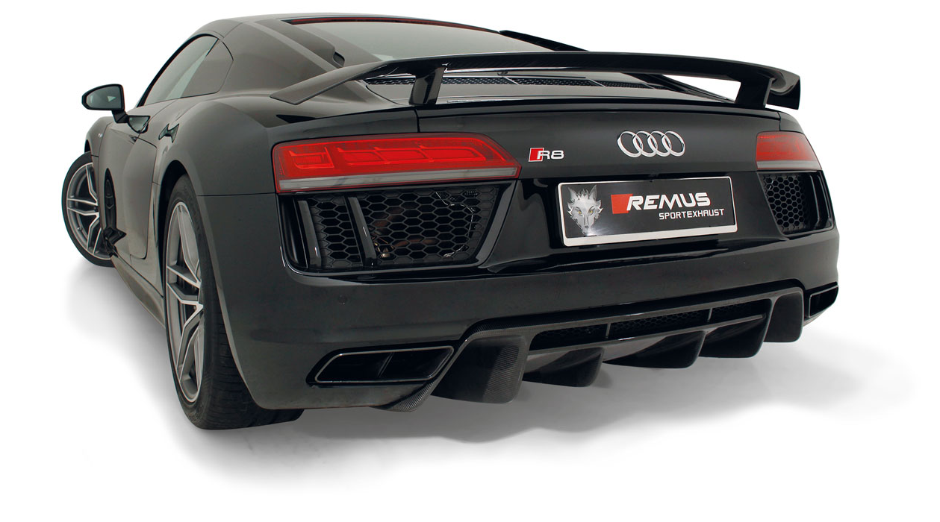

Car and engine specification
AUDI R8 / R8 Spyder, type 4S, 5/2015=>
V10 plus 5.2l FSI 449 kW
V10 / V10 RWS 5.2l FSI 397 kW
INFOBOX:
- RACING-axle-back-system: 049315 1500! Suitable for the original exhaust outlets! No cutting of the original exhaust system required!
- The use of racing products and products which do not have EC approval is generally not permitted on public roads.
Part no. | Description | € RRP price excl. VAT
049315 1500 | Stainless steel RACING sport exhaust centered (without tail pipes)  suitable for the original exhaust outlets  with 2 vacuum operated valves, without homologation  Original tube Ø 76 mm, REMUS tube Ø 76 mm  The valves are vacuum controlled via the onboard electronics. | 2.050,--
DISCLAIMER

The products of REMUS Innovation Forschungs- und Abgasanlagen Produktions GmbH („REMUS“) are distributed worldwide. REMUS and its affiliates shall not assume any obligations, warranties, guarantees or other liabilities for the fact that the products manufactured by REMUS comply with the applicable law of the respective country of destination or may be used without (official) approval. This applies equally to products approved in Austria, which are subsequently manipulated, modified, edited or otherwise interfered or changed by the respective buyer, so that it no longer has its original condition.

The buyer shall be solely responsible for obtaining all whatsoever approvals and permissions required by the respective national law for suchlike products and shall be solely responsible for ensuring that the products manufactured by REMUS comply with the approvals required for the respective usage in the country of destination.

Intended use in Austria:
Products manufactured by REMUS without (EC-)approval are only eligible for usage at motor sport events or tests within the meaning of KFG 1967. They are not intended for vehicles used on public roads.

The buyer is solely responsible for obtaining the permissions where applicable required by the applicable law for the intended purposes/usage. In no event a whatsoever claim shall be constituted by the buyer against REMUS and its affiliates arising from or in connection with required approvals for public road usage.

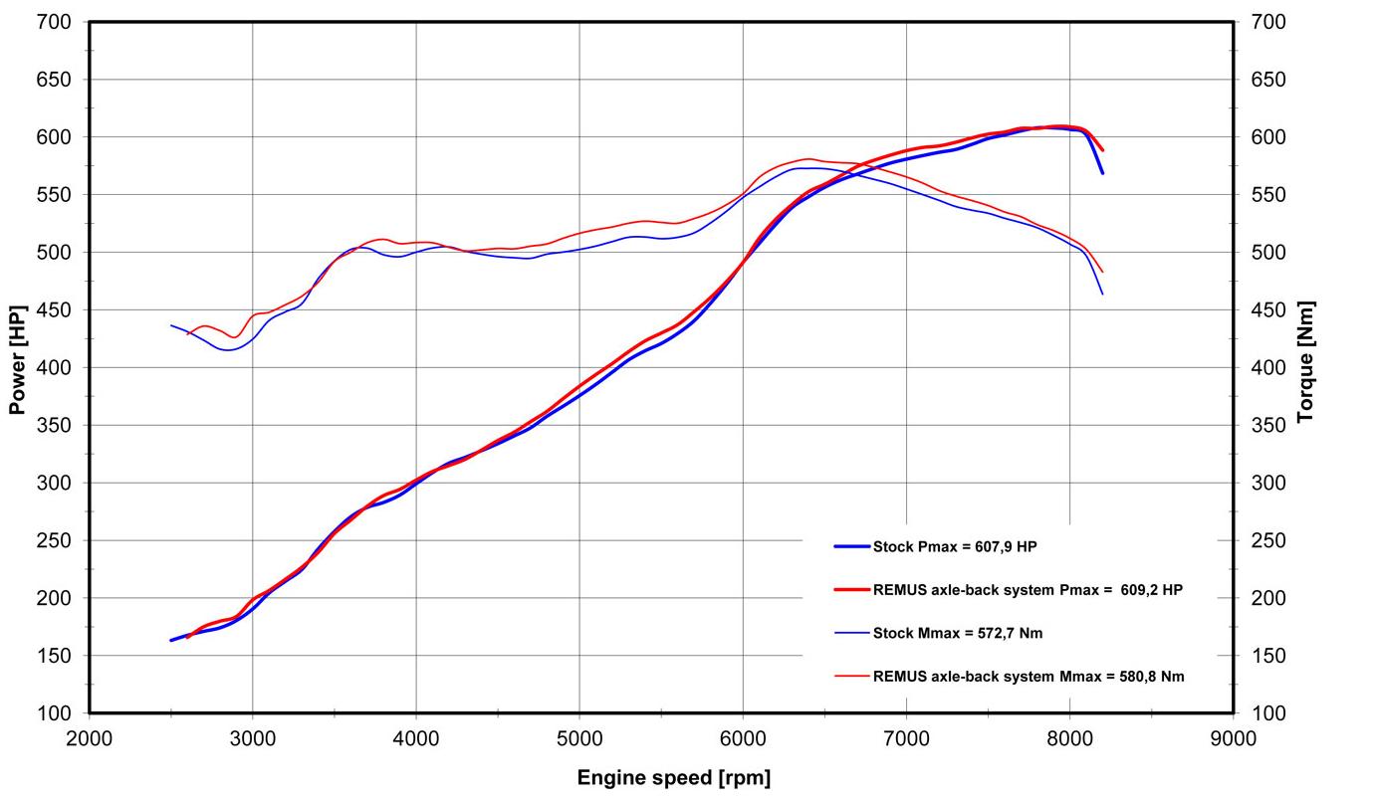
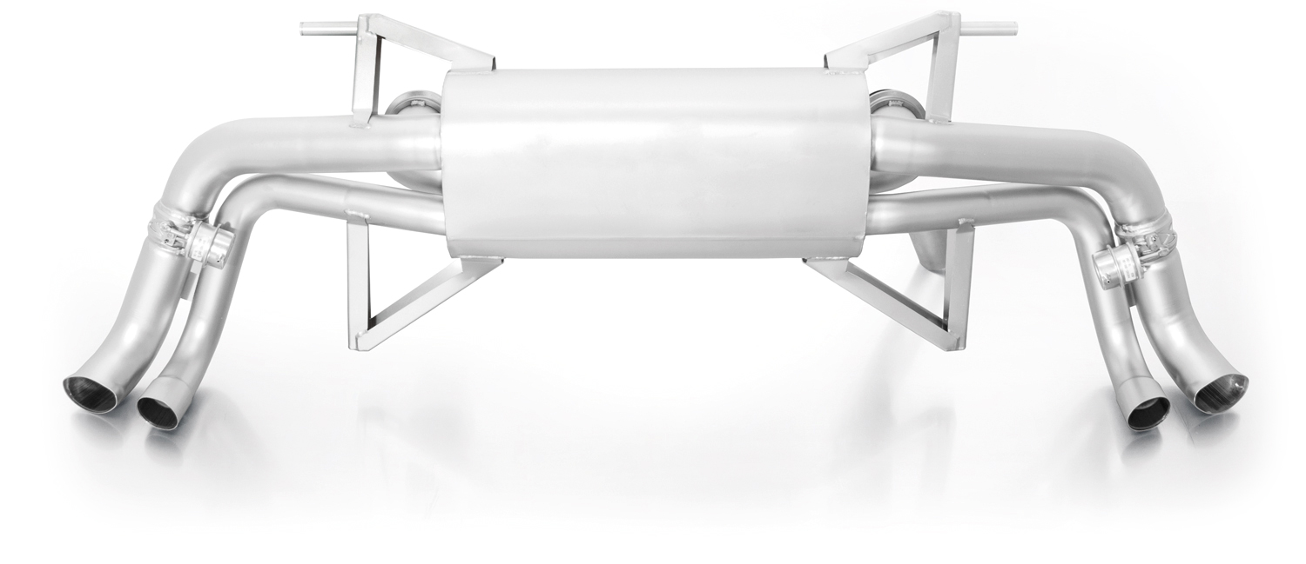
AUDI R8 Typ 4S
V10 plus 5.2l FSI 449 kW

049315 1500
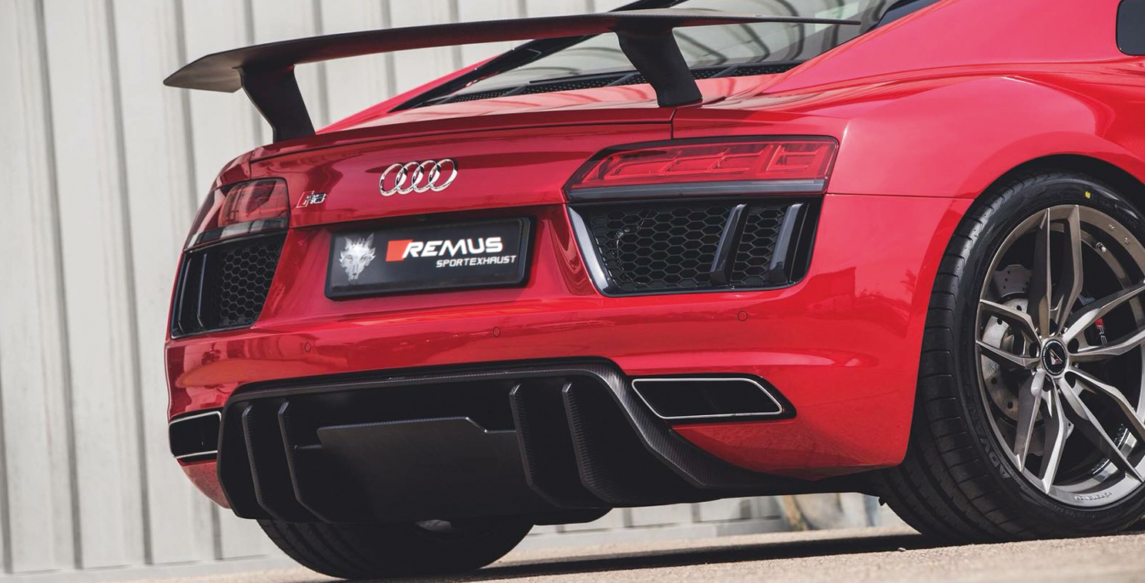

AUDI R8 Typ 4S
V10 RWS 5.2l FSI 397 kW

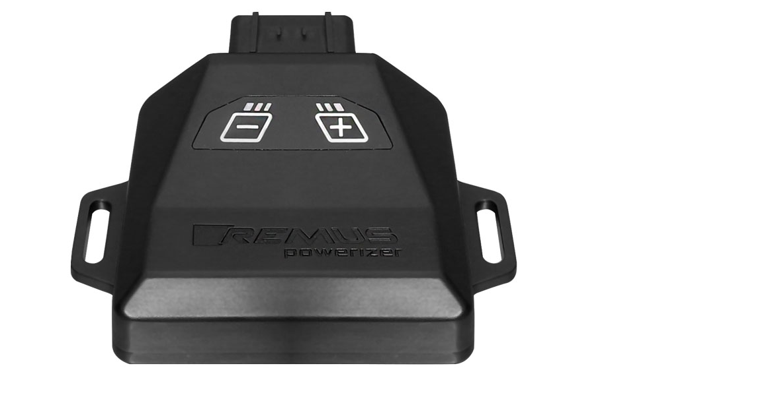
REMUS Powerizer
More power, more torque means more fun!
The perfectly matched electronics and advanced technology of the
REMUS Powerizer enhances Engine ECU mapping is optimized in
excess of 1000 times per second and ensures for a considerable and
noticeable power increase. The engine safety parameters (Check engine light) and engine management remains totally untouched to ensure that individual engine components are not overstrained.
Because of the plug & play concept, the REMUS Powerizer is installed in the engine compartment and connected to sensors such as intake manifold pressure sensor, boost pressure sensor, camshaft position sensor or fuel injection sensor. In real time, the incoming signals are processed, optimized and transmitted to the additional control unit. The Powerizer can be easily removed or decommissioned at any time using the supplied blind connector.
Due to the torque increase, the engine has more power at lower RPM which can lead to a reduction in fuel consumption. The power increase of the engine can easily be fine-tuned by means of seven preset levels via the keypad. The REMUS Powerizer is available for over 3300 petrol and diesel powered cars.
Furthermore, the latest Powerizer is also available for all vehicle engines with SENT technology. This newly developed multi-protocol technology combines analog and digital motor control the same time captures important analog signals of the engine management system which leads to increased engine performance. The capability to tune vehicles with SENT technology is an absolute highlight of the latest Powerizer.

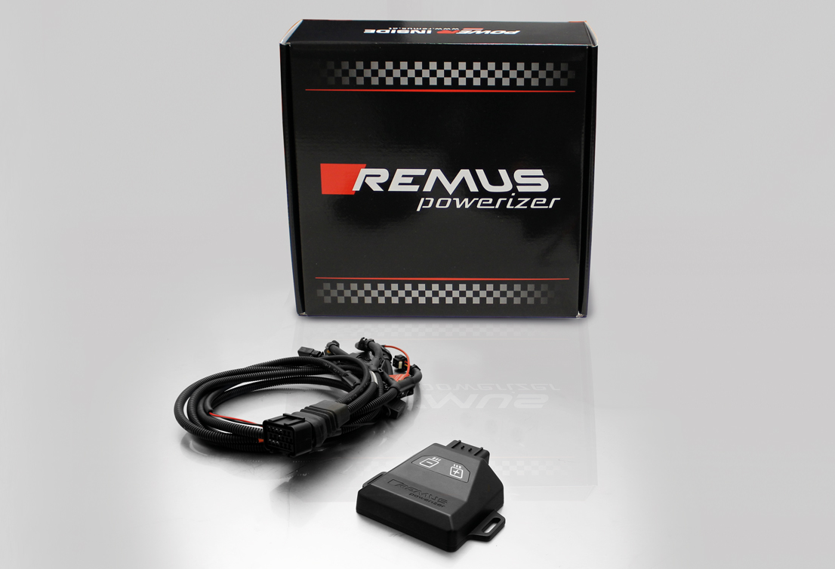

- Up to 30% more power
- Up to 20% more torque
- Easy installation and removal (plug & play)
- Up to 1l/100 km fuel saving
- No vehicle modifications required
- 7 preset power levels

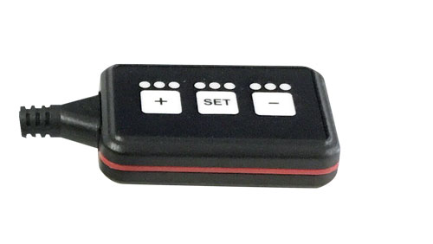
REMUS Responder

Improved throttle response for more driving dynamic!

The REMUS Responder improves throttle response and is the best power boost for
many electronically managed gas pedals. Results of up to 10% better acceleration are not uncommon and no annoying throttle delay and lag during take-off or in between manual / automatic shifts makes driving with the REMUS Responder much more dynamic.

The REMUS Responder attaches between the OEM gas pedal sensor and the OEM wiring loom and is ready to use in minutes due to plug & play technology.

The fully adjustable Responder settings can be adjusted in 20 different stages. The individual user-selectable and adjustable performance settings allow drivers to select according to their own preferences & road conditions.

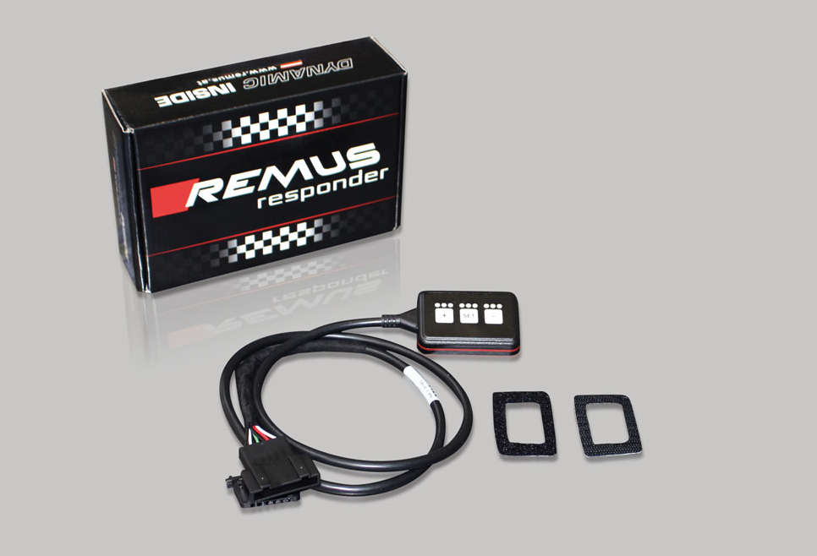

- Improves throttle response and lag during take-off and gear changes
- Quicker reaction times, more driving dynamic
- 20 individual user selectable performance settings
- Vehicle specific programming using OEM quality connectors
- Simple plug & play installation and removal without leaving traces

