Product information 43/2016

AUDI RS3

RS3 Sportback, type 8V, ab 4/2015 - 2.5l Turbo 270 kW,
REMUS Cat-back-system
- 100% stainless steel
- Powerful sound
- Performance and torque increase
- EEC homologation

+ 4,4 HP
+ 6,6 Nm

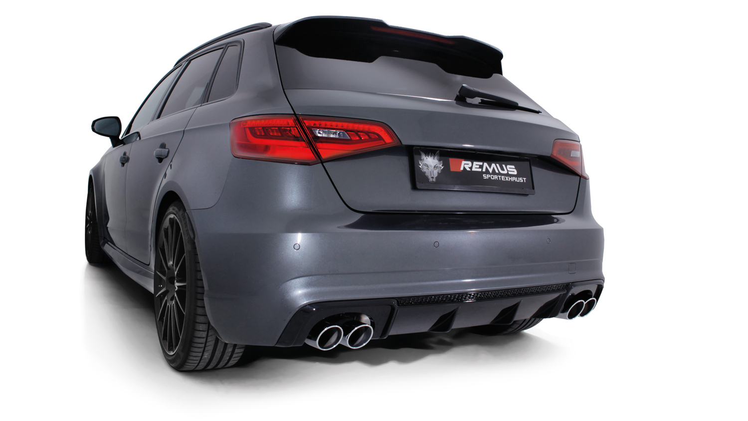

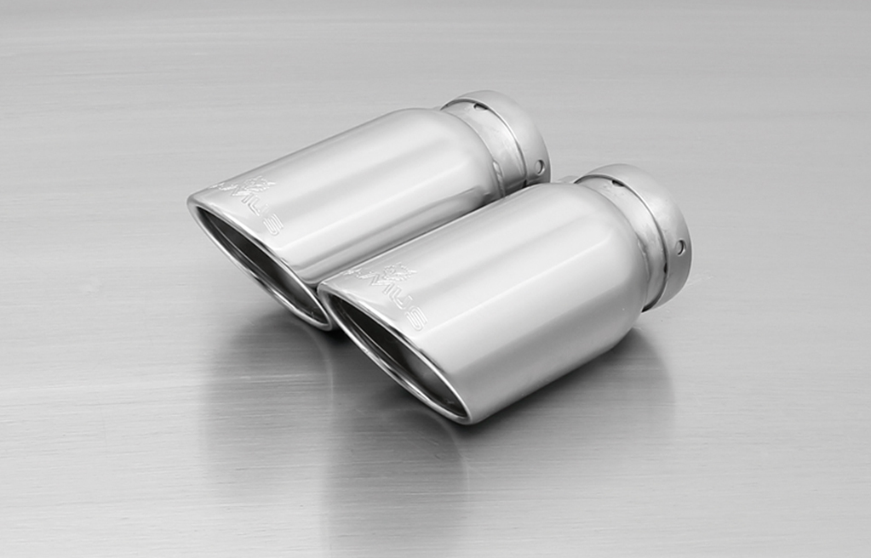

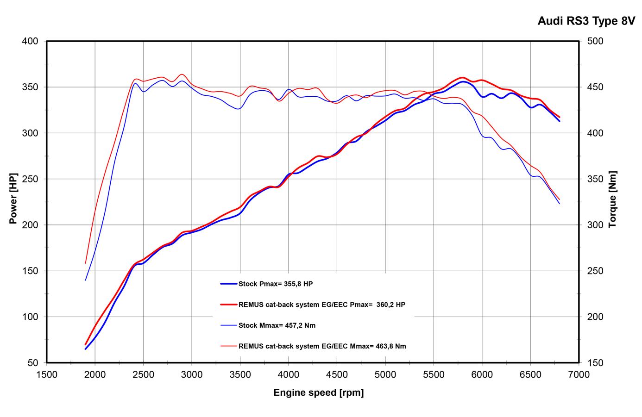
#83CTS: Carbon-tail pipes Ø 84 mm angled, Titanium internals

#55S: tail pipes Ø 84 mm
angled, chromed

#83CS: tail pipe Ø 84 mm
Carbon Race, angled, polished

#98C: tail pipes Ø 98 mm
Street Race, polished

#98CB: tail pipes Ø 98 mm
Street Race Black Chrome

Car and engine specification
AUDI RS3 Sportback, type 8V, 4/2015=>
2.5l Turbo 270 kW
Part no. | Description | € RRP price excl. VAT
047015 1200 | Stainless steel RACING cat replacement pipe instead of secondary (underbody) catalytic converter, without homologation  REMUS tube Ø 76 mm | 280,--
047015 0000 | Stainless steel non resonated RACING cat-back section, without homologation  REMUS tube Ø 76 mm | 260,--
047015 0300 | Stainless steel resonated front section, incl. EEC homologation  REMUS tube Ø 76 mm | 360,--
047015 1500 | Stainless steel sport exhaust centered for L/R system (selectable tail pipes),  with 2 integrated valves, incl. EEC homologation  REMUS tube Ø 76 mm | 1.180,--
choose from following tail pipe package:
0046 55S | Stainless steel tail pipe set L/R consisting of 4 tail pipes Ø 84 mm angled, chromed, with adjustable spherical clamp connection | 300,--
0046 83C | Stainless steel tail pipe set L/R consisting of 4 tail pipes Ø 84 mm Street Race, with adjustable spherical clamp connection | 340,--
0046 83CS | Stainless steel tail pipe set L/R consisting of 4 tail pipes Ø 84 mm Carbon Race, with adjustable spherical clamp connection | 360,--
0046 83CB | Stainless steel tail pipe set L/R consisting of 4 tail pipes Ø 84 mm Street Race black chrome, with adjustable spherical clamp connection | 388,--
0046 83CTS | Stainless steel tail pipe set L/R consisting of 4 carbon tail pipes Ø 84 mm angled, Titanium internals, with adjustable spherical clamp connection | 680,--
INFOBOX:
- Resonated front section resp. non resonated front section and sport exhaust centered with tail pipe set only fits as a complete system!
- Cat-back-system (from secondary, underbody catalytic converter): 047015 0300 resp. 047015 0000 (Racing) + 047015 1500 + tail pipe set! No vehicle modifications required!
- Cat-back-system (from main catalytic converter): 047015 1200 (Racing) + 047015 0300 resp. 047015 0000 (Racing) + 047015 1500 + tail pipe set! No vehicle modifications required!
- The supplied actuators activate the valves to factory preset positions via the vehicle onboard electronics.
- 047015 1200: When installing REMUS cat replacements pipes on vehicles which are used for closed road driving, it is advisable to tune the ECU for a maximum gain in performance and to ensure that the CEL does not come on.

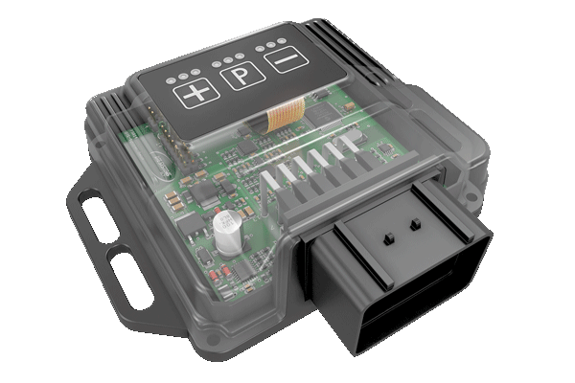
REMUS Powerizer
More power, more economy and more fun!
The electronics of the REMUS Powerizer enhances in real time
the engine management parameter. The engine mapping
is optimized in excess of 1000 times per second and ensures for a
considerable and noticeable power increase. The engine safety parameters and management remains totally original to ensure that individual engine components are not overstrained. Furthermore, the original mapping software remains totally untouched.
Due to the Plug & Play concept, the REMUS Powerizer is simple to install and can be easily removed or decommissioned using the supplied blind connector. Due to the torque increase, the engine has more power at lower RPM which leads to a reduction in fuel consumption. The power increase of the engine can be adjusted according to different driving styles by means of a „maximum power setting“, „eco fuel saving mode“ or a combination of both. The REMUS Powerizer is available for over 3000 petrol and diesel powered cars.

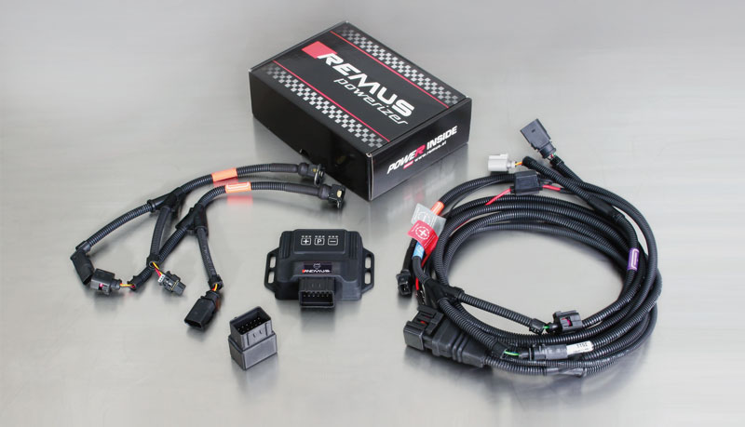

- Up to 25% more power
- Up to 20% more torque
- Easy installation and removal (Plug & Play)
- Up to 1l/100 km fuel saving
- 3 preset programs (RACE/SPORT/ECO) with individual power adjustment

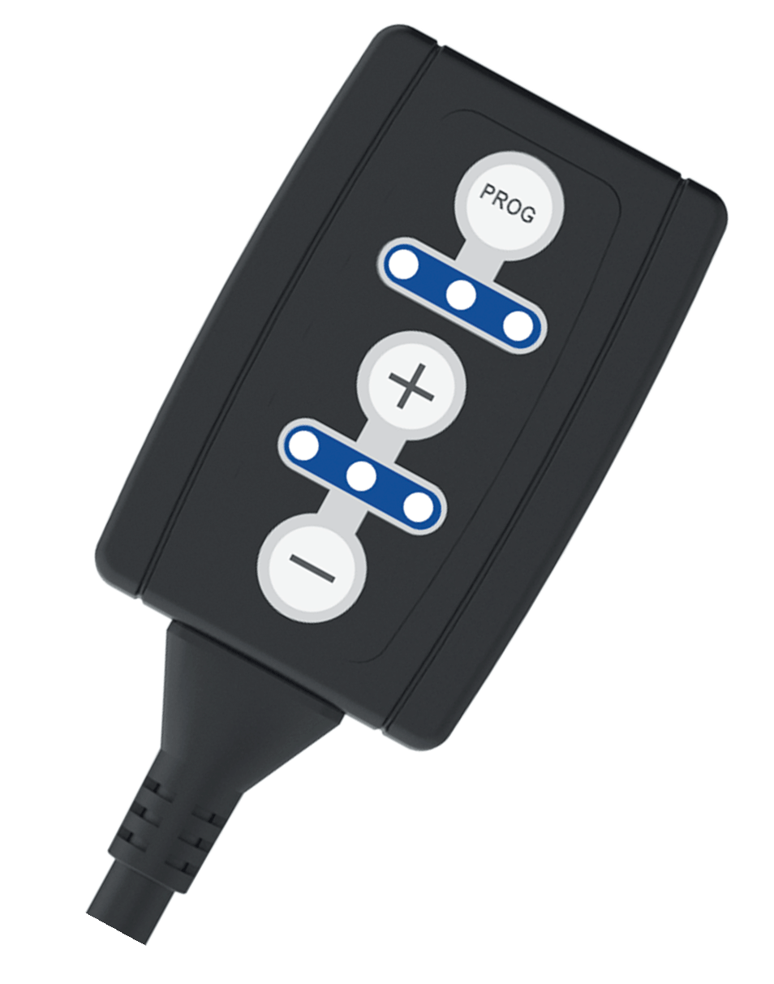
REMUS Responder

Improved throttle response, more dynamic!

Der REMUS ResponderThe REMUS Responder improves throttle response by means
of modifying the accelerator pedal output signal.
No more throttle delay and reduced lag during automatic shifting makes driving
with the REMUS Responder more fun. The Responder attaches between the
OEM pedal sensor and the OEM connector, ready to use in seconds due to plug & play technology.
Sophisticated adjustable programming profiles can lead to improved fuel consumption and
more efficiency. The 4 individual user selectable and adjustable performance settings
allow drivers to select according to their own preferences. The REMUS Responder totally eliminates the delay in modern electronic accelerator pedals!

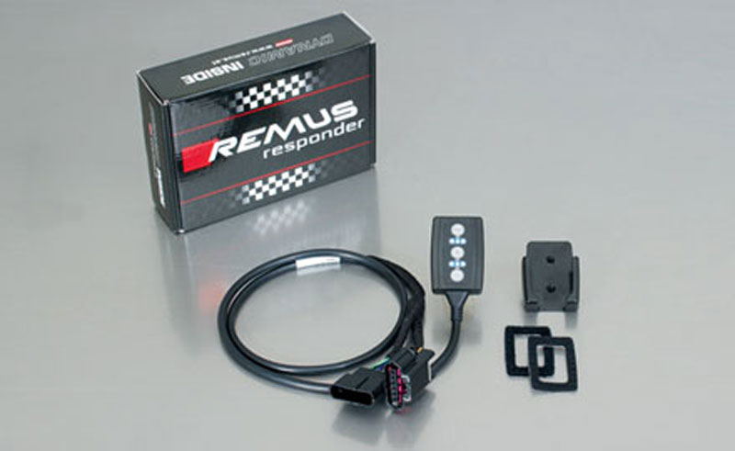

- Improved throttle response, reduced lag during gear changes
- Quicker reaction times, more dynamic without changing engine parameters
- 4 individual user selectable and adjustable performance settings
- Vehicle specific programming using OEM quality connectors
- Simple plug & play installation and easily removed without leaving traces

