Product information 39/2016

PORSCHE Carrera / Carrera 4
Carrera S / Carrera 4S

Carrera / Carrera 4 Coupe & Cabrio type 991.2 (Facelift), from 2015 - 3.0l Turbo 272 kW
Carrera S / Carrera 4S Coupe & Cabrio type 991.2 (Facelift), from 2015 - 3.0l Turbo 309 kW
REMUS sport exhaust
- 100% stainless steel
- Powerful sound
- Performance and torque increase
- EEC homologation

+ 4,2 HP
+ 8,8 Nm

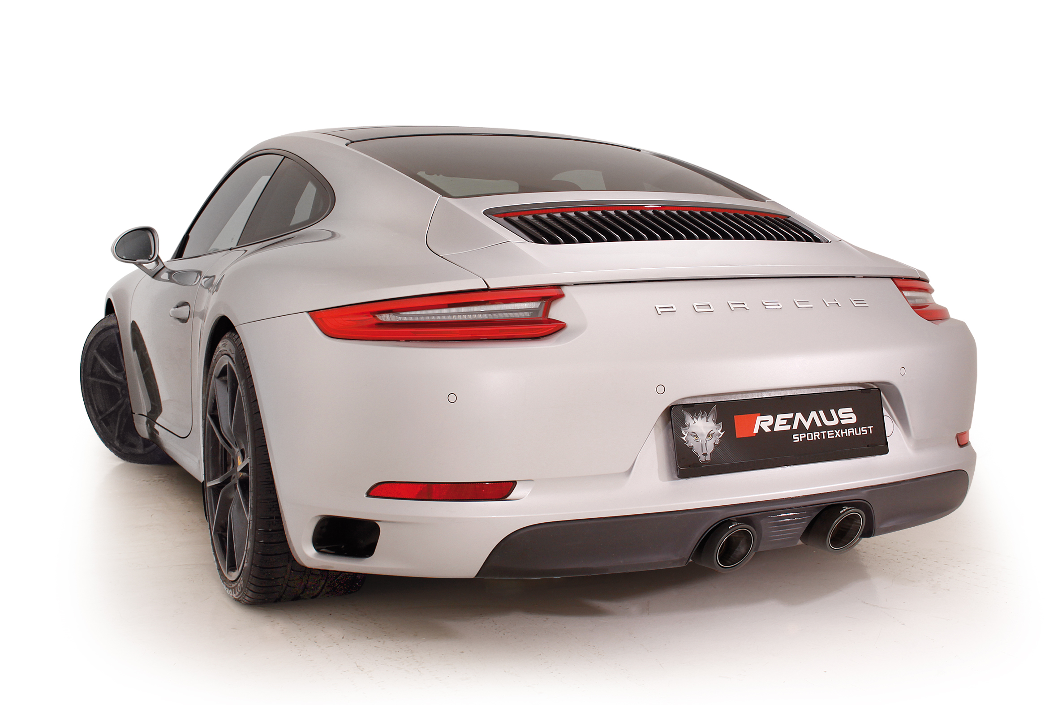
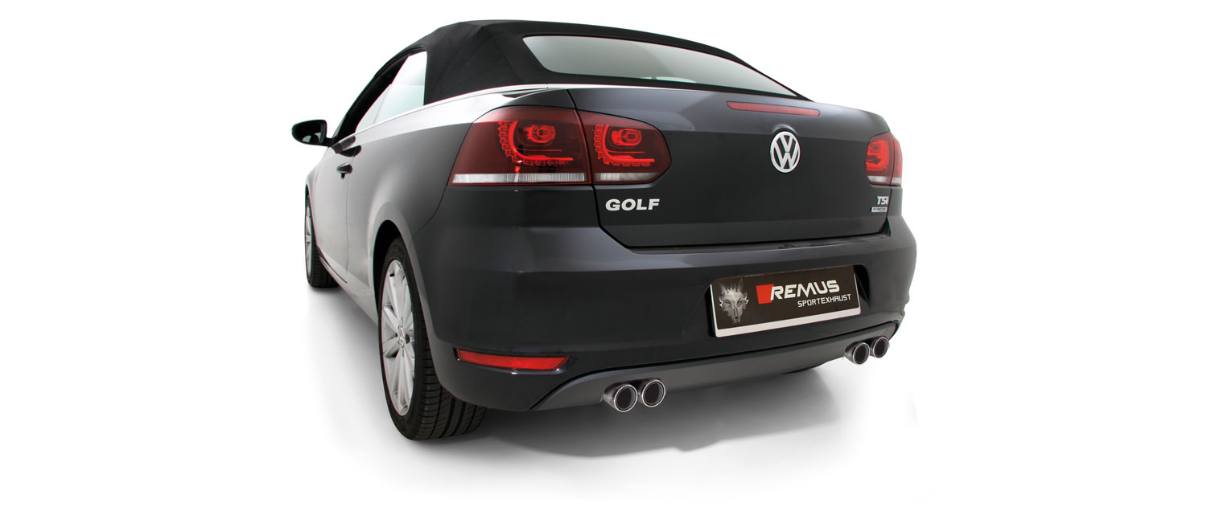

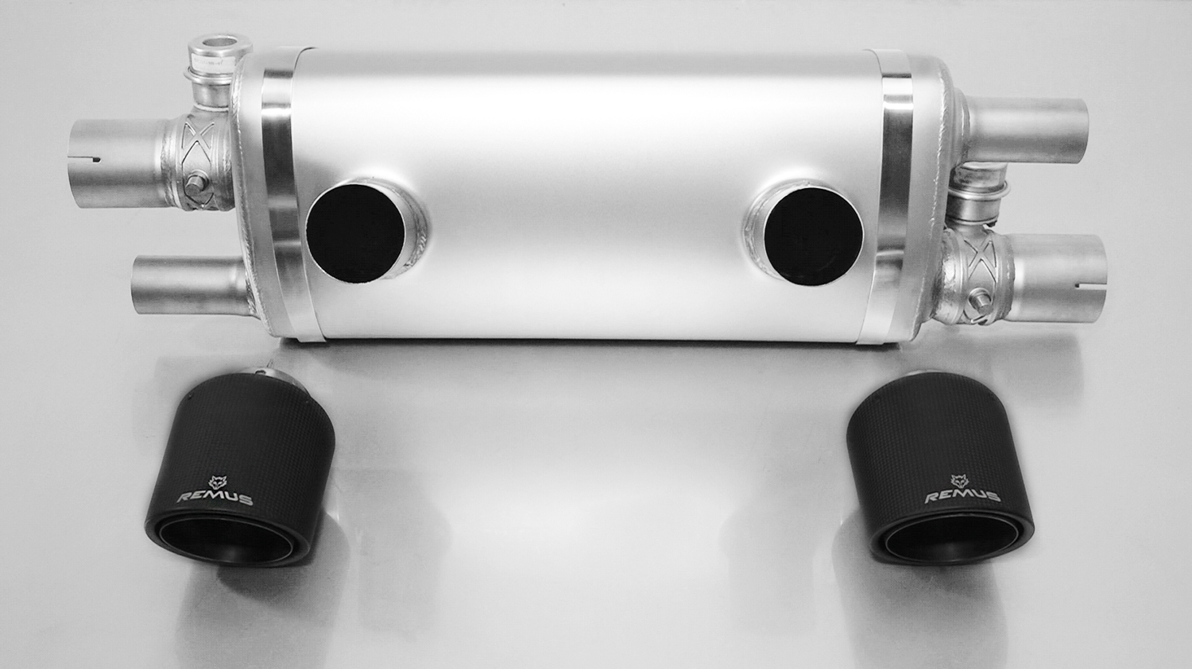

688015 1500 + 0526 70CS

Car and engine specification
PORSCHE Carrera / Carrera 4 Coupe & Cabrio type 991.2 (Facelift), 2015=>
Only for models with center exit Porsche sport exhaust system!
3.0l Turbo 272 kW

PORSCHE Carrera S / Carrera 4S Coupe & Cabrio type 991.2 (Facelift), 2015=>
Only for models with center exit Porsche sport exhaust system!
3.0l Turbo 309 kW
Part no. | Description | € RRP price excl. VAT
688015 1500 | Stainless steel sport exhaust system center exit (without tail pipes),  with vacuum operated valves, incl. EEC homologation  Original tube Ø 76/70 mm - REMUS tube Ø 76/70 mm | 1.850,--
0526 70CS | Tail pipe set consisting of 2 Carbon tail pipes Ø 102 mm angled, Titanium internals, with adjustable spherical clamp connection  This tail pipe set also fits without the REMUS sport exhaust onto the center exit Porsche sport exhaust system! | 560,--
INFOBOX:
- Only for models with center exit Porsche sport exhaust system!
- Axle-back-system: 688015 1500 + 0526 70CS. No vehicle modifications required!
- The valves are vacuum controlled via the onboard electronics.
- Design Option: 0526 70CS also fits on the center exit Porsche sport exhaust system!
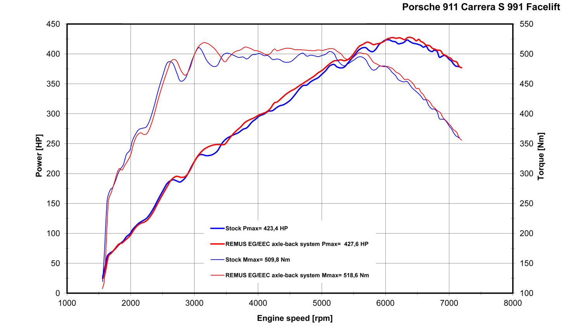

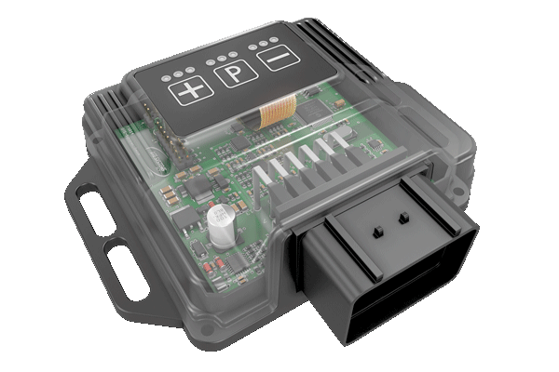
REMUS Powerizer
More power, more economy and more fun!
The electronics of the REMUS Powerizer enhances in real time
the engine management parameter. The engine mapping
is optimized in excess of 1000 times per second and ensures for a
considerable and noticeable power increase. The engine safety parameters and management remains totally original to ensure that individual engine components are not overstrained. Furthermore, the original mapping software remains totally untouched.
Due to the Plug & Play concept, the REMUS Powerizer is simple to install and can be easily removed or decommissioned using the supplied blind connector. Due to the torque increase, the engine has more power at lower RPM which leads to a reduction in fuel consumption. The power increase of the engine can be adjusted according to different driving styles by means of a „maximum power setting“, „eco fuel saving mode“ or a combination of both. The REMUS Powerizer is available for over 3000 petrol and diesel powered cars.

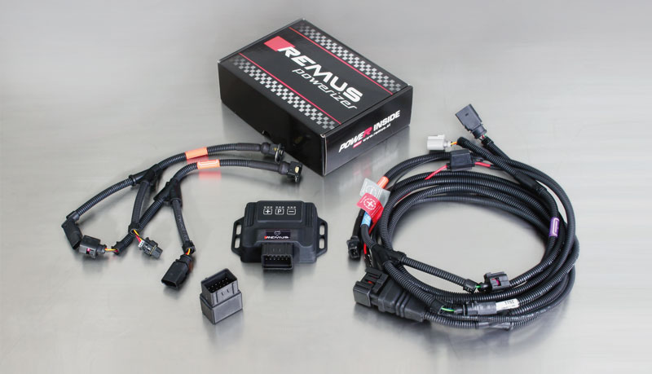

- Up to 25% more power
- Up to 20% more torque
- Easy installation and removal (Plug & Play)
- Up to 1l/100 km fuel saving
- 3 preset programs (RACE/SPORT/ECO) with individual power adjustment

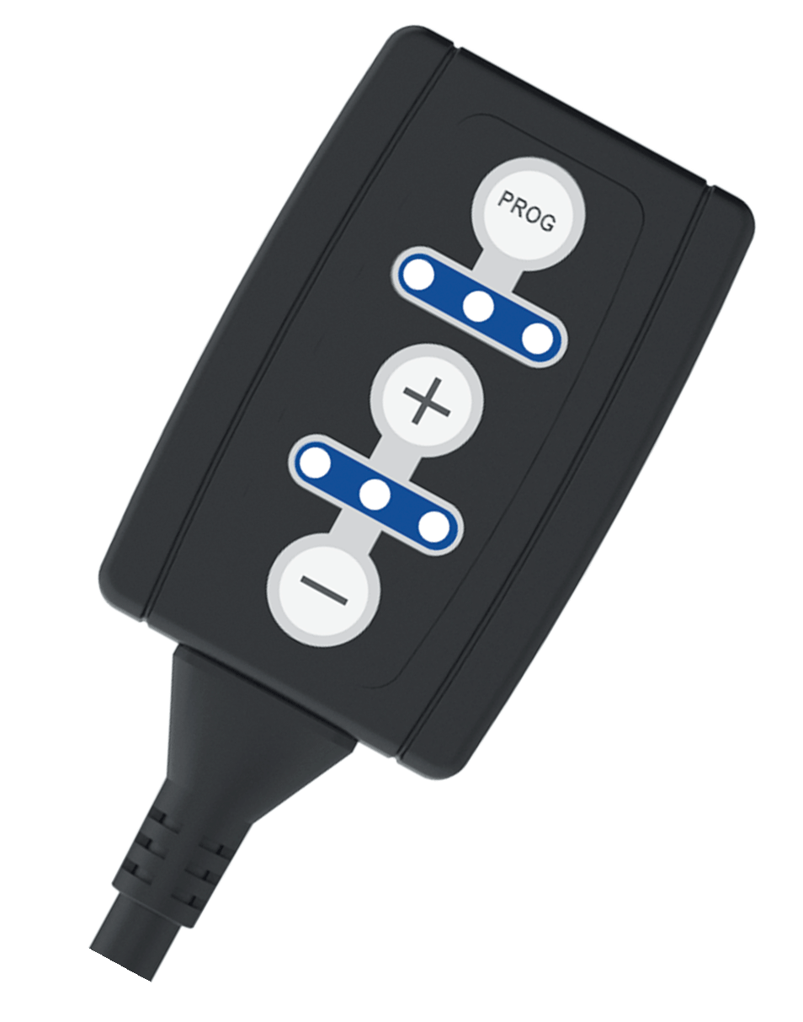
REMUS Responder

Improved throttle response, more dynamic!

Der REMUS ResponderThe REMUS Responder improves throttle response by means
of modifying the accelerator pedal output signal.
No more throttle delay and reduced lag during automatic shifting makes driving
with the REMUS Responder more fun. The Responder attaches between the
OEM pedal sensor and the OEM connector, ready to use in seconds due to plug & play technology.
Sophisticated adjustable programming profiles can lead to improved fuel consumption and
more efficiency. The 4 individual user selectable and adjustable performance settings
allow drivers to select according to their own preferences. The REMUS Responder totally eliminates the delay in modern electronic accelerator pedals!

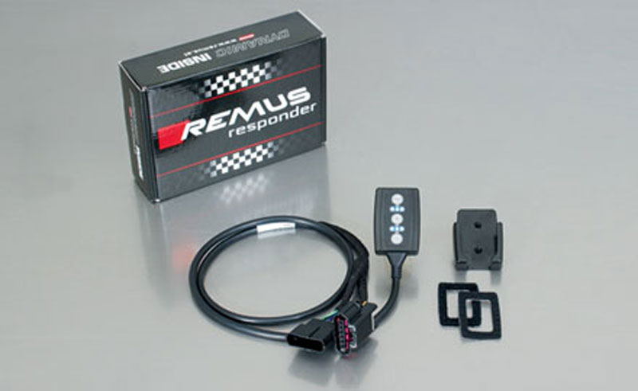

- Improved throttle response, reduced lag during gear changes
- Quicker reaction times, more dynamic without changing engine parameters
- 4 individual user selectable and adjustable performance settings
- Vehicle specific programming using OEM quality connectors
- Simple plug & play installation and easily removed without leaving traces

