REMUS product information 35-2015

Universal sport exhaust with remote controlled electronic valve

Dear REMUS-Partner,

We are pleased to inform you that we have completed our next development:
REMUS Universal sport exhaust with remote controlled electronic valve
and selectable tail pipes

It would be a pleasure for us to receive your order.

Stay tuned!
Your REMUS Team
#55S: tail pipes Ø 84 mm angled, chromed
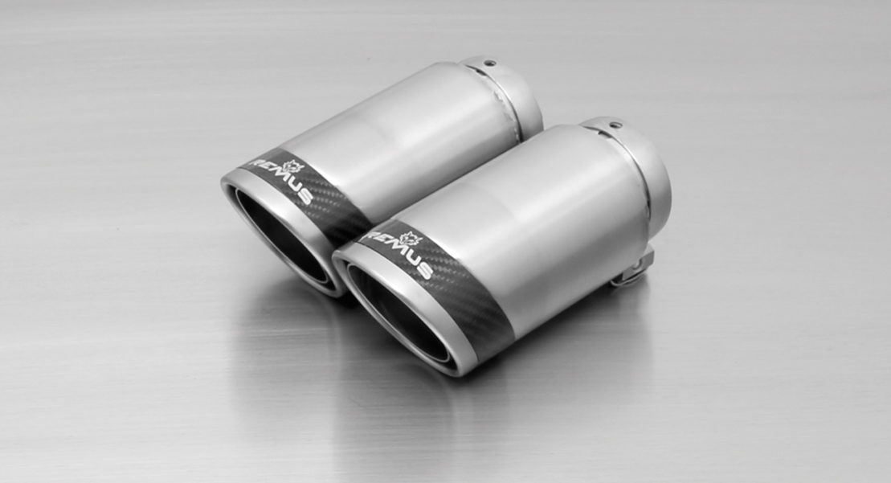
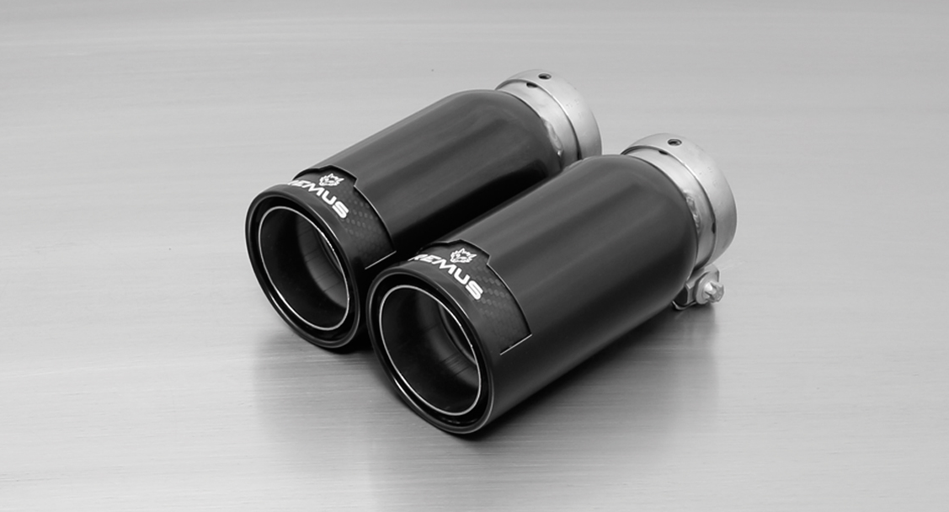
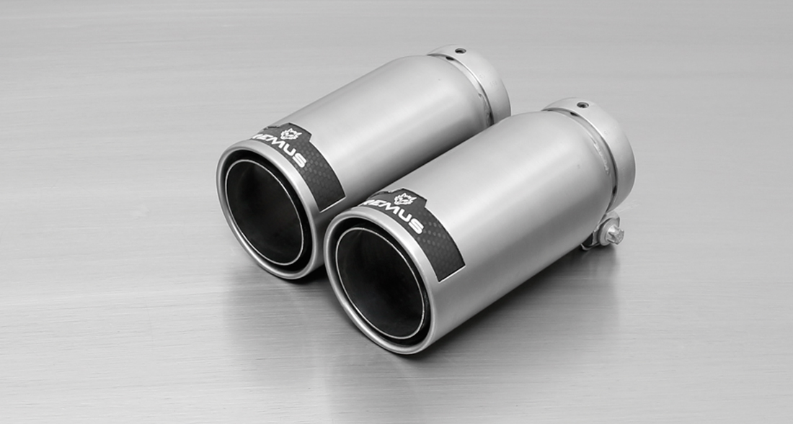
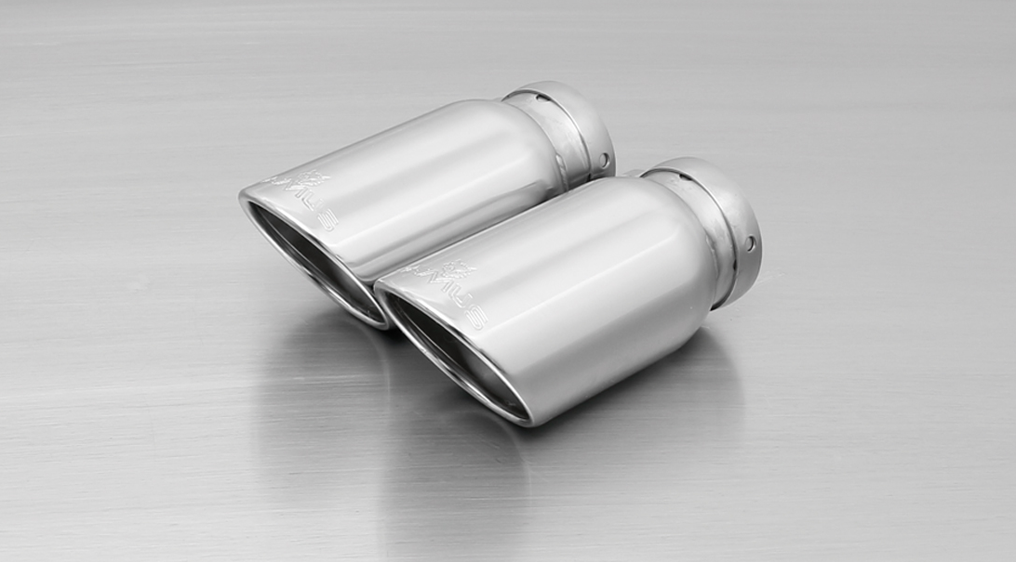
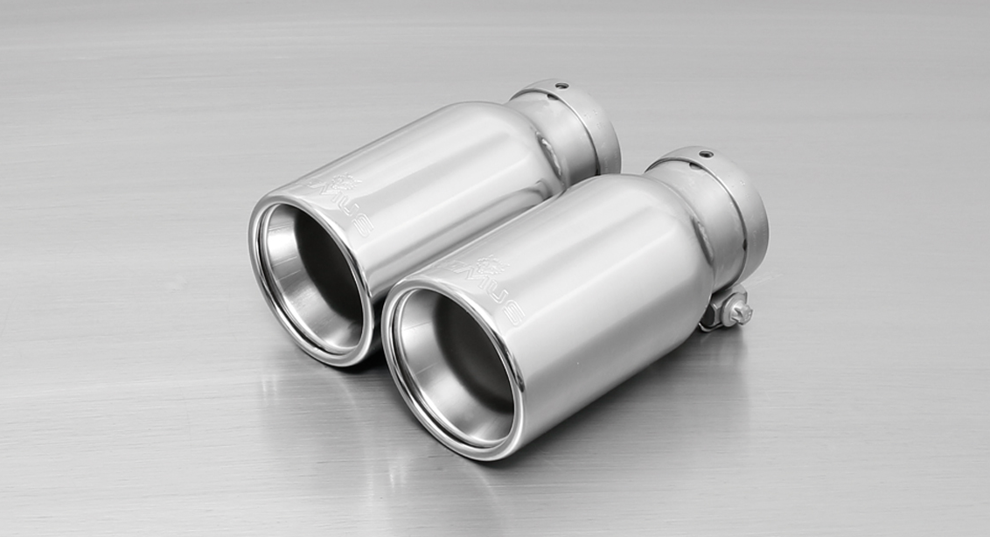
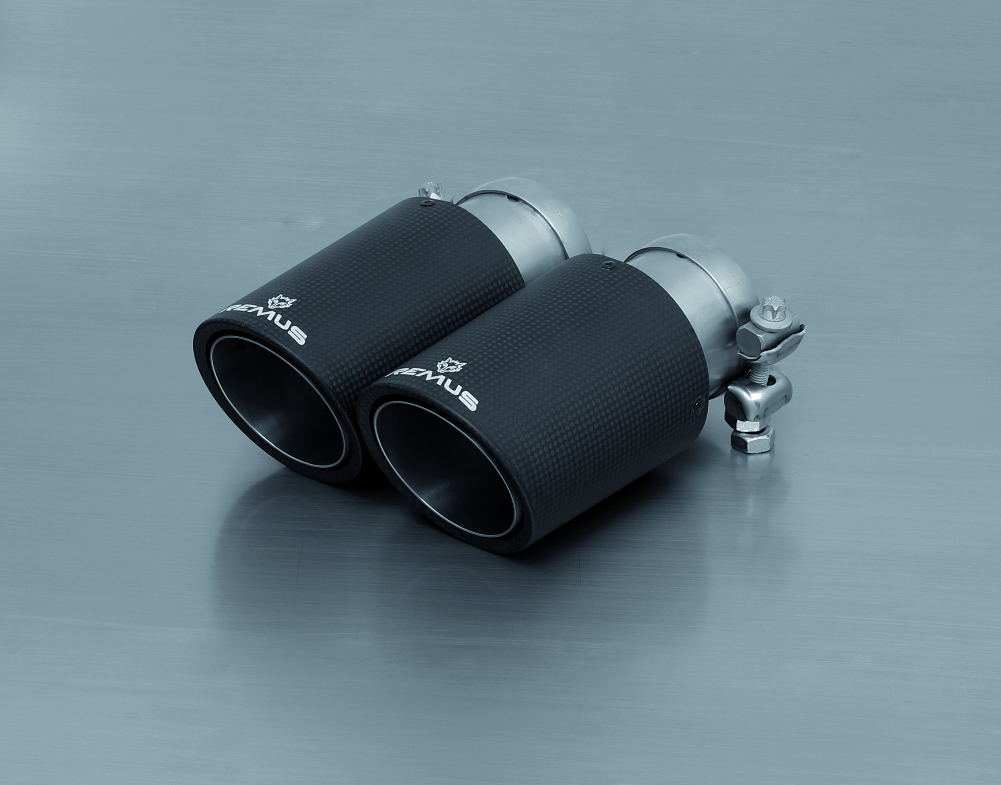

#05: tail pipes Ø 90 mm, chromed
#83C: tail pipes Ø 84 mm
Street Race, polished
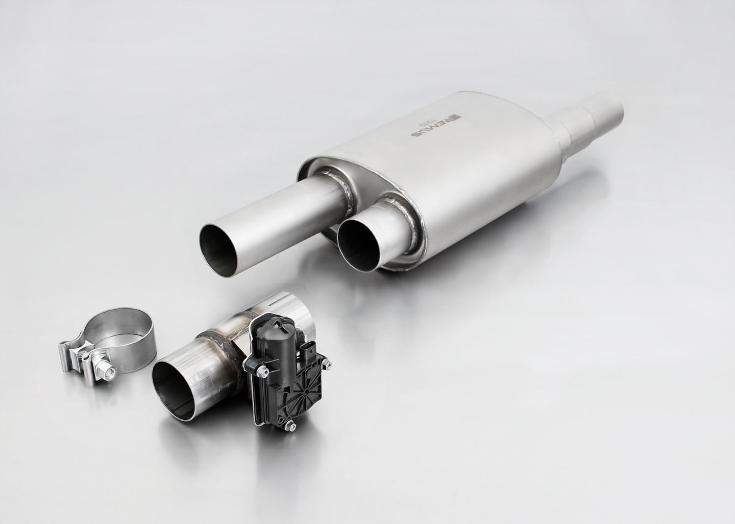
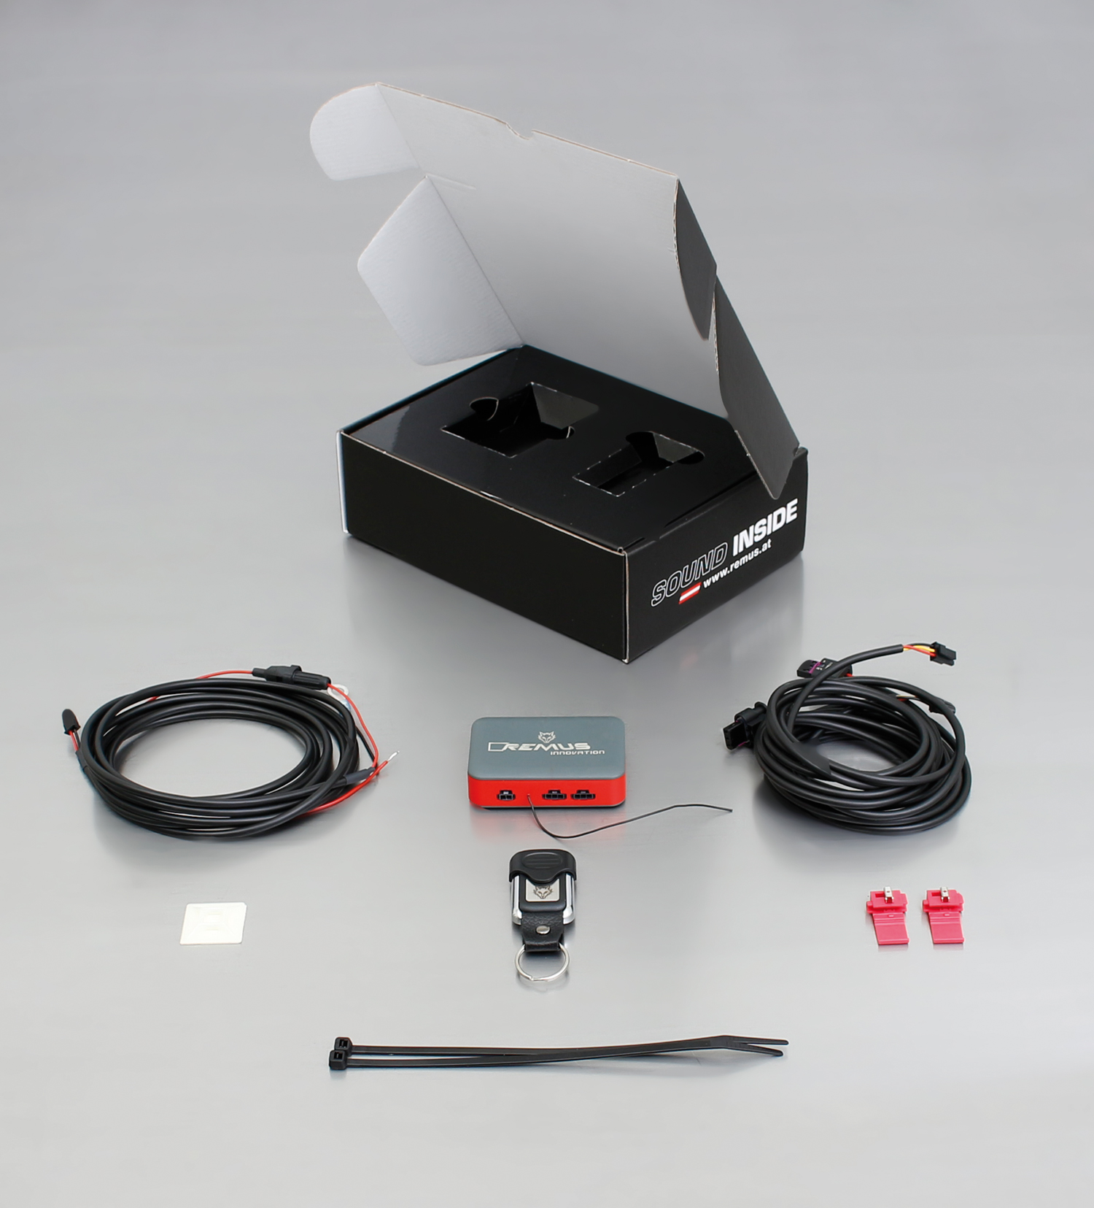

004513 0500
STE 0003 / STE 0004
#83CS: tail pipes Ø 84 mm
Carbon Race, polished
#83CTS: Carbon-Endrohre
Ø 84 mm angled, Titanium internals

#83CB: tail pipes Ø 84 mm
Street Race Black Chrome
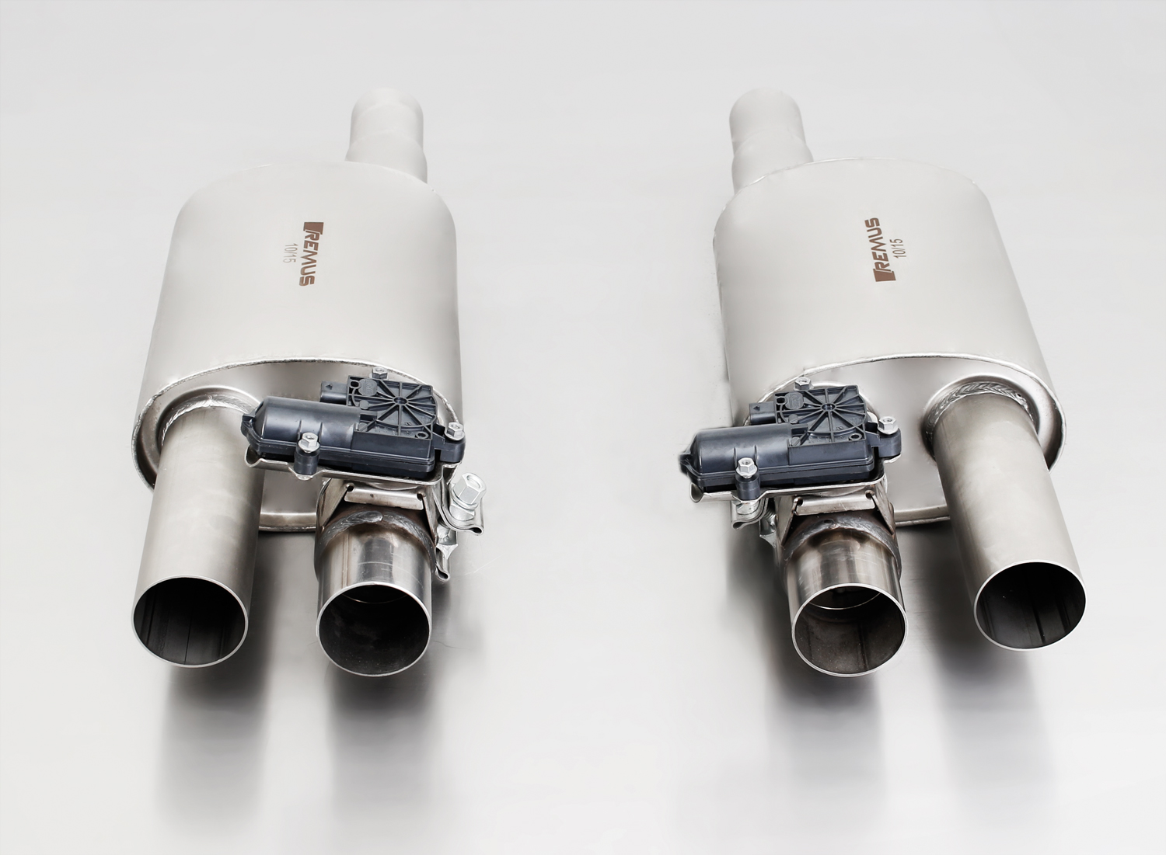
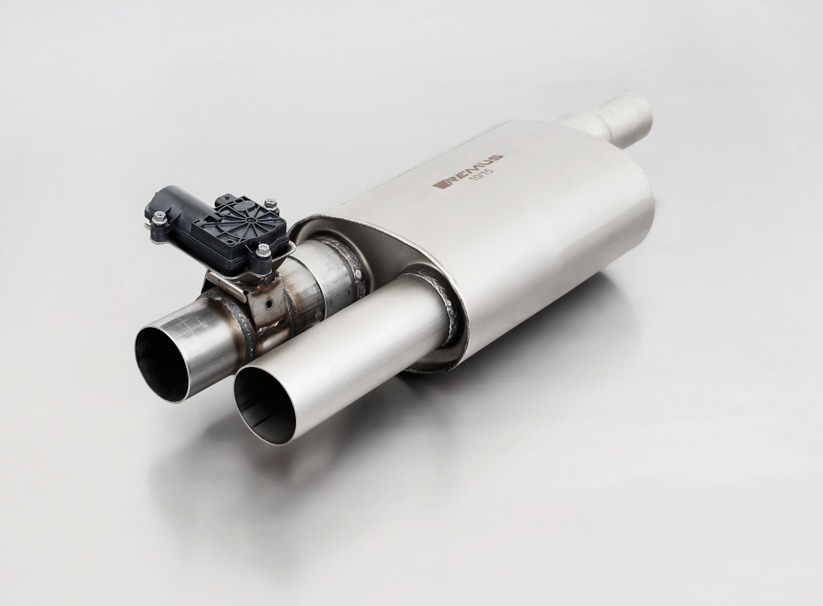
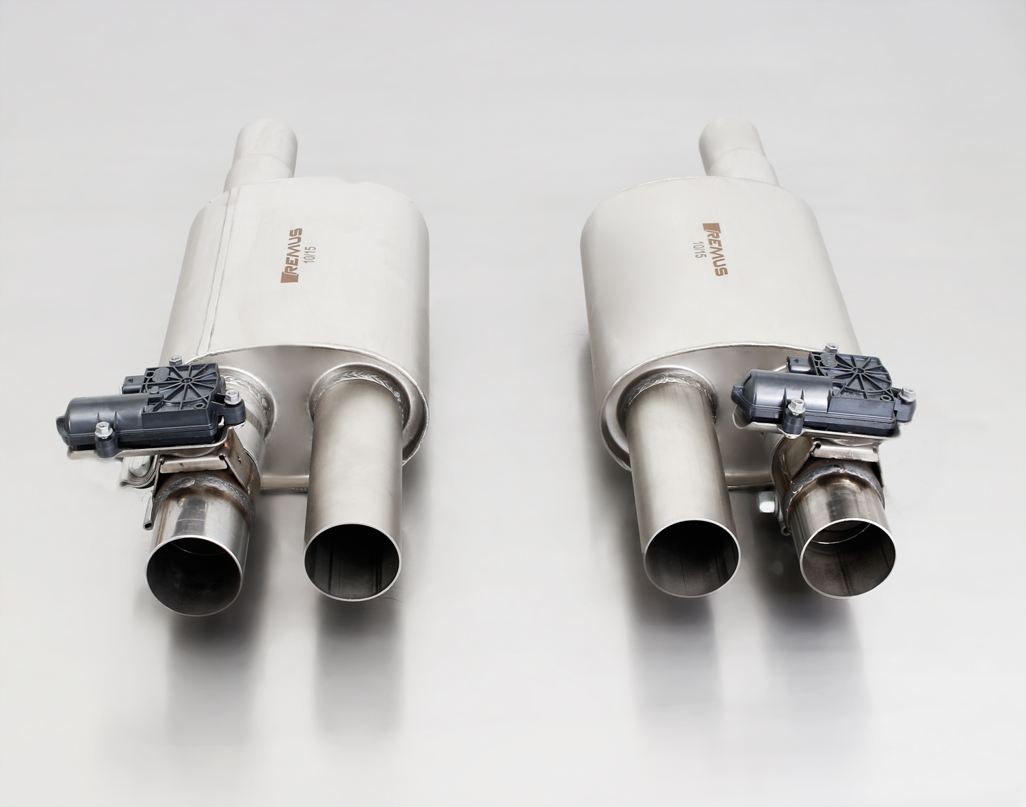
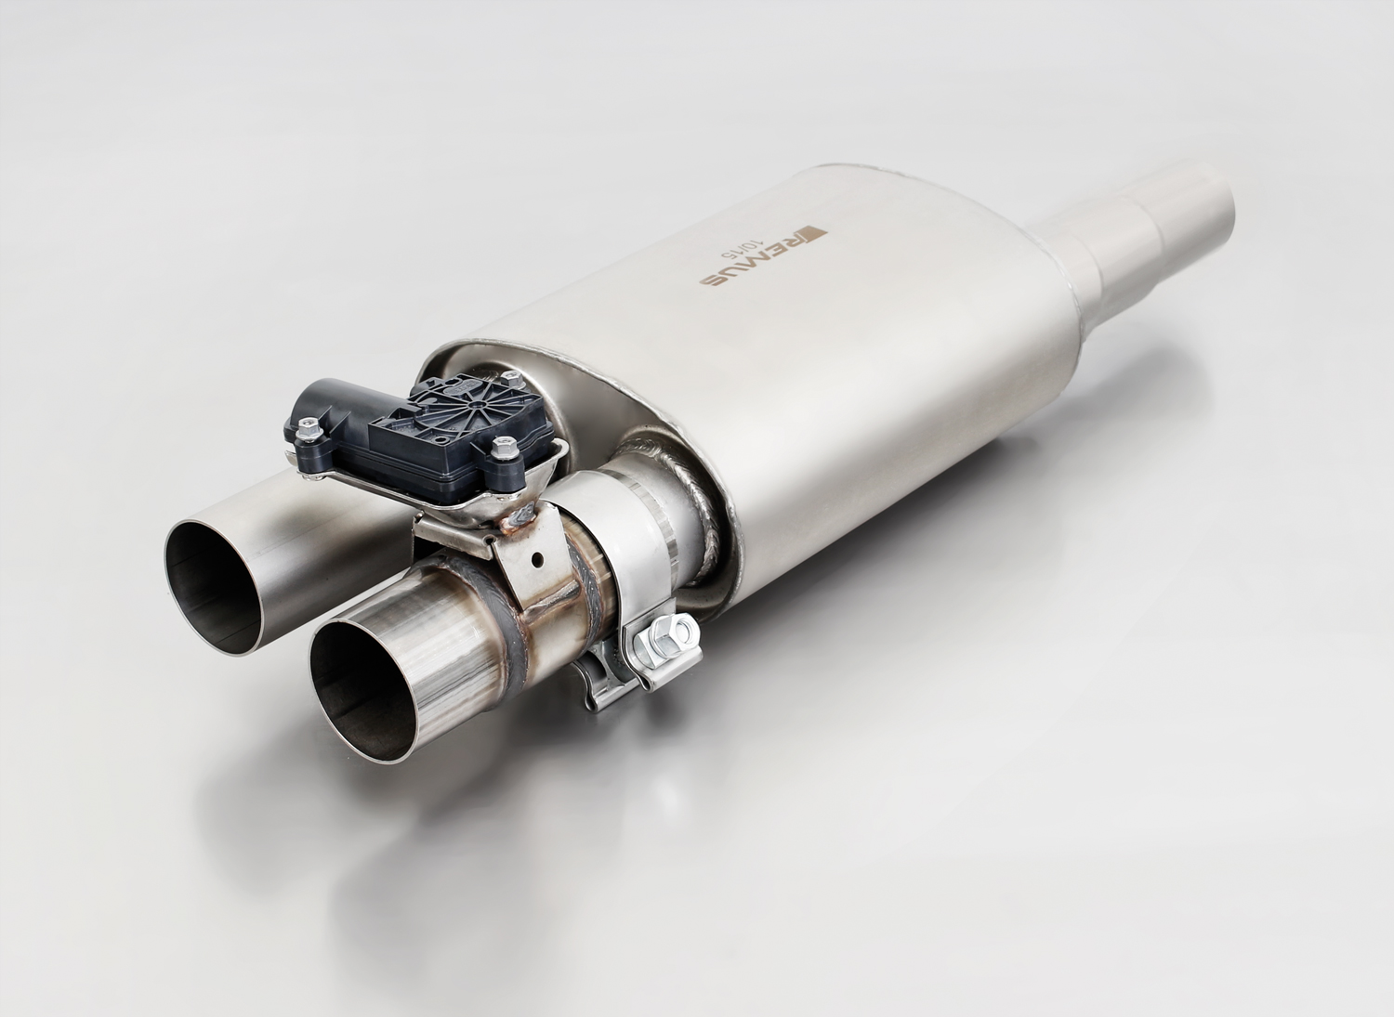
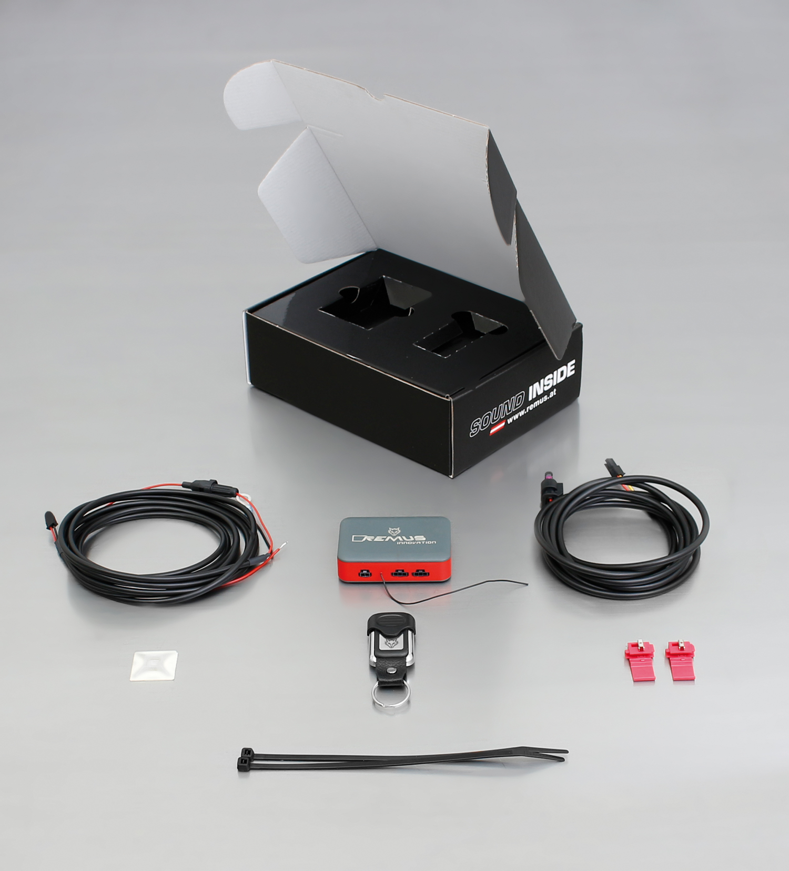
004513 0500 (turned 180°) used as a left OR right side system
STE 0004 for left/right system
2 x 004513 0500 used as a left/right system
004513 0500 Used as a left OR right side system

STE 0003 for one sided system (left OR right)
STE 0003 for one sided system (left OR right)

+
+
+

Car and engine specification
UNIVERSAL 30 - 200 kW
Part no. | Description | € RRP price excl. VAT
004513 0500 | Stainless steel universal sport exhaust (without tail pipes),  without homologation, with integrated electronic valve  body measurements: W:190xH:120xL:260 mm  stepped inlet connection: 51 / 57 / 63,5 mm (2 / 2,25 / 2,5 inch)  without body clamp!  The sport exhaust can be turned 180° and can therefore be used on left OR right side of the car. The outlet pipe with the valve is clamped-on and can also be turned.  Attention: Order 2x 004513 0500 and 2x tail pipe package for left/right-system! | 407,--
Choose following control unit for 1x 004513 0500:
STE 0003 | Sound Controller for 004513 0500 for one sided system (left OR right) consisting of:  Electronic module incl. remote control for individual sound in 4 levels, no homologation | 260,--
Choose following control unit for 2x 004513 0500:
STE 0004 | Sound Controller for 004513 0500 for both sided system (left AND right) consisting of:  Electronic module incl. remote control for individual sound in 4 levels, no homologation | 290,--
Choose from following tail pipe package:
0026 05 | Tail pipe set 2 tail pipes Ø 90 mm, chromed, with adjustable spherical clamp connection | 150,--
0026 55S | Tail pipe set 2 tail pipes Ø 84 mm angled, chromed, with adjustable spherical clamp connection | 150,--
0026 83C | Tail pipe set 2 tail pipes Ø 84 mm Street Race, with adjustable spherical clamp connection | 170,--
0026 83CB | Tail pipe set 2 tail pipes Ø 84 mm Street Race Black Chrome, with adjustable spherical clamp connection | 194,--
0026 83CS | Tail pipe set 2 tail pipes Ø 84 mm Carbon Race, with adjustable spherical clamp connection | 180,--
0026 83CTS | Tail pipe set 2 Carbon tail pipes Ø 84 mm angled, Titanium internals, with adjustable spherical clamp connection | 340,--
ATTENTION:
- Sport exhaust, remote control unit and tail pipe sets only fit as a complete system!

