REMUS product information 32-2016

NISSAN Juke Facelift type F15, 2WD, 2014=>

Dear REMUS Partner,

We are pleased to inform you that we have completed the development of the
REMUS sport exhaust with selectable tail pipes
fitting the NISSAN Juke Facelift type F15, 2WD, 2014=>

It would be a pleasure for us to receive your order.

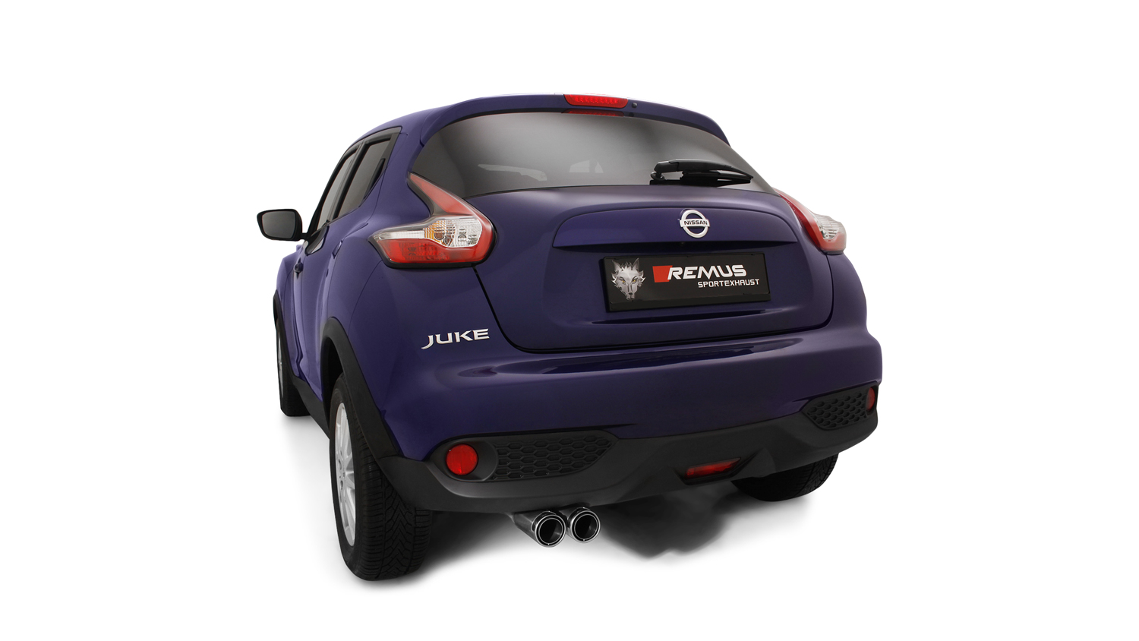
Stay tuned!

Your REMUS Team

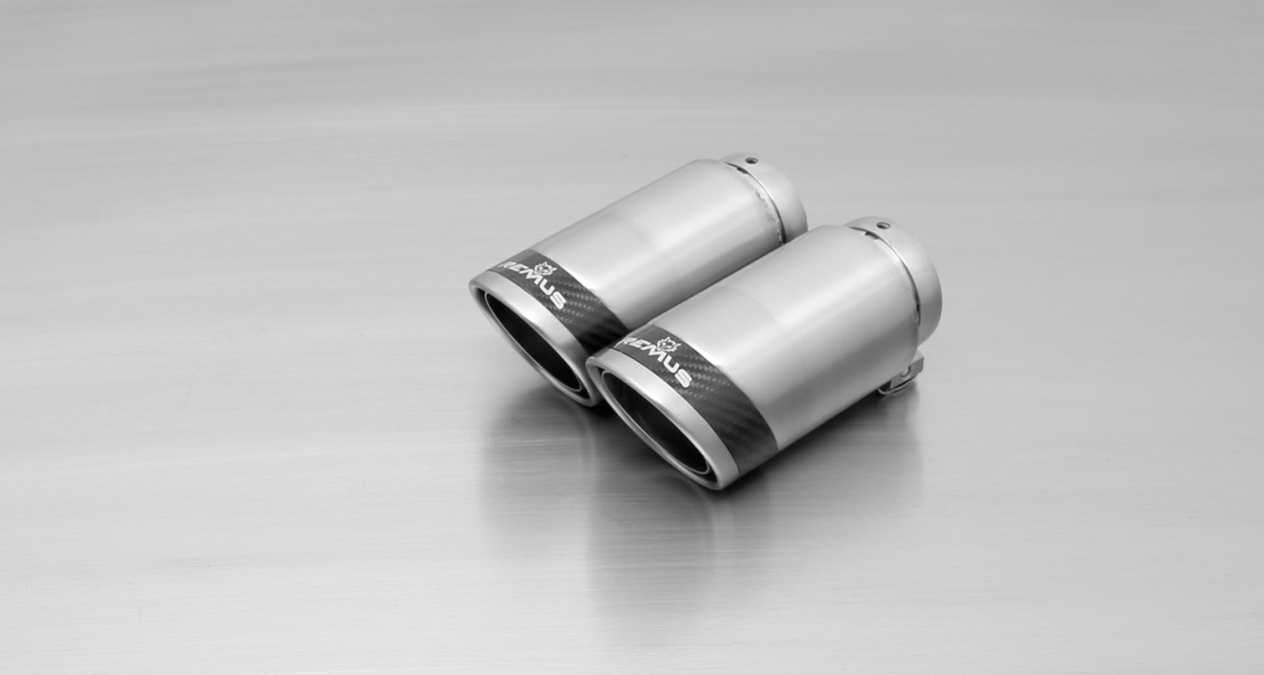
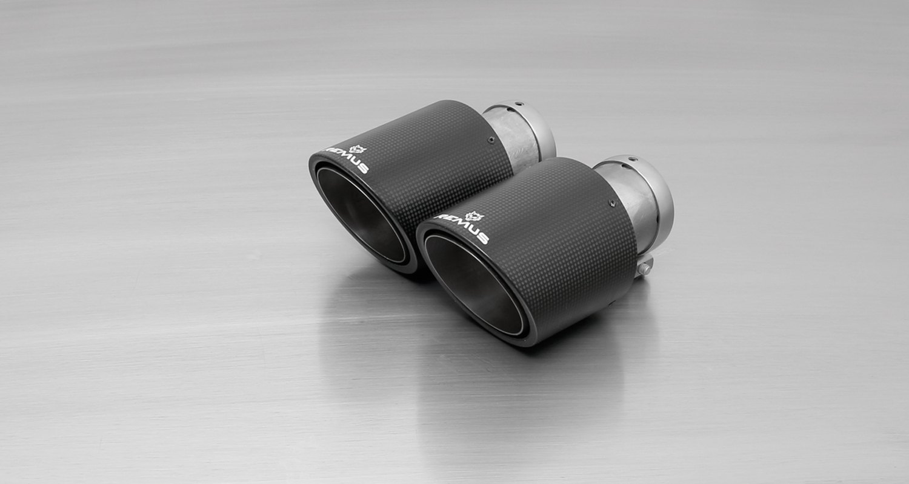
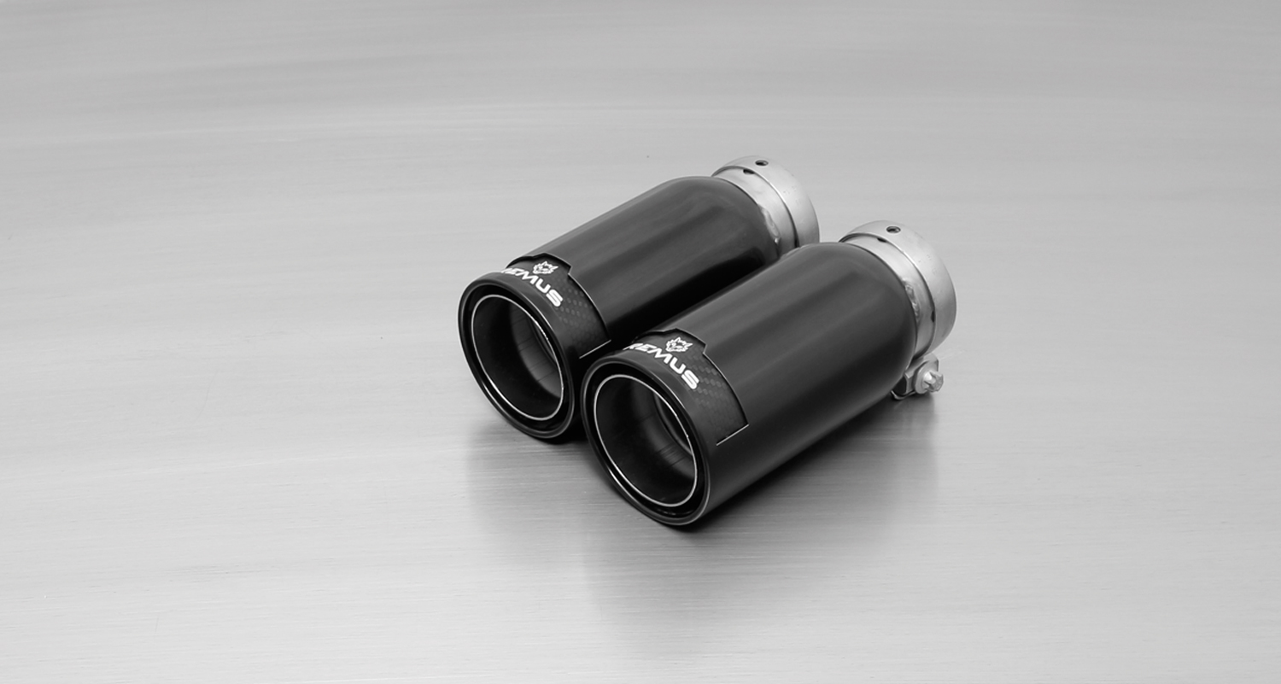
#83CS: tail pipes Ø 84 mm
Carbon Race, polished
#83CTS: Carbon-tail pipes
Ø 84 mm angled, Titanium internals

#83CB: tail pipes Ø 84 mm
Street Race Black Chrome

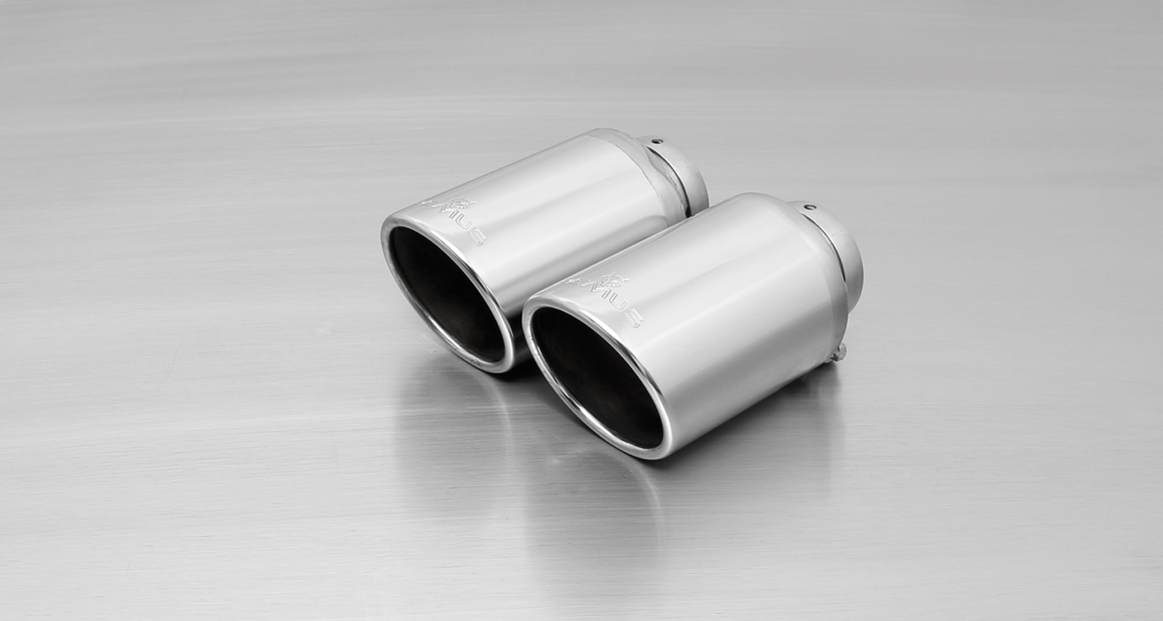
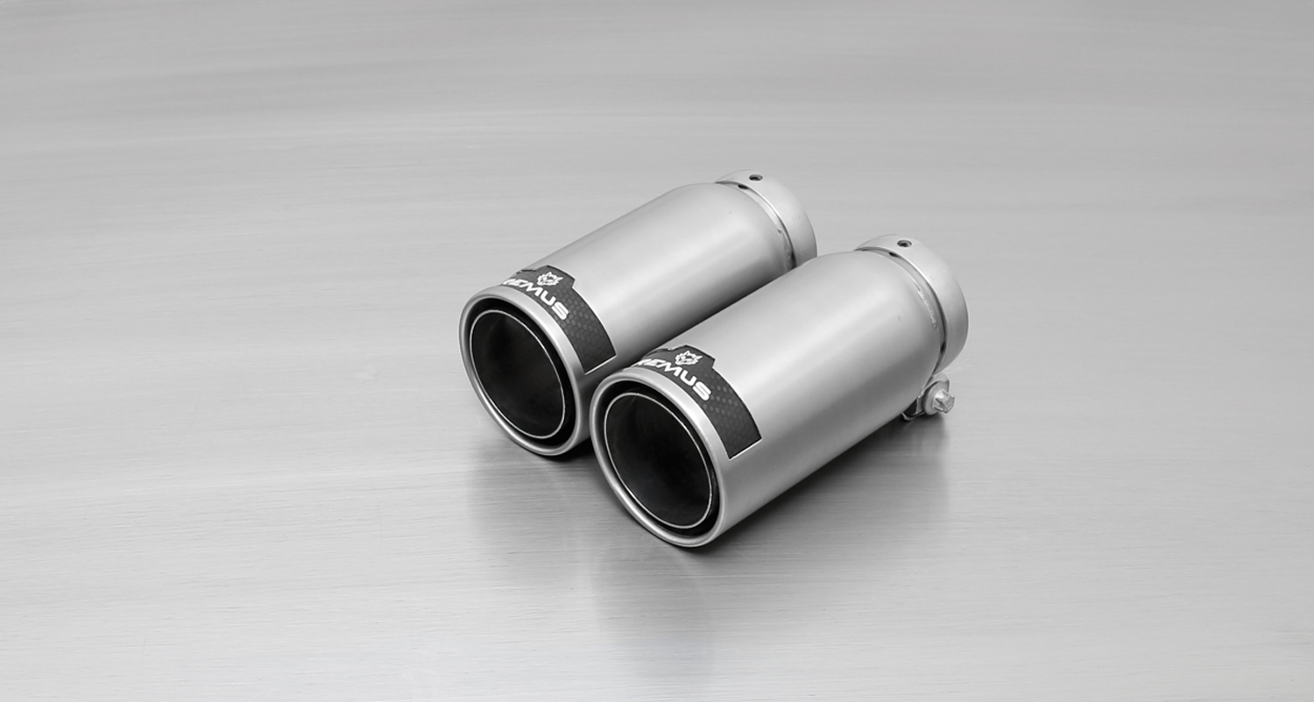
#55S: tail pipes Ø 84 mm
angled, chromed

#83C: tail pipes Ø 84 mm
Street Race, polished

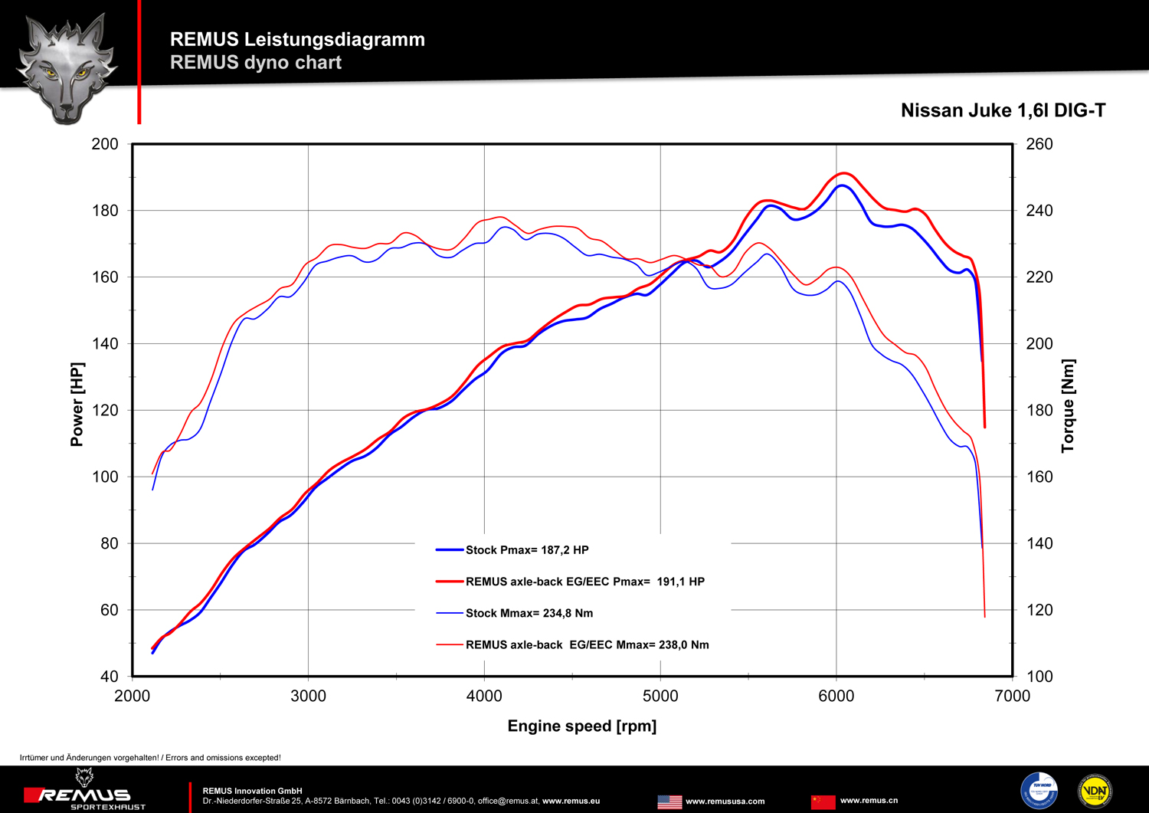

Car and engine specification
NISSAN Juke Facelift type F15, 2WD, 2014=>
1.6l 140 kW
NISSAN Juke type F15, 2WD, 2010=>
1.6l 140 kW (MR16); 1.6l 86 kW (HR16); 1.5l 81 kW (K9K)
Part no. | Description | € RRP price excl. VAT
604111 0500 | Stainless steel sport exhaust system left (without tail pipes), with EEC homologation.  Original tube Ø 50 mm / REMUS tube Ø 54 mm | 360,--
choose from following tail pipe package:
0026 55S | Stainless steel tail pipe set, 2 x Ø 84 mm angled, chromed, with adjustable spherical clamp connection | 150,--
0026 83C | Stainless steel tail pipe set, 2 x Ø 84 mm Street Race, with adjustable spherical clamp connection | 170,--
0026 83CS | Stainless steel tail pipe set, 2 x Ø 84 mm Carbon Race, with adjustable spherical clamp connection | 180,--
0026 83CB | Stainless steel tail pipe set, 2 x Ø 84 mm Street Race Black Chrome, with adjustable spherical clamp connection | 194,--
0026 83CTS | Carbon tail pipe set 2 x Ø 84 mm angled, Titanium internals, with adjustable spherical clamp connection | 340,--
INFOBOX:
- The sport exhaust can only be installed using the above mentioned tip sets!
- Sport exhaust and tail pipe set only fit as a complete system! The rear skirt must be trimmed as per the supplied template!
- 604111 0500 and tail pipe package replaces part numbers 604111 0584C which will be available as long as stock lasts.

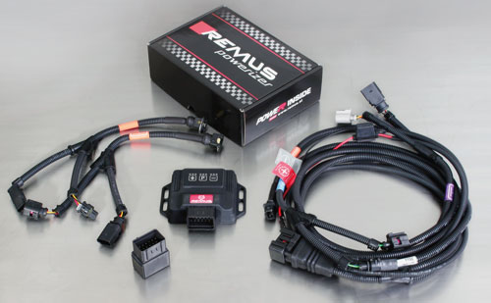

Under http://www.remus.eu/powerizer/ and http://www.remus.eu/remusresponder you will find the entire product range, prices and installation instructions.

REMUS Powerizer: More power, more economy and more fun.
- Up to 25 % more power
- Up to 20 % more torque
- Up to 1l/100 km fuel saving
- Fully adjustable power increase
- Simple DIY installation (Plug & Play)
REMUS POWERIZER: The performance figures represent the maximum achievable values. The actual performance output depends on the original tolerances of each engine. REMUS delivers the POWERIZER with the best possible setting for your vehicle type. You can adjust the performance according to your requirements as per the POWERIZER instructions

Legal references

1. Completion and registration of chip tuning in the car documents
Due to chip tuning, the operating license of the vehicle will terminate if the installation and registration of the POWERIZER is not carried out or immediately reported to an official approved testing facility. Please consider that driving a vehicle without the required operating license will cause legal penalties.

2. Vehicle insurance must be informed upon installing a POWERIZER
The installation of the POWERIZER can have influence on the insurance policy of your vehicle. You must inform the insurance company if you install a POWERIZER in your vehicle.

3. Effect of chip tuning on warranty and guarantee claims
a) When installing a POWERIZER, you will lose all guarantee claims regarding the engine against the vehicle manufacturer.
b) Installing a POWERIZER, can have influence on warranty claims against the seller of the vehicle.
c) REMUS excludes any claims regarding compensation for damages on the engine and drivetrain.

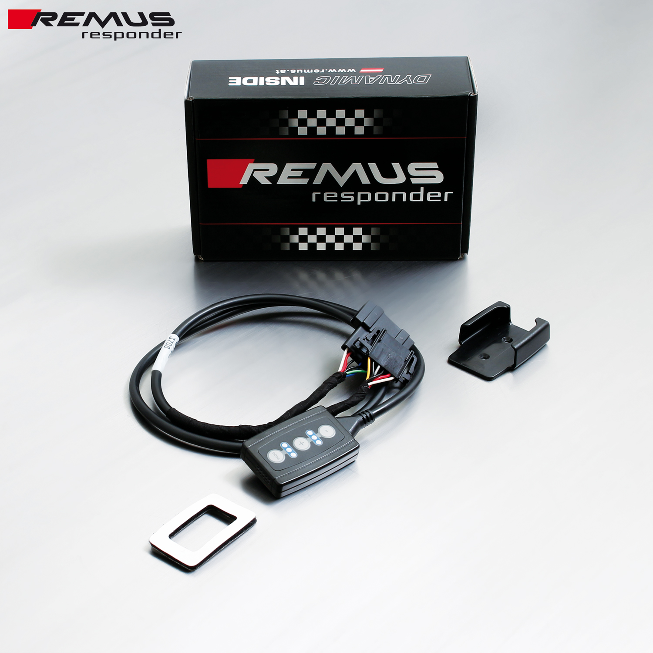

Under http://www.remus.eu/powerizer/ and http://www.remus.eu/remusresponder you will find the entire product range, prices and installation instructions.

REMUS RESPONDER:
Improved throttle response, more dynamic!
The REMUS Responder improves throttle response by means of modifying the accelerator pedal output signal. No more throttle delay and reduced lag during automatic shifting makes driving with the REMUS Responder more fun. The Responder attaches between the OEM pedal sensor and the OEM connector, ready to use in seconds due to plug & play technology. Sophisticated adjustable programming profiles can lead to improved fuel consumption and more efficiency. The 4 individual user selectable and adjustable performance settings allow drivers to select according to their own preferences.
The REMUS Responder totally eliminates the delay in modern electronic accelerator pedals!
