REMUS product information 29-2016

SEAT Ibiza Cupra, type 6J, 2016=>

Dear REMUS Partner,

We are pleased to inform you that we have completed our next development:
REMUS cat-back system for the
SEAT Ibiza Cupra, type 6J, 2016=>

It would be a pleasure for us to receive your orders.

Stay tuned!
Your REMUS Team
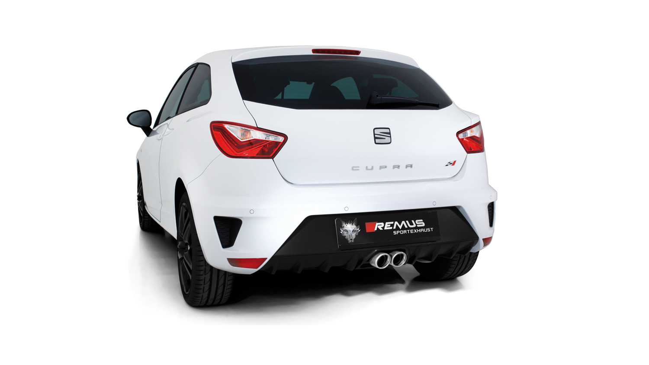

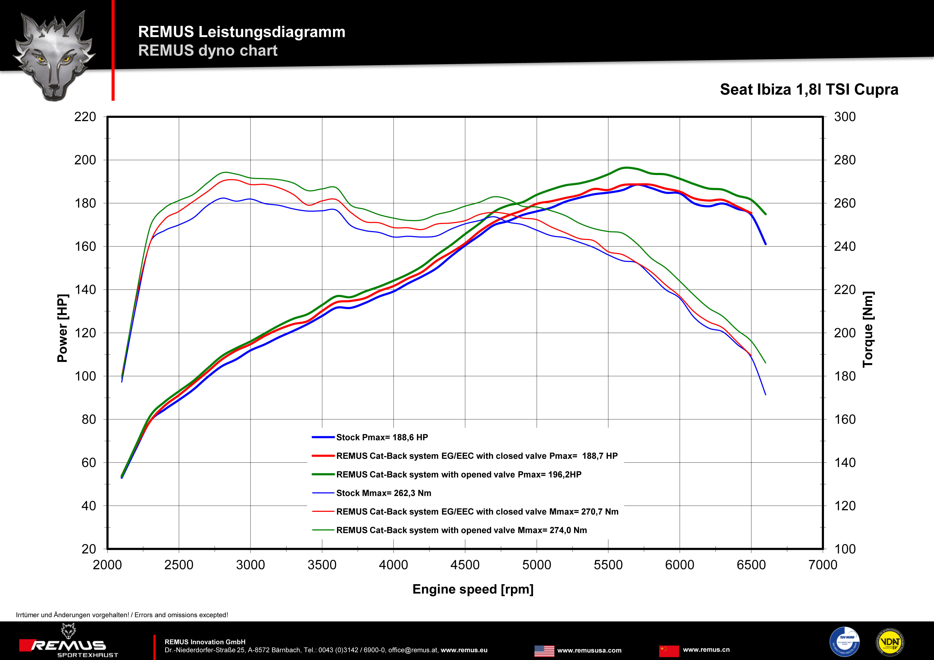

Car and engine specification
SEAT Ibiza Cupra, type 6J, 2016=>
1.8l TSI 141 kW (DAJ)
Part no. | Description | € RRP price excl. VAT
Optional: stainless steel non-resonated RACING front section without homologation
954513 0000 | Stainless steel non-resonated RACING cat-back front section instead of front silencer, without homologation  Original tube Ø 55 mm - REMUS tube Ø 60 mm | 95,--
Stainless steel cat-back system incl. EEC Homologation
954513 0300 | Stainless steel resonated cat-back front section, incl. EEC homologation  Original tube Ø 55 mm - REMUS tube Ø 60 mm | 190,--
795015 5504S | Stainless steel sport exhaust centered with 2 tail pipes Ø 76 mm angled, chromed with integrated valves, incl. EEC homologation  Original tube Ø 55 mm - REMUS tube Ø 60 mm | 980,--
INFOBOX:
- Cat-back system: 954513 0300 + 795015 5504S! No vehicle modifications are required!
- RACING cat-back system: 954513 0000 + 795015 5504S! No vehicle modifications are required!
- 795015 5504S: It is not permissible to activate the valve on public roads as per the EU transport authority. The activation of the valve is carried out using the supplied remote control key fob, sound controller and electrical actuator which allows the valve to be operated in 4 different positions.

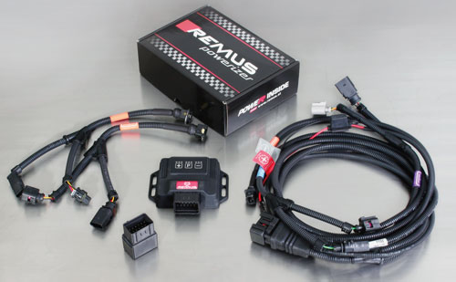

Under http://www.remus.eu/powerizer/ and http://www.remus.eu/remusresponder you will find the entire product range, prices and installation instructions.

REMUS Powerizer: More power, more economy and more fun.
- Up to 25 % more power
- Up to 20 % more torque
- Up to 1l/100 km fuel saving
- Fully adjustable power increase
- Simple DIY installation (Plug & Play)
REMUS POWERIZER: The performance figures represent the maximum achievable values. The actual performance output depends on the original tolerances of each engine. REMUS delivers the POWERIZER with the best possible setting for your vehicle type. You can adjust the performance according to your requirements as per the POWERIZER instructions

Legal references

1. Completion and registration of chip tuning in the car documents
Due to chip tuning, the operating license of the vehicle will terminate if the installation and registration of the POWERIZER is not carried out or immediately reported to an official approved testing facility. Please consider that driving a vehicle without the required operating license will cause legal penalties.

2. Vehicle insurance must be informed upon installing a POWERIZER
The installation of the POWERIZER can have influence on the insurance policy of your vehicle. You must inform the insurance company if you install a POWERIZER in your vehicle.

3. Effect of chip tuning on warranty and guarantee claims
a) When installing a POWERIZER, you will lose all guarantee claims regarding the engine against the vehicle manufacturer.
b) Installing a POWERIZER, can have influence on warranty claims against the seller of the vehicle.
c) REMUS excludes any claims regarding compensation for damages on the engine and drivetrain.

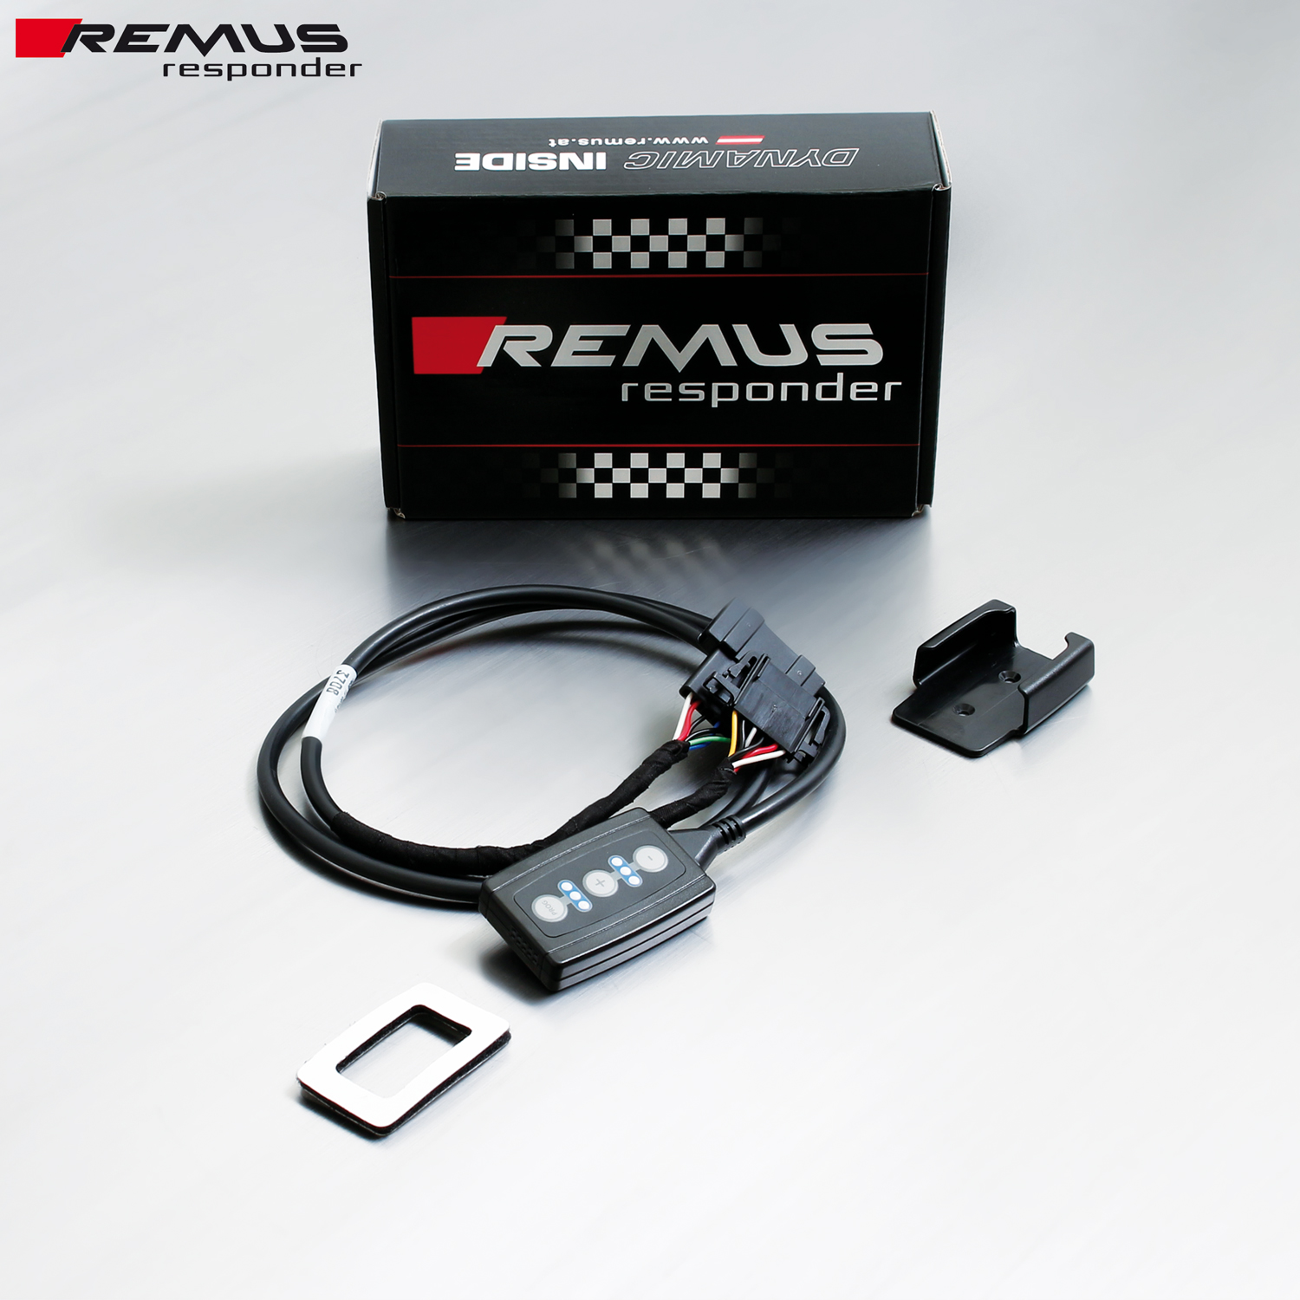

Under http://www.remus.eu/powerizer/ and http://www.remus.eu/remusresponder you will find the entire product range, prices and installation instructions.

REMUS RESPONDER:
Improved throttle response, more dynamic!
The REMUS Responder improves throttle response by means of modifying the accelerator pedal output signal. No more throttle delay and reduced lag during automatic shifting makes driving with the REMUS Responder more fun. The Responder attaches between the OEM pedal sensor and the OEM connector, ready to use in seconds due to plug & play technology. Sophisticated adjustable programming profiles can lead to improved fuel consumption and more efficiency. The 4 individual user selectable and adjustable performance settings allow drivers to select according to their own preferences.
The REMUS Responder totally eliminates the delay in modern electronic accelerator pedals!

