REMUS product information 23-2016

BMW M3 F80 / M4 F82, 2014=>

Dear REMUS Partner,

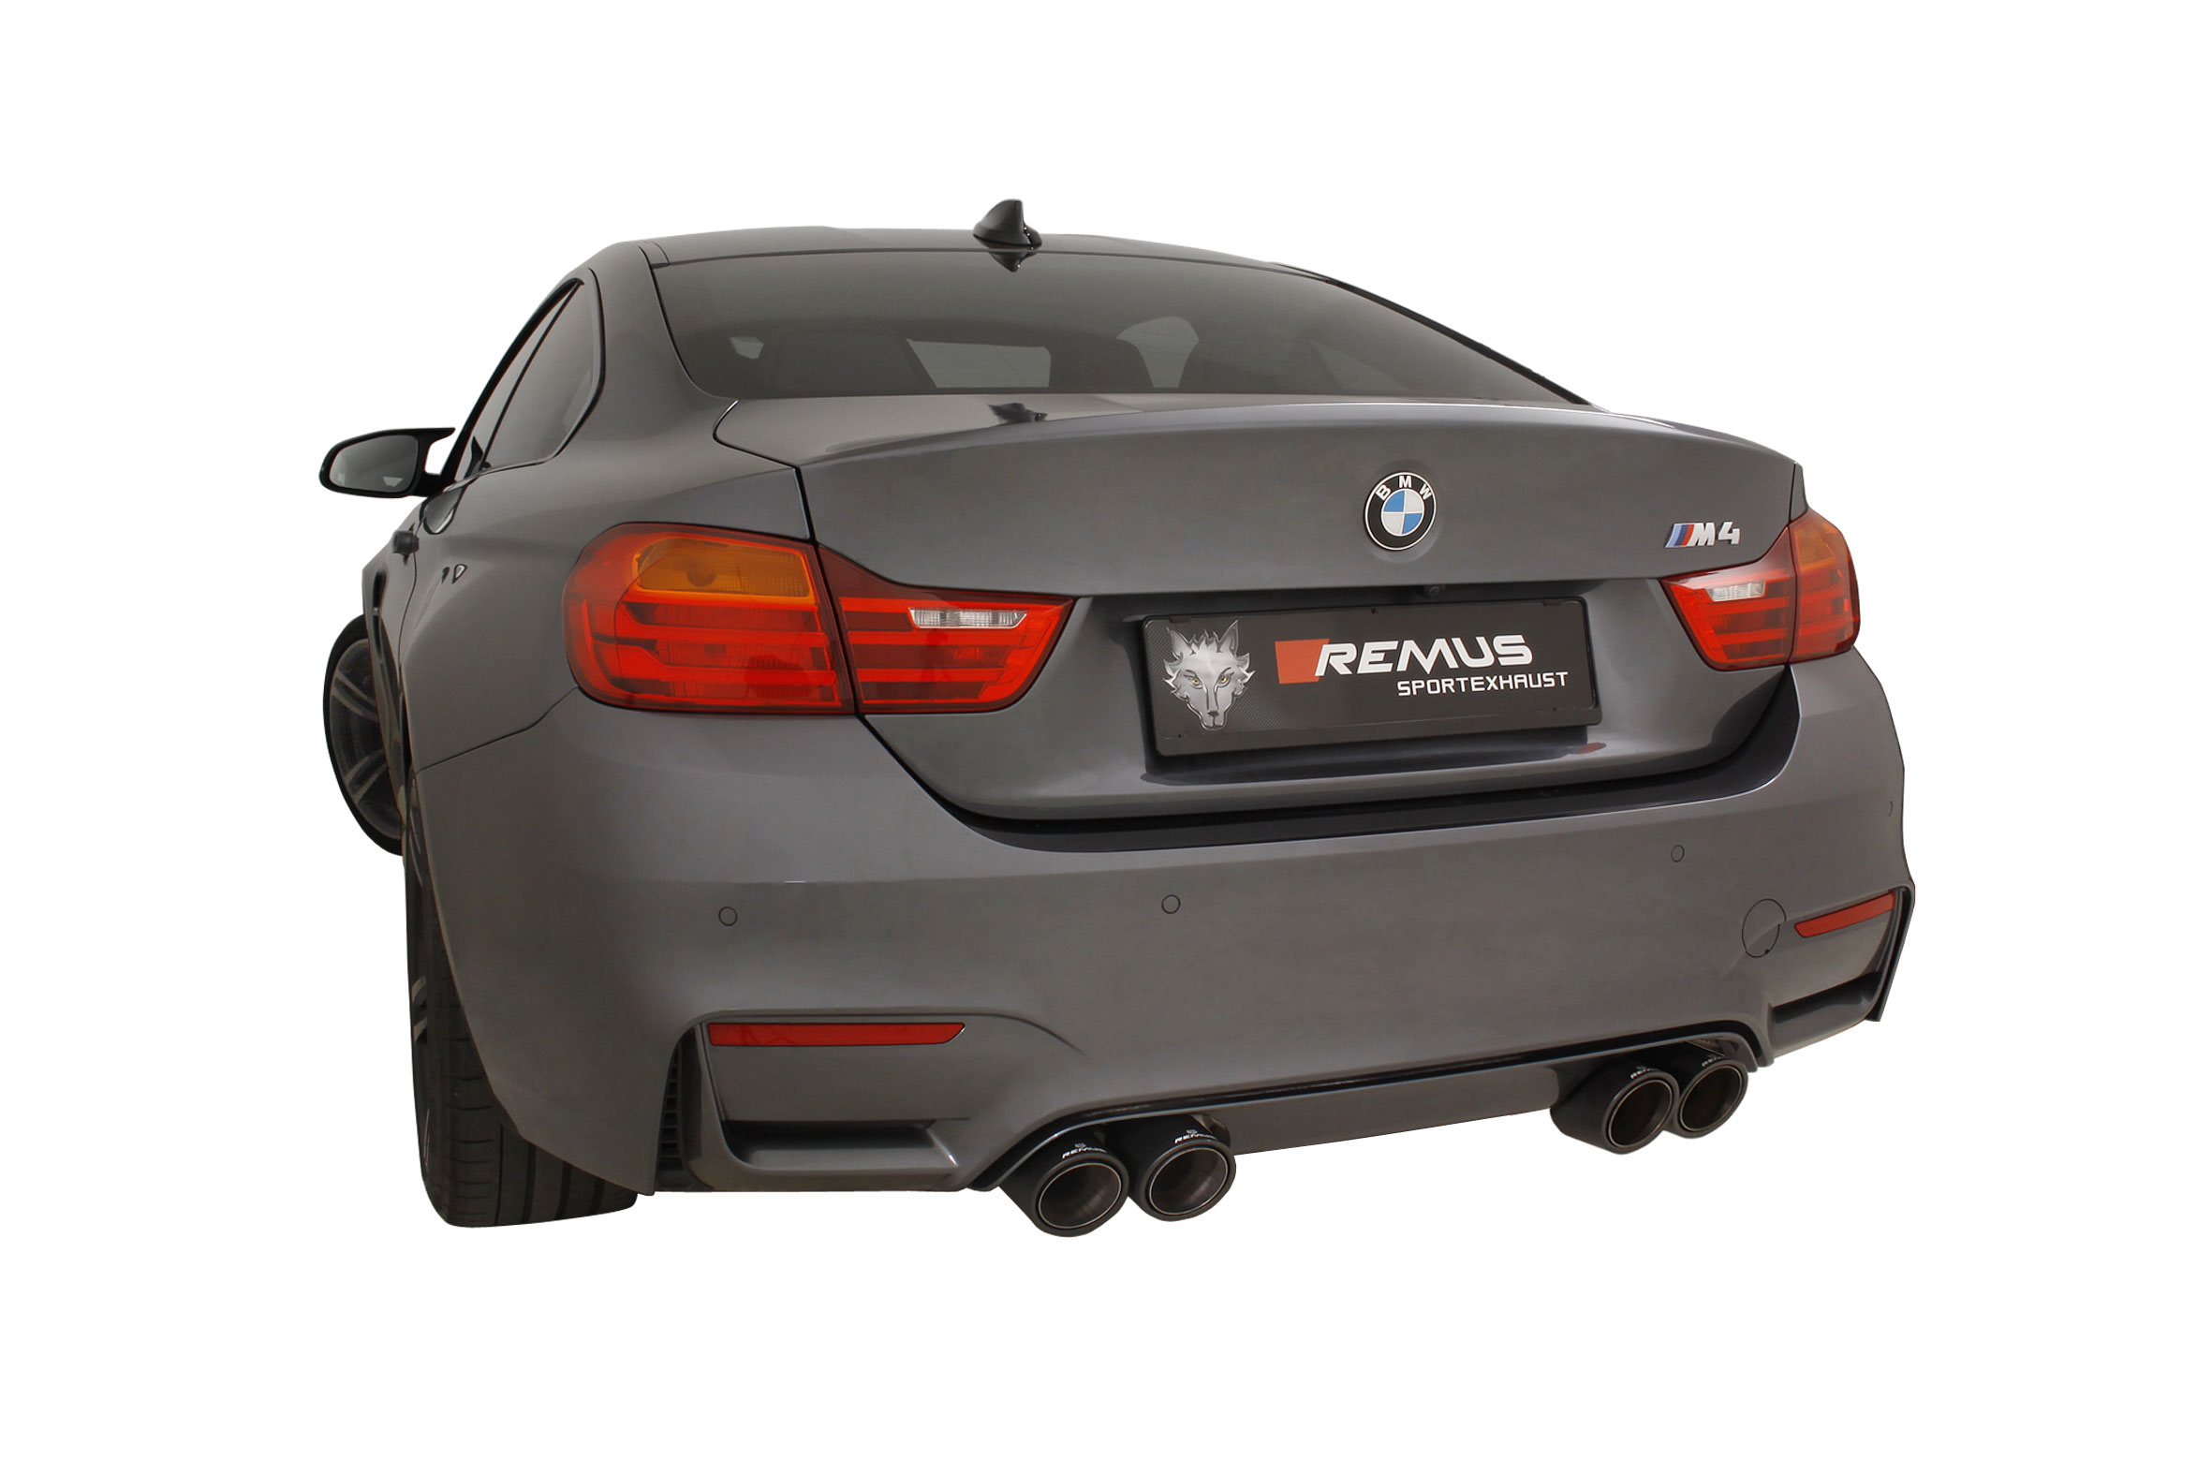
We are pleased to inform you that we have completed our next development:
REMUS RACING resonated front section for the BMW M3 F80 / M4 F82, 2014=>.

It would be a pleasure for us to receive your order.

Stay tuned!
Your REMUS Team

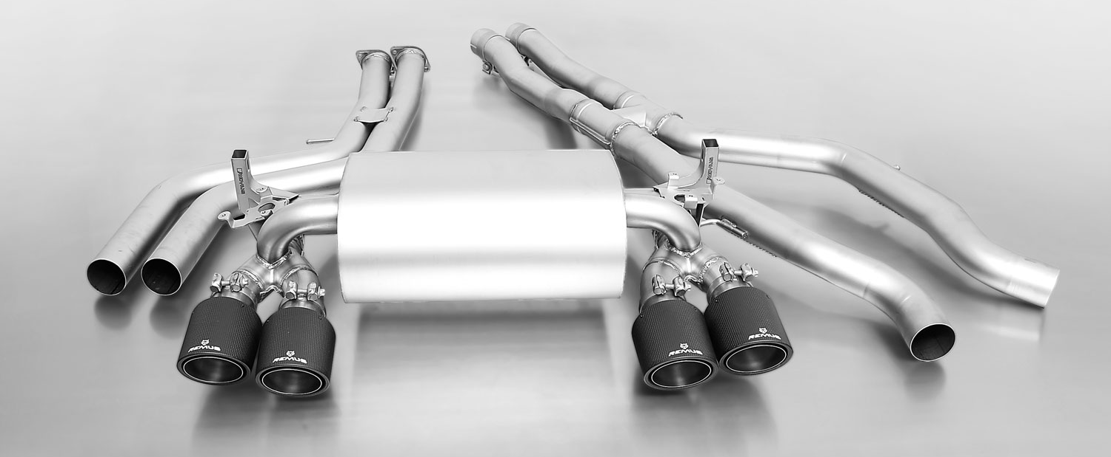
089014 0000 + 089014 0500 + 0046 70CS

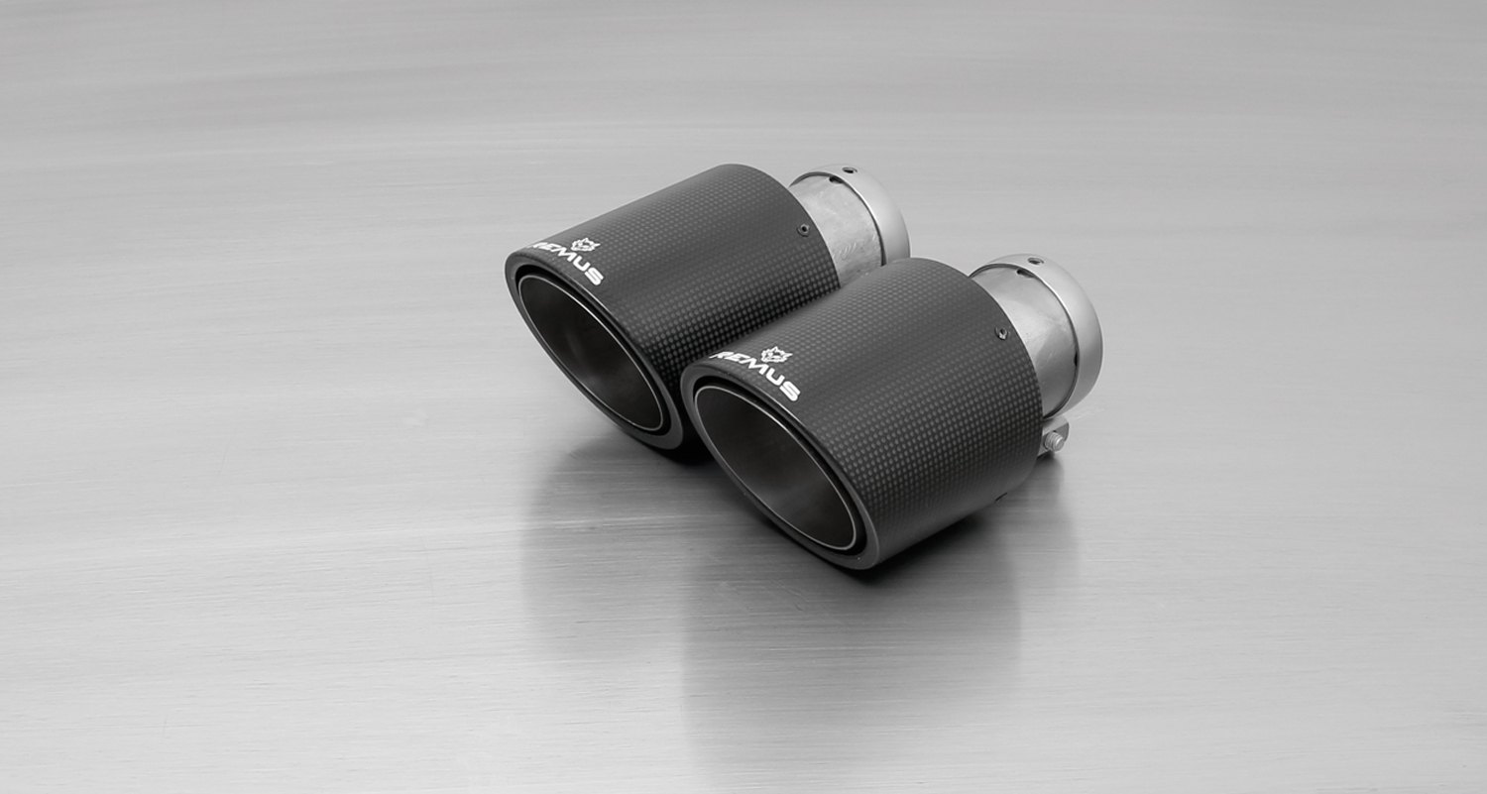
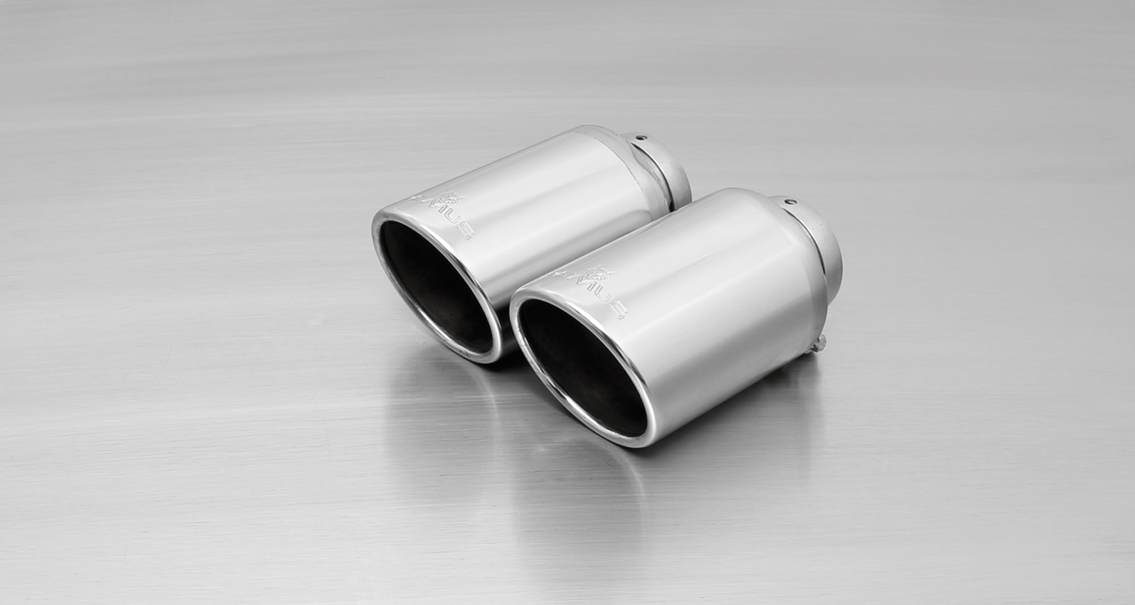
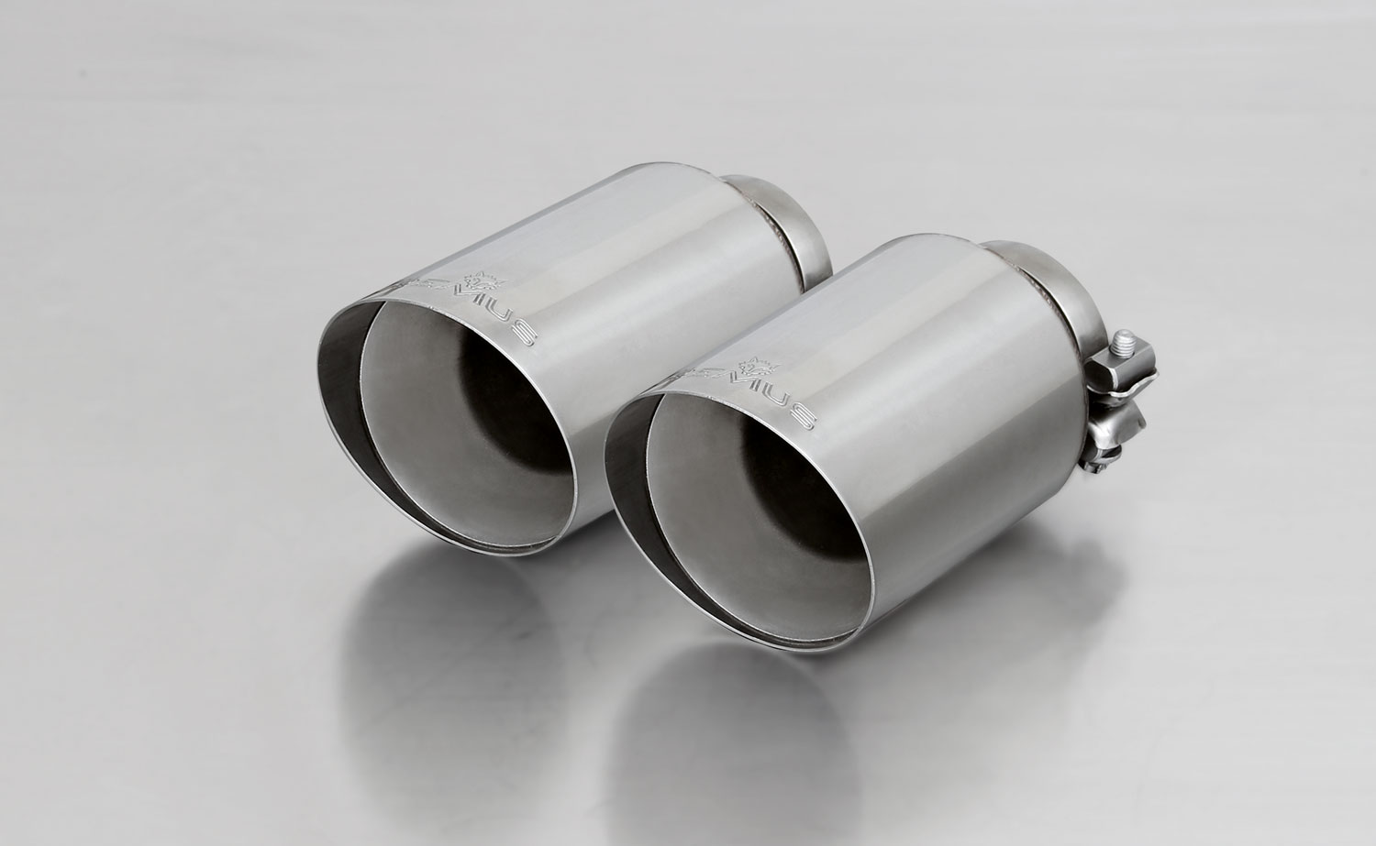
#70SG: tail pipes Ø 102 mm
angled, straight cut, chromed
#70CS: Carbon tail pipes
Ø 102 mm angled, Titanium internals

#70S: tail pipes Ø 102 mm
angled, chromed

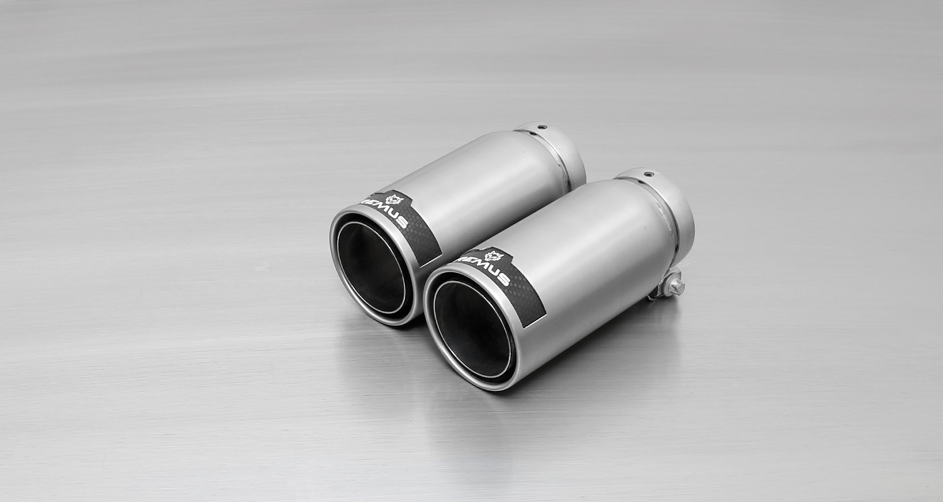
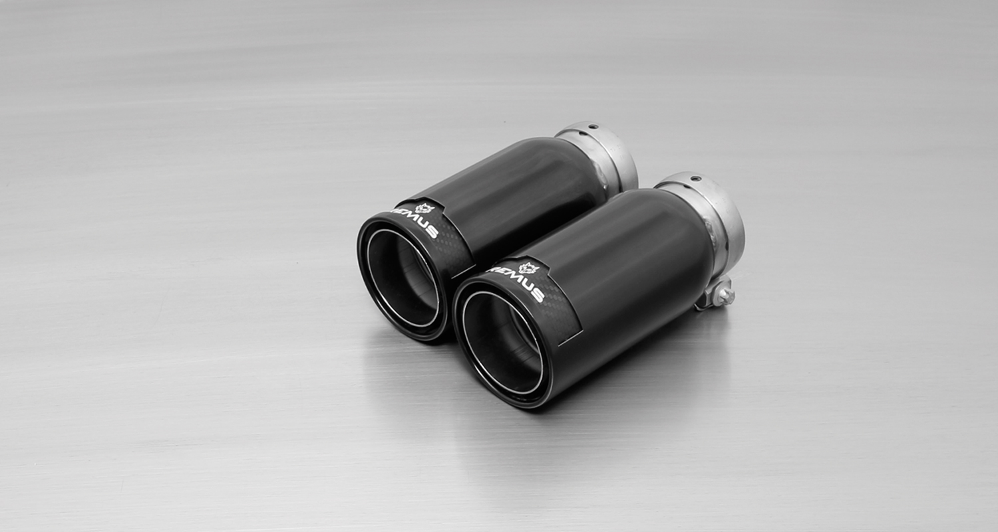
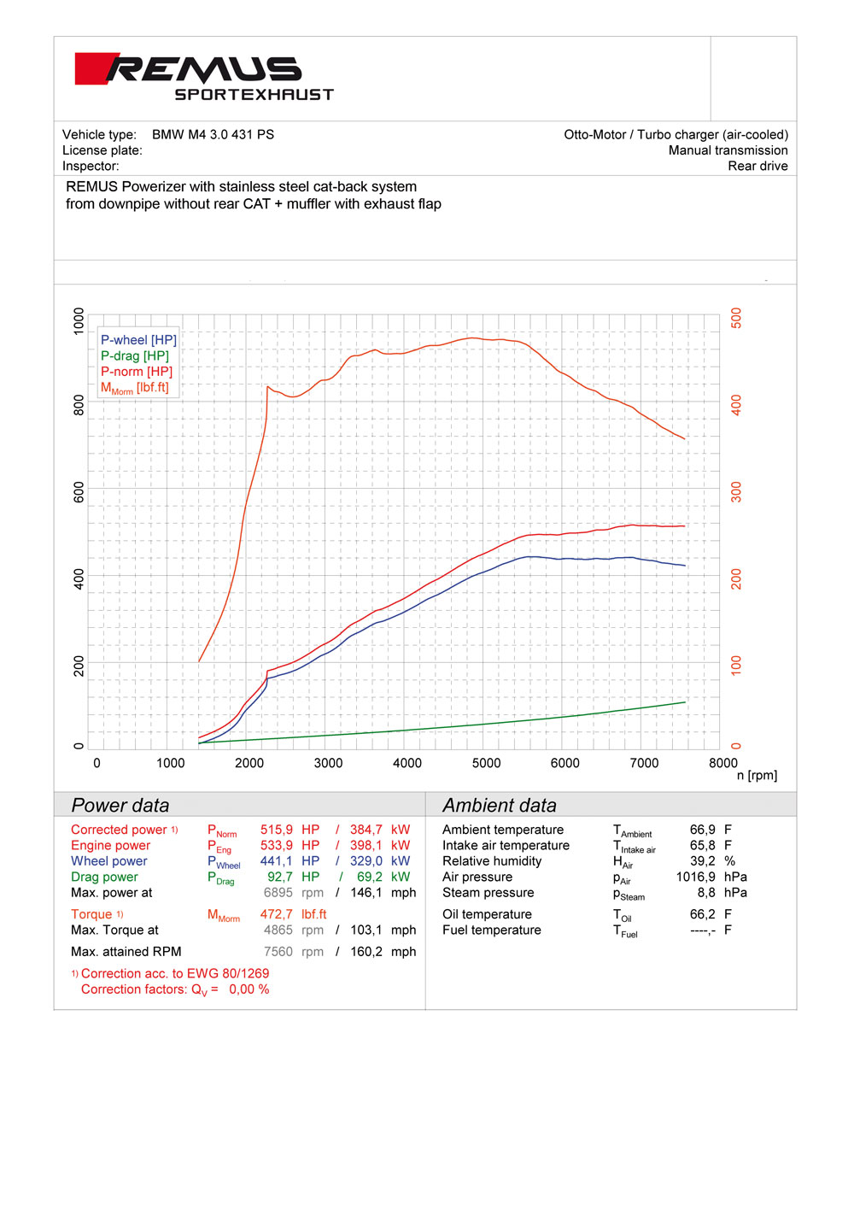
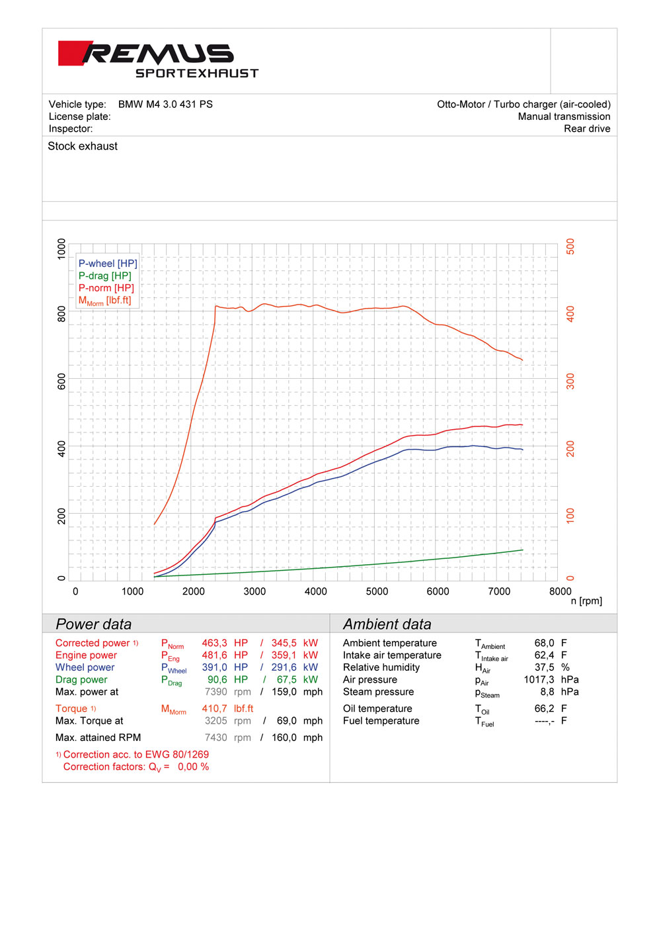
#98C: tail pipes Ø 98 mm
Street Race, polished
#98CB: tail pipes Ø 98 mm
Street Race Black Chrome

Car and engine specification
BMW M3 F80 Sedan, 2014=>
BMW M4 F82 Coupe, 2014=>
3.0l 317 kW (S55B30)
Part no. | Description | € RRP price excl. VAT
089014 0000 | Stainless steel RACING X-pipe NON-resonated front section (eliminating front silencer and secondary catalytic convertors), without homologation  Original tube Ø 65 mm, REMUS tube Ø 70 mm | 634,--
089014 0300 | Stainless steel RACING X-pipe RESONATED front section (instead of front silencer and eliminates secondary catalytic convertors), without homologation  Original tube Ø 65 mm, REMUS tube Ø 70 mm | 745,--
089014 0500 | Stainless steel sport exhaust, L/R axle-back system (without tail pipes),  with 2 integrated valves, incl. EEC homologation  Original tube Ø 65 mm, REMUS tube Ø 70 mm | 1.523,--
choose from following tail pipe package:
0046 70SG | Stainless steel tail pipe set L/R consisting of 4 tail pipes Ø 102 mm angled, straight cut, chromed, with adjustable spherical clamp connection | 280,--
0046 70S | Stainless steel tail pipe set L/R consisting of 4 tail pipes Ø 102 mm angled, chromed, with adjustable spherical clamp connection | 320,--
0046 70CS | Stainless steel tail pipe set L/R consisting of 4 Carbon tail pipes Ø 102 mm angled, Titanium internals, with adjustable spherical clamp connection | 740,--
0046 98C | Stainless steel tail pipe set L/R consisting of 4 tail pipes Ø 98 mm Street Race, with adjustable spherical clamp connection | 392,--
0046 98CB | Stainless steel tail pipe set L/R consisting of 4 tail pipes Ø 98 mm Street Race Black Chrome, with adjustable spherical clamp connection | 440,--
INFOBOX:
- Axle-back-system: 089014 0500 + tail pipe set! The original exhaust will need to be cut at the manufacturer marked cutting point!
- Racing cat-back-system: 089014 0000 resp. 089014 0300 + 089014 0500 + tail pipe set! No cutting of the original exhaust system required!
- The activation of the valve is carried out using the original actuator via the vehicle onboard electronics.

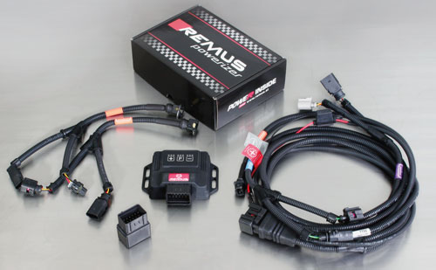

Under http://www.remus.eu/powerizer/ and http://www.remus.eu/remusresponder you will find the entire product range, prices and installation instructions.

REMUS Powerizer: More power, more economy and more fun.
- Up to 25 % more power
- Up to 20 % more torque
- Up to 1l/100 km fuel saving
- Fully adjustable power increase
- Simple DIY installation (Plug & Play)
REMUS POWERIZER: The performance figures represent the maximum achievable values. The actual performance output depends on the original tolerances of each engine. REMUS delivers the POWERIZER with the best possible setting for your vehicle type. You can adjust the performance according to your requirements as per the POWERIZER instructions

Legal references

1. Completion and registration of chip tuning in the car documents
Due to chip tuning, the operating license of the vehicle will terminate if the installation and registration of the POWERIZER is not carried out or immediately reported to an official approved testing facility. Please consider that driving a vehicle without the required operating license will cause legal penalties.

2. Vehicle insurance must be informed upon installing a POWERIZER
The installation of the POWERIZER can have influence on the insurance policy of your vehicle. You must inform the insurance company if you install a POWERIZER in your vehicle.

3. Effect of chip tuning on warranty and guarantee claims
a) When installing a POWERIZER, you will lose all guarantee claims regarding the engine against the vehicle manufacturer.
b) Installing a POWERIZER, can have influence on warranty claims against the seller of the vehicle.
c) REMUS excludes any claims regarding compensation for damages on the engine and drivetrain.

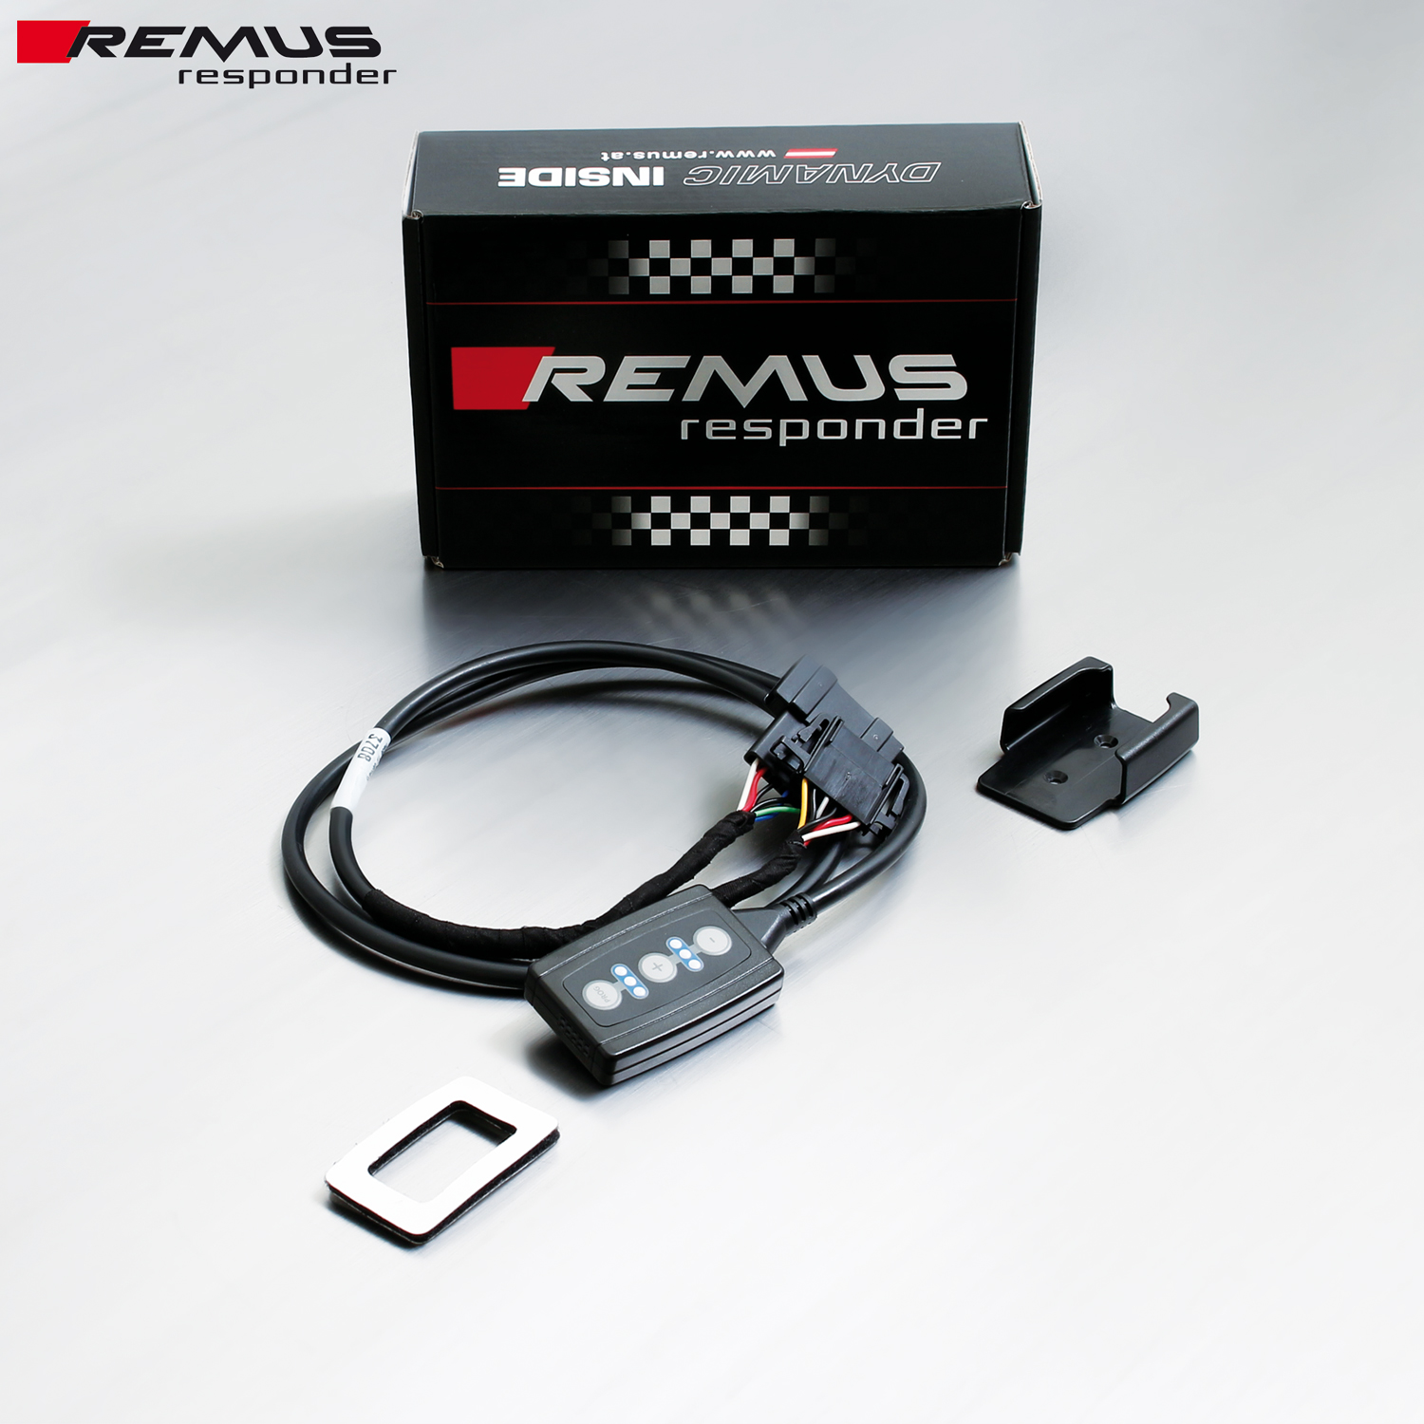

Under http://www.remus.eu/powerizer/ and http://www.remus.eu/remusresponder you will find the entire product range, prices and installation instructions.

REMUS RESPONDER:
Improved throttle response, more dynamic!
The REMUS Responder improves throttle response by means of modifying the accelerator pedal output signal. No more throttle delay and reduced lag during automatic shifting makes driving with the REMUS Responder more fun. The Responder attaches between the OEM pedal sensor and the OEM connector, ready to use in seconds due to plug & play technology. Sophisticated adjustable programming profiles can lead to improved fuel consumption and more efficiency. The 4 individual user selectable and adjustable performance settings allow drivers to select according to their own preferences.
The REMUS Responder totally eliminates the delay in modern electronic accelerator pedals!

