REMUS Product information 15-2016

BMW 3er F30/F31 LCI 340i, type 3K, 2015=>

Dear REMUS Partner,

We are pleased to inform you that we have completed our next development:
REMUS cat-back resonated section and REMUS sport exhaust left/right for the
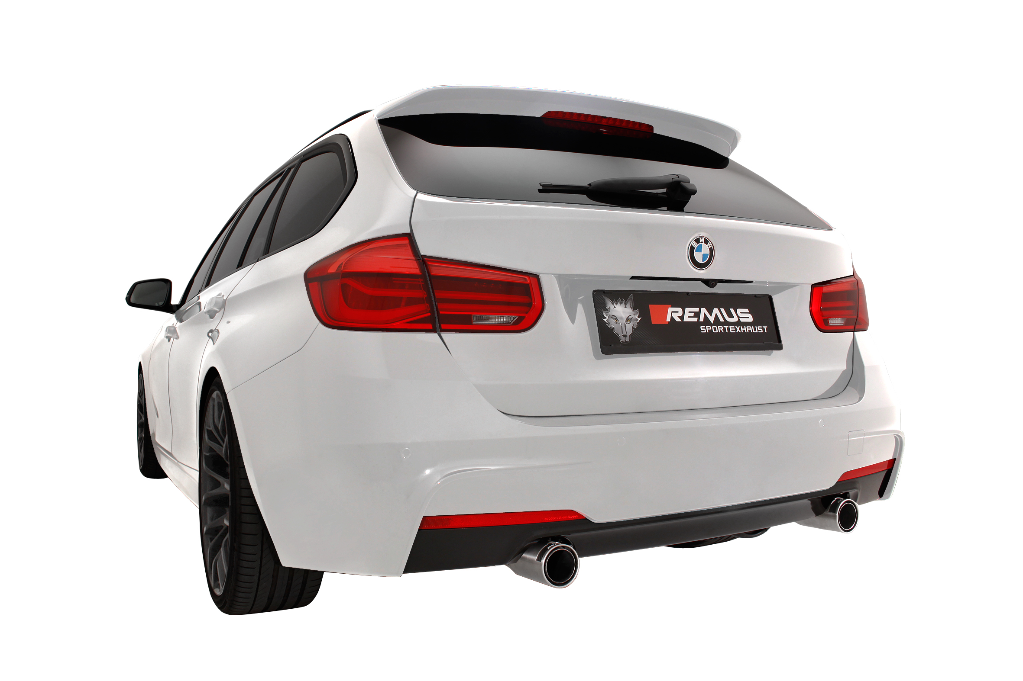
BMW 3 Series F30/F31 LCI 340i, 2015=>.

It would be a pleasure for us to receive your order.

Stay tuned!
Your REMUS Team

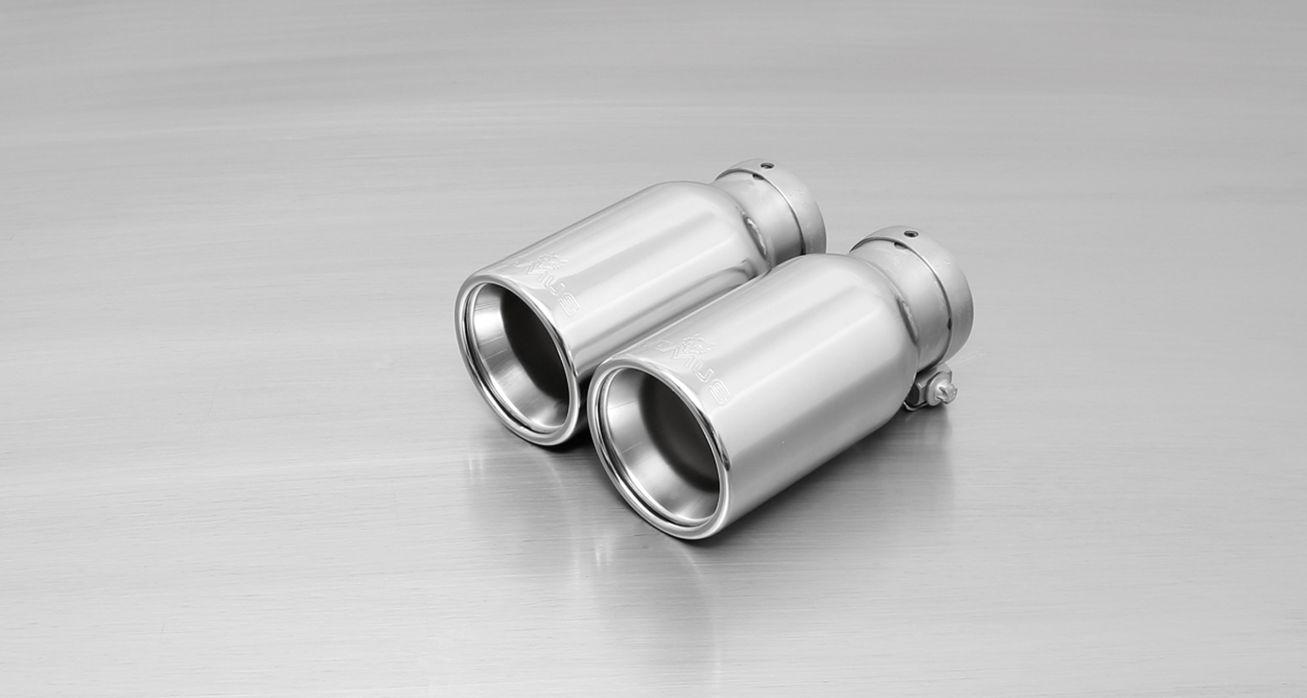
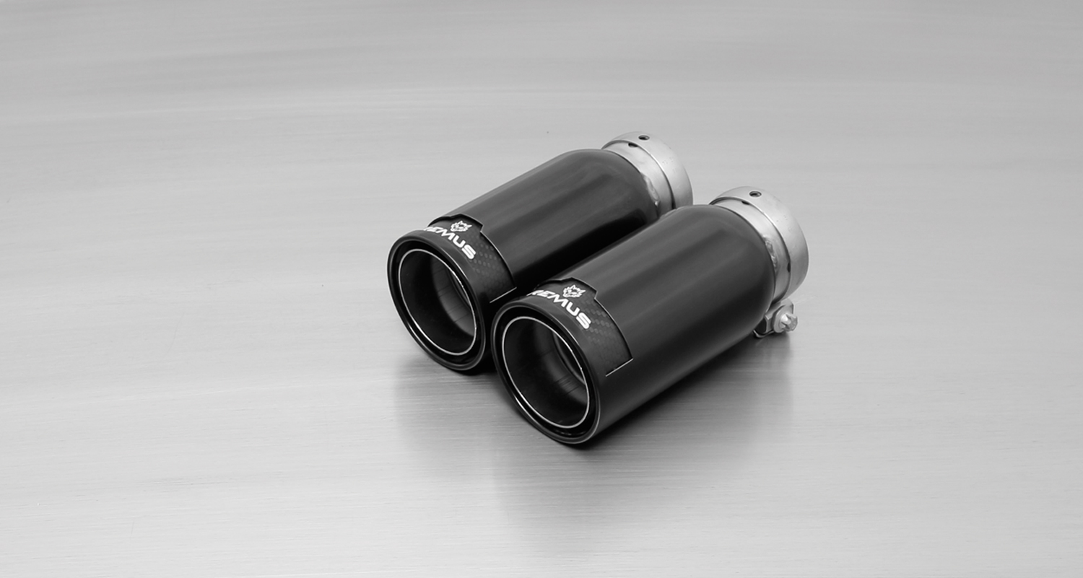
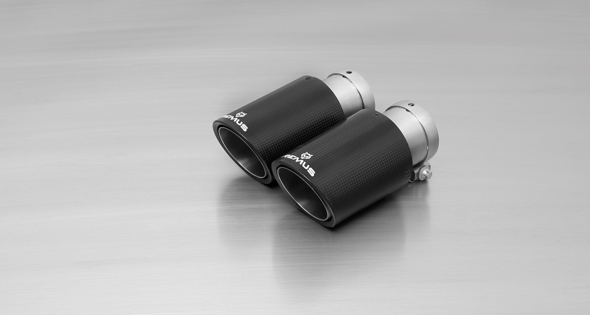
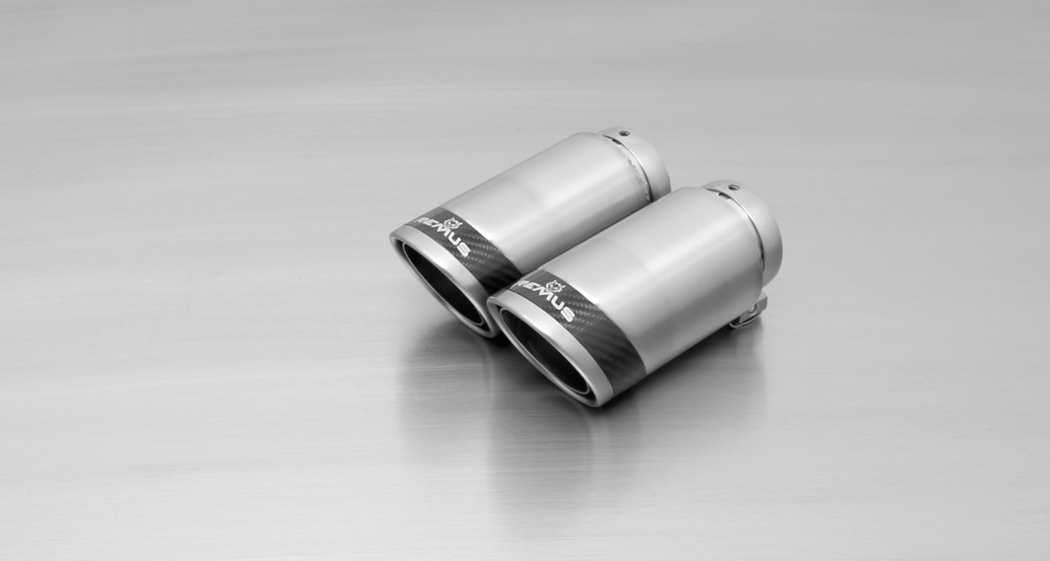
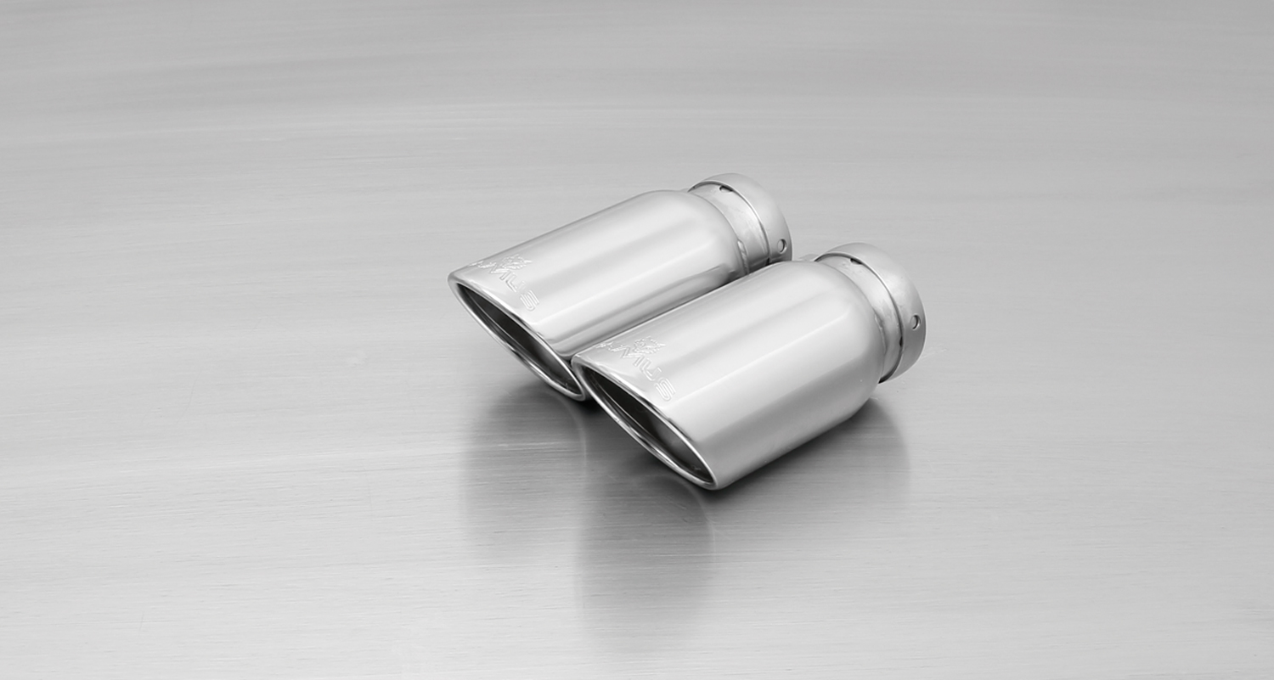
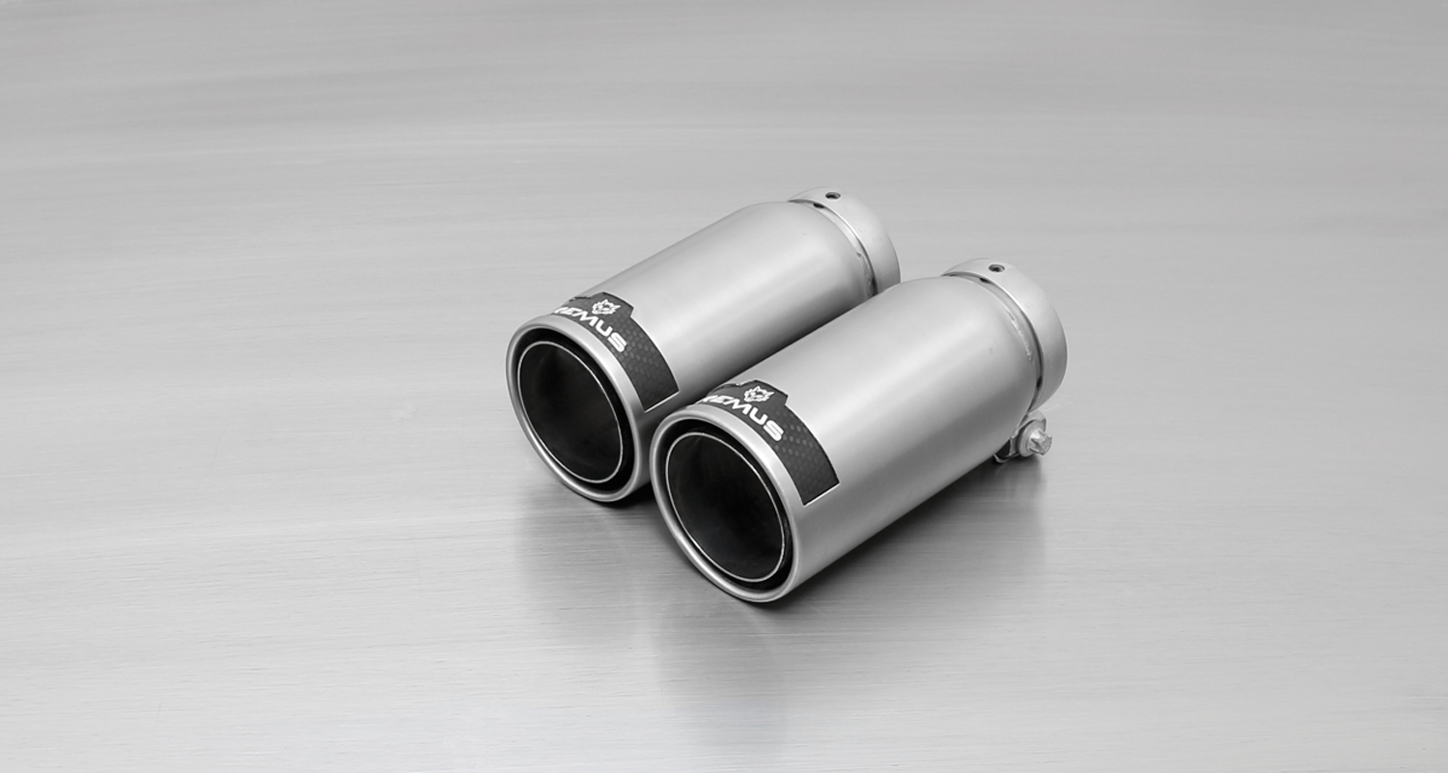
#83CTS: Carbon-tail pipes
Ø 84 mm angled, Titanium internals

#05: tail pipes Ø 90 mm, chromed
#83CS: tail pipes Ø 84 mm
Carbon Race, polished
#83CB: tail pipes Ø 84 mm
Street Race Black Chrome
#55S: tail pipes Ø 84 mm angled, chromed
#83C: tail pipes Ø 84 mm
Street Race, polished

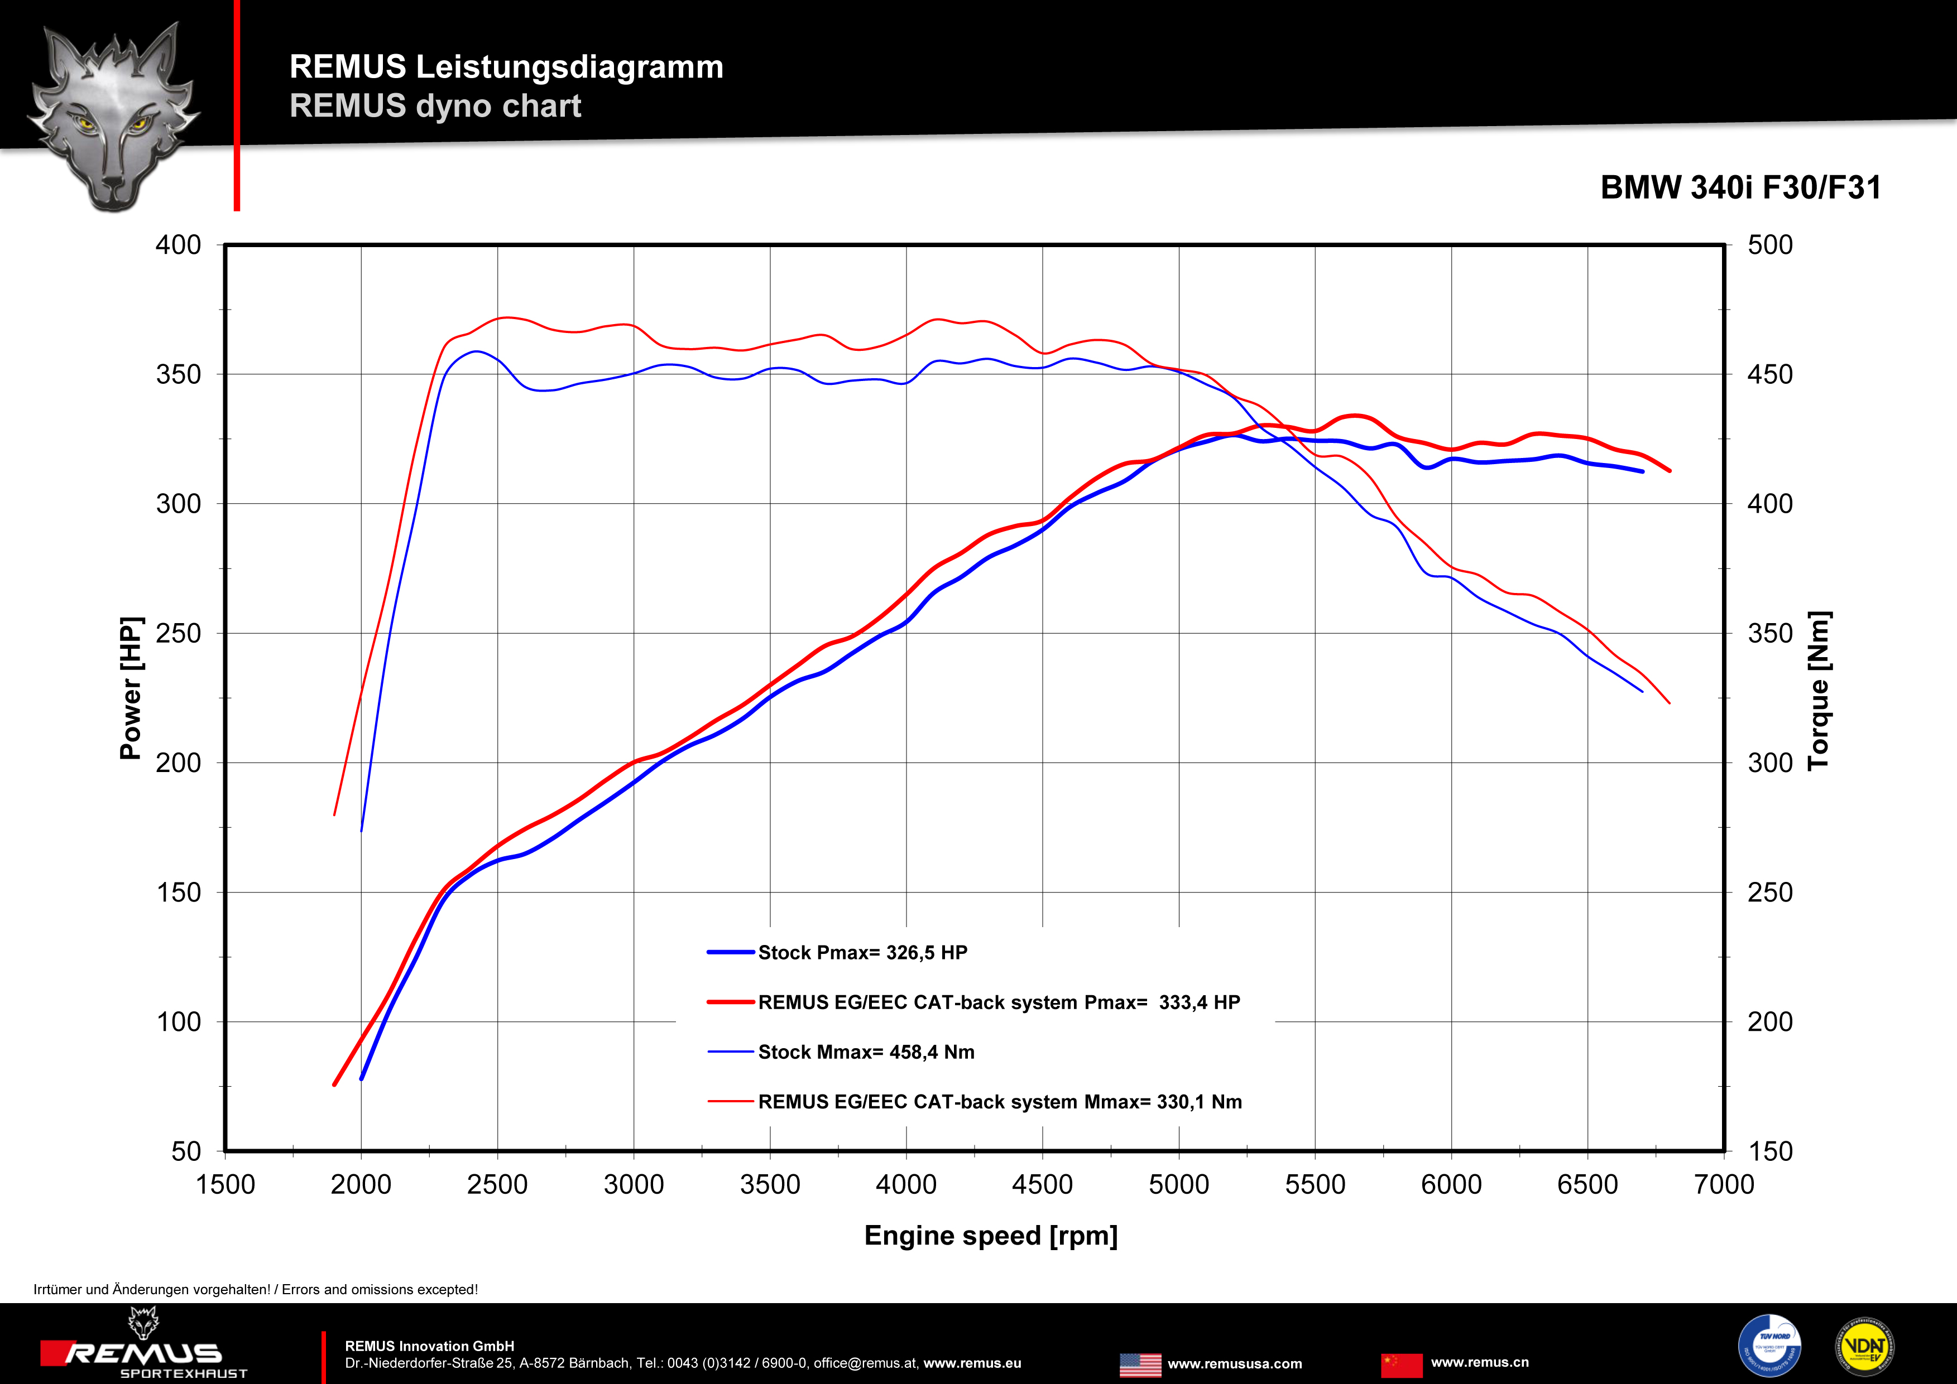
Cat-back: 088015 0300 + 088015 1500 + tail pipe set

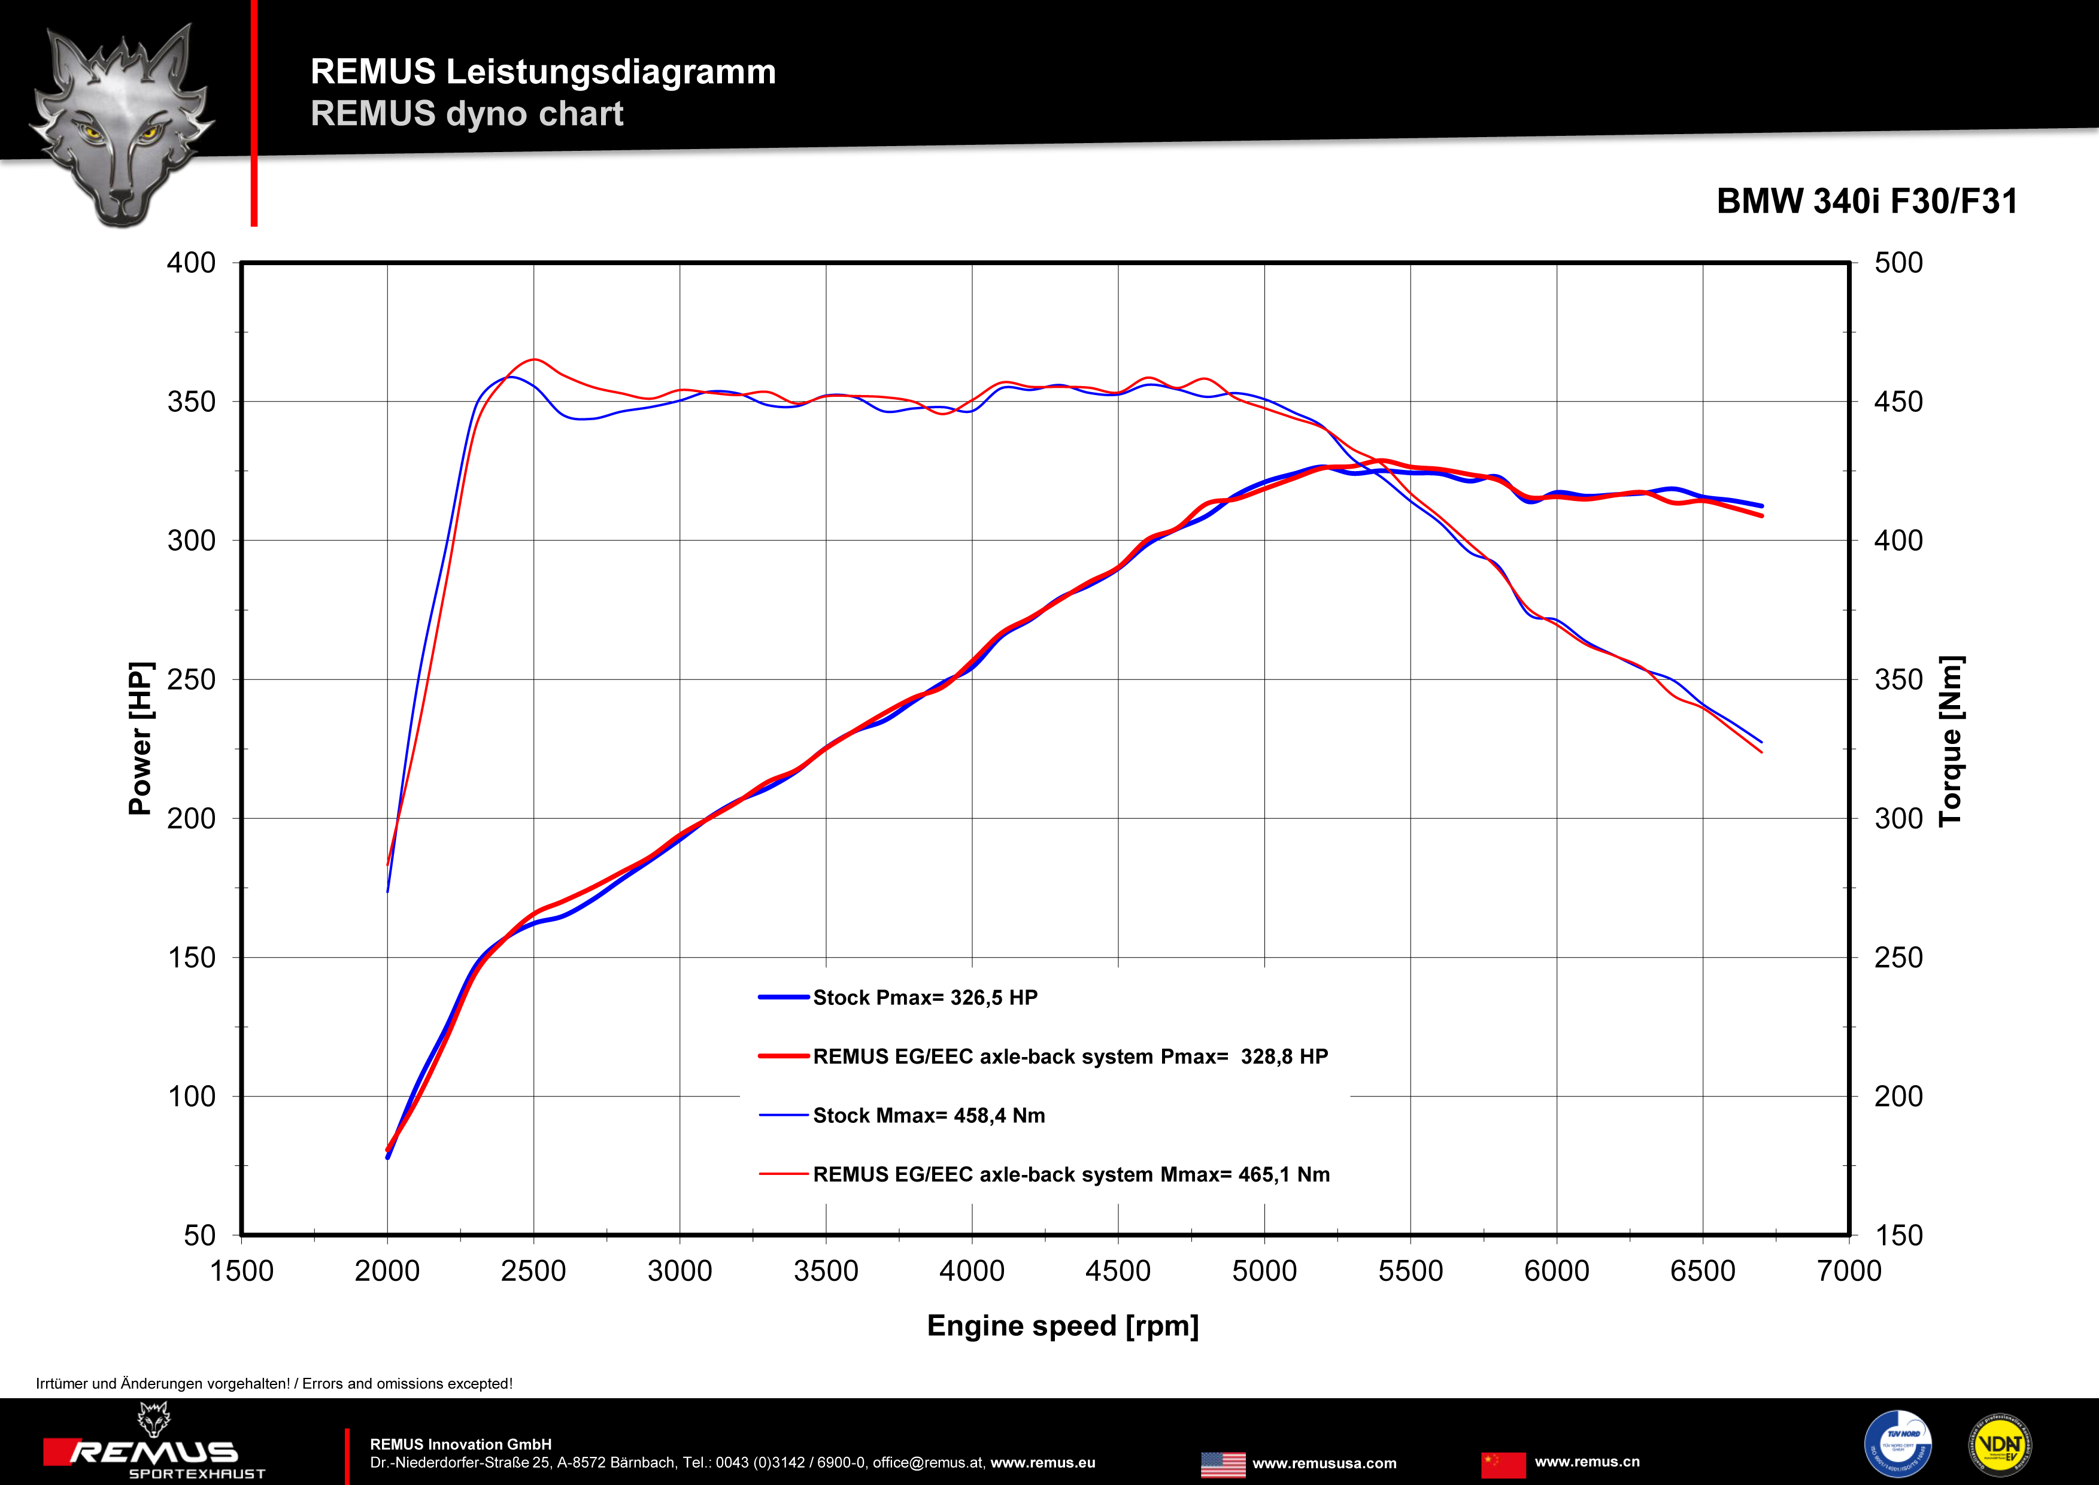
Axle-Back: 088015 1500 + tail pipe set

Car and engine specification
BMW 3 Series F30 Sedan, type 3K, 2015=>
340i LCI 3.0l 240 kW, 340i xDrive LCI 3.0l 240 kW
BMW 3er F31 Touring, type 3K, 2015=>
340i LCI 3.0l 240 kW, 340i xDrive LCI 3.0l 240 kW
Part no. | Description | € RRP price excl. VAT
088015 0300 | Stainless steel resonated cat-back section, incl. EEC homologation | 530,--
088015 1500 | Stainless steel sport exhaust centered for L/R system (without tail pipes), with integrated valves, incl. EEC homologation | 590,--
choose from following tail pipe package:
0026 05 | Tail pipe set 2 tail pipes Ø 90 mm, chromed, with adjustable spherical clamp connection | 150,--
0026 55S | Tail pipe set 2 tail pipes Ø 84 mm angled, chromed, with adjustable spherical clamp connection | 150,--
0026 83C | Tail pipe set 2 tail pipes Ø 84 mm Street Race, with adjustable spherical clamp connection | 170,--
0026 83CB | Tail pipe set 2 tail pipes Ø 84 mm Street Race Black Chrome, with adjustable spherical clamp connection | 194,--
0026 83CS | Tail pipe set 2 tail pipes Ø 84 mm Carbon Race, with adjustable spherical clamp connection | 180,--
0026 83CTS | Tail pipe set 2 Carbon tail pipes Ø 84 mm angled, Titanium internals, with adjustable spherical clamp connection | 340,--
ATTENTION:
- Sport exhaust and tail pipe set only fit as a complete system!
- Suitable for standard and M-sport bumper option!
- No rear skirt modifications are required!
- Axle-back-system: 204014 0500 + tail pipe set. The original exhaust must be cut!
- Cat-back-system: 204014 0300 + 204014 0500 + tail pipe set. No vehicle modifications are required.

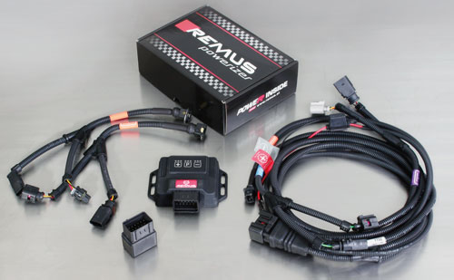

Under http://www.remus.eu/powerizer/ and http://www.remus.eu/remusresponder you will find the entire product range, prices and installation instructions.

REMUS Powerizer: More power, more economy and more fun.
- Up to 25 % more power
- Up to 20 % more torque
- Up to 1l/100 km fuel saving
- Fully adjustable power increase
- Simple DIY installation (Plug & Play)
REMUS POWERIZER: The performance figures represent the maximum achievable values. The actual performance output depends on the original tolerances of each engine. REMUS delivers the POWERIZER with the best possible setting for your vehicle type. You can adjust the performance according to your requirements as per the POWERIZER instructions

Legal references

1. Completion and registration of chip tuning in the car documents
Due to chip tuning, the operating license of the vehicle will terminate if the installation and registration of the POWERIZER is not carried out or immediately reported to an official approved testing facility. Please consider that driving a vehicle without the required operating license will cause legal penalties.

2. Vehicle insurance must be informed upon installing a POWERIZER
The installation of the POWERIZER can have influence on the insurance policy of your vehicle. You must inform the insurance company if you install a POWERIZER in your vehicle.

3. Effect of chip tuning on warranty and guarantee claims
a) When installing a POWERIZER, you will lose all guarantee claims regarding the engine against the vehicle manufacturer.
b) Installing a POWERIZER, can have influence on warranty claims against the seller of the vehicle.
c) REMUS excludes any claims regarding compensation for damages on the engine and drivetrain.

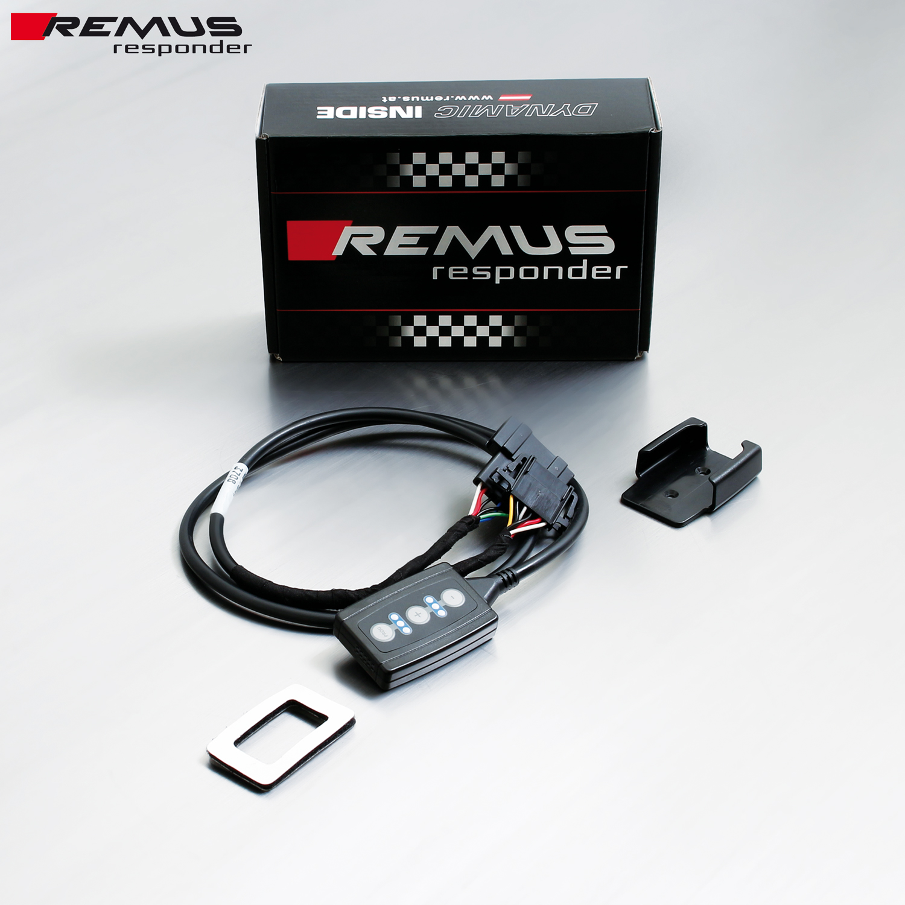

Under http://www.remus.eu/powerizer/ and http://www.remus.eu/remusresponder you will find the entire product range, prices and installation instructions.

REMUS RESPONDER:
Improved throttle response, more dynamic!
The REMUS Responder improves throttle response by means of modifying the accelerator pedal output signal. No more throttle delay and reduced lag during automatic shifting makes driving with the REMUS Responder more fun. The Responder attaches between the OEM pedal sensor and the OEM connector, ready to use in seconds due to plug & play technology. Sophisticated adjustable programming profiles can lead to improved fuel consumption and more efficiency. The 4 individual user selectable and adjustable performance settings allow drivers to select according to their own preferences.
The REMUS Responder totally eliminates the delay in modern electronic accelerator pedals!
