REMUS product information 14-2016

VW Polo V GTI Facelift, type 6R, 2014=>

Dear REMUS Partner,

We are pleased to inform you that we have completed our next development:
REMUS bi-modal cat-back system with selectable tail pipes for the
VW Polo V GTI Facelift, type 6R, 2014=>.

It would be a pleasure for us to receive your order.

Stay tuned!
Your REMUS Team
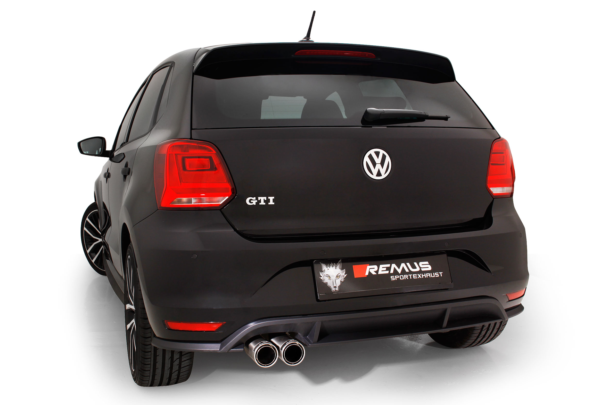

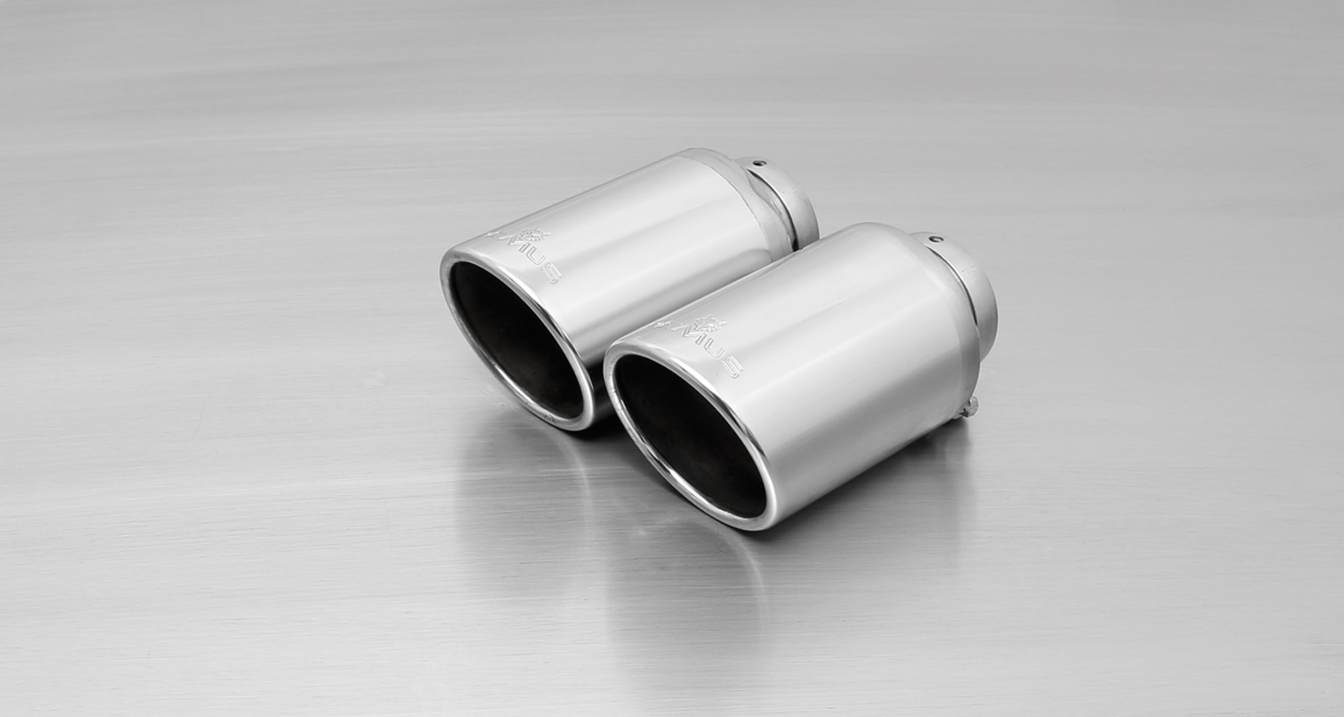
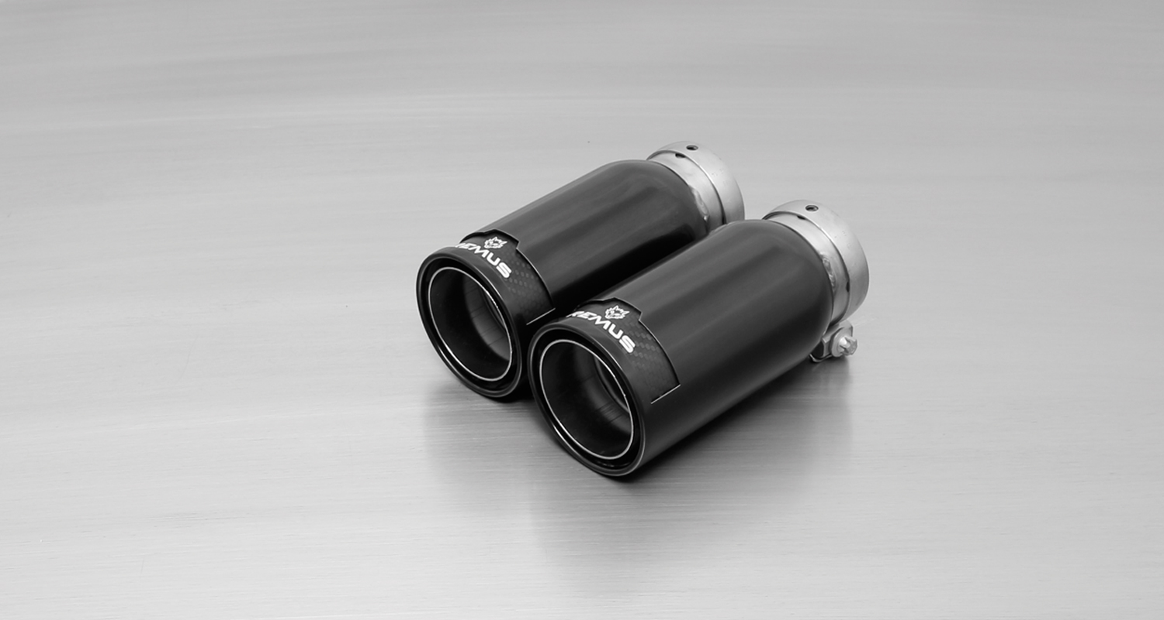
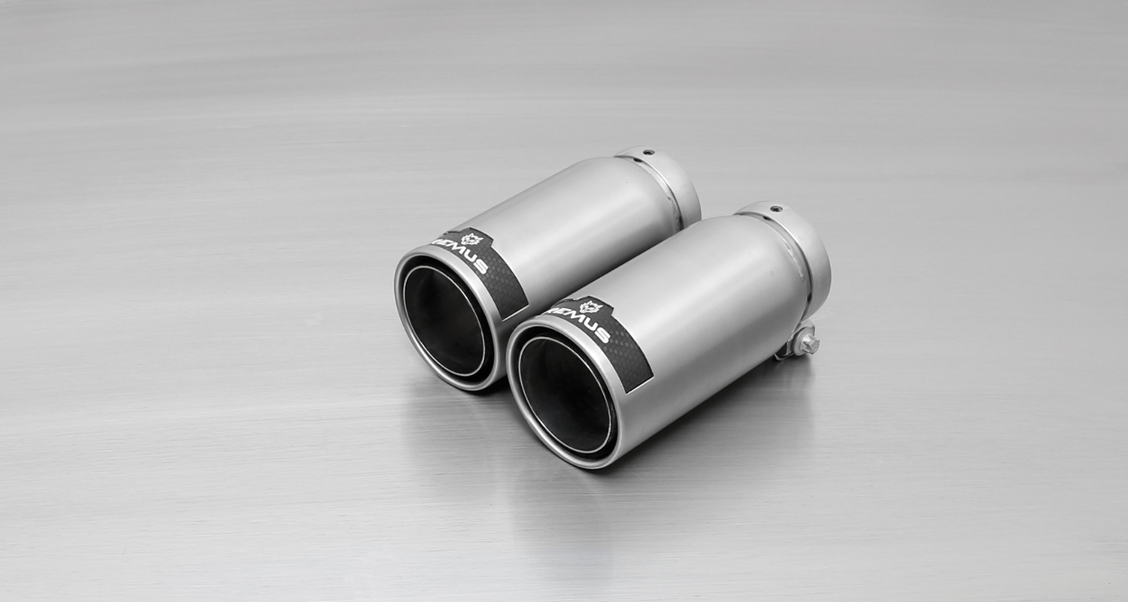
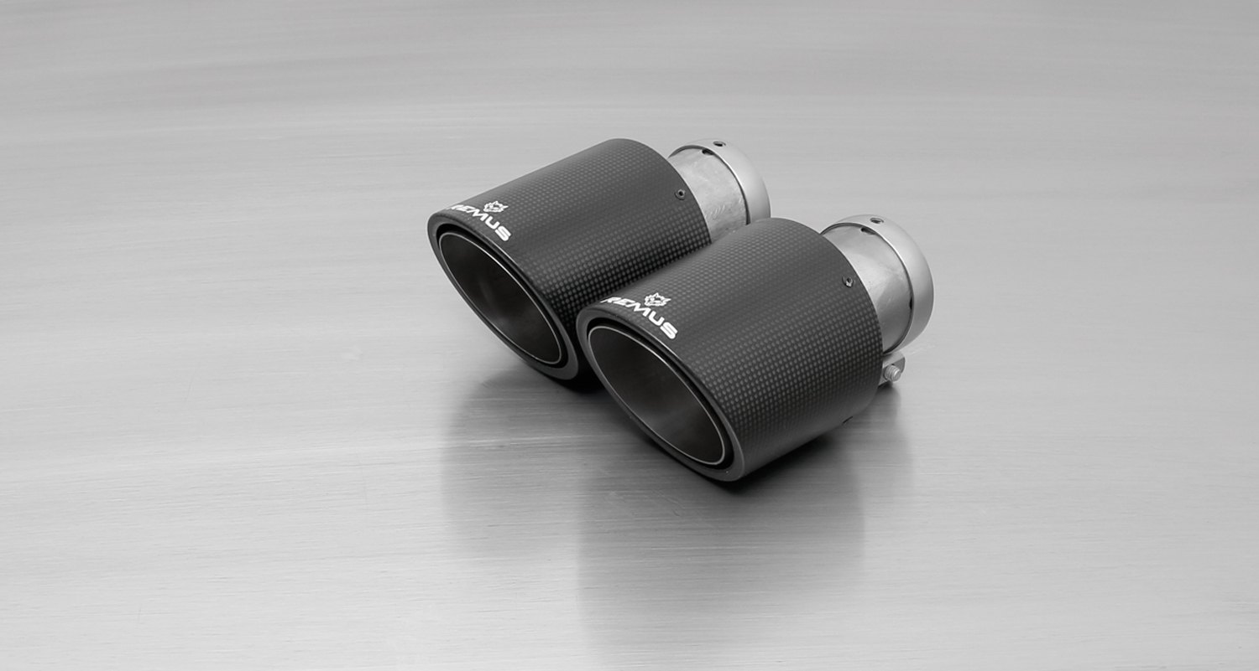
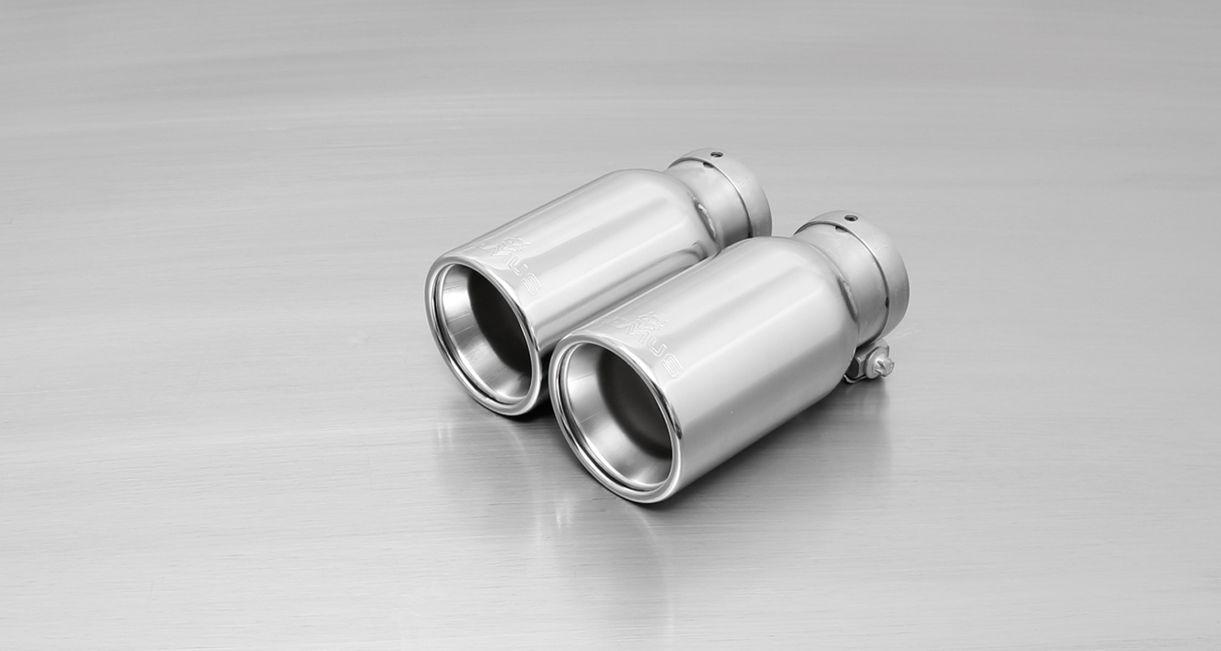
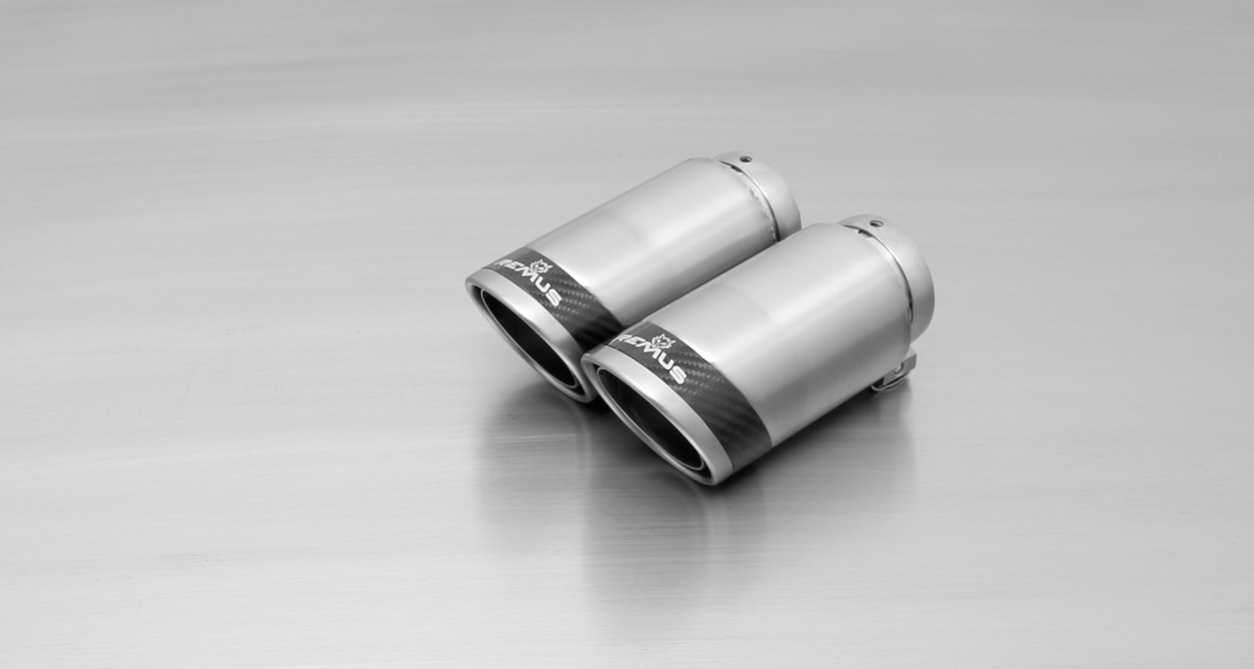
#55S: tail pipes Ø 84 mm
angled, chromed

#05: tail pipes Ø 90 mm, chromed
#83C: tail pipes Ø 84 mm
Street Race, polished
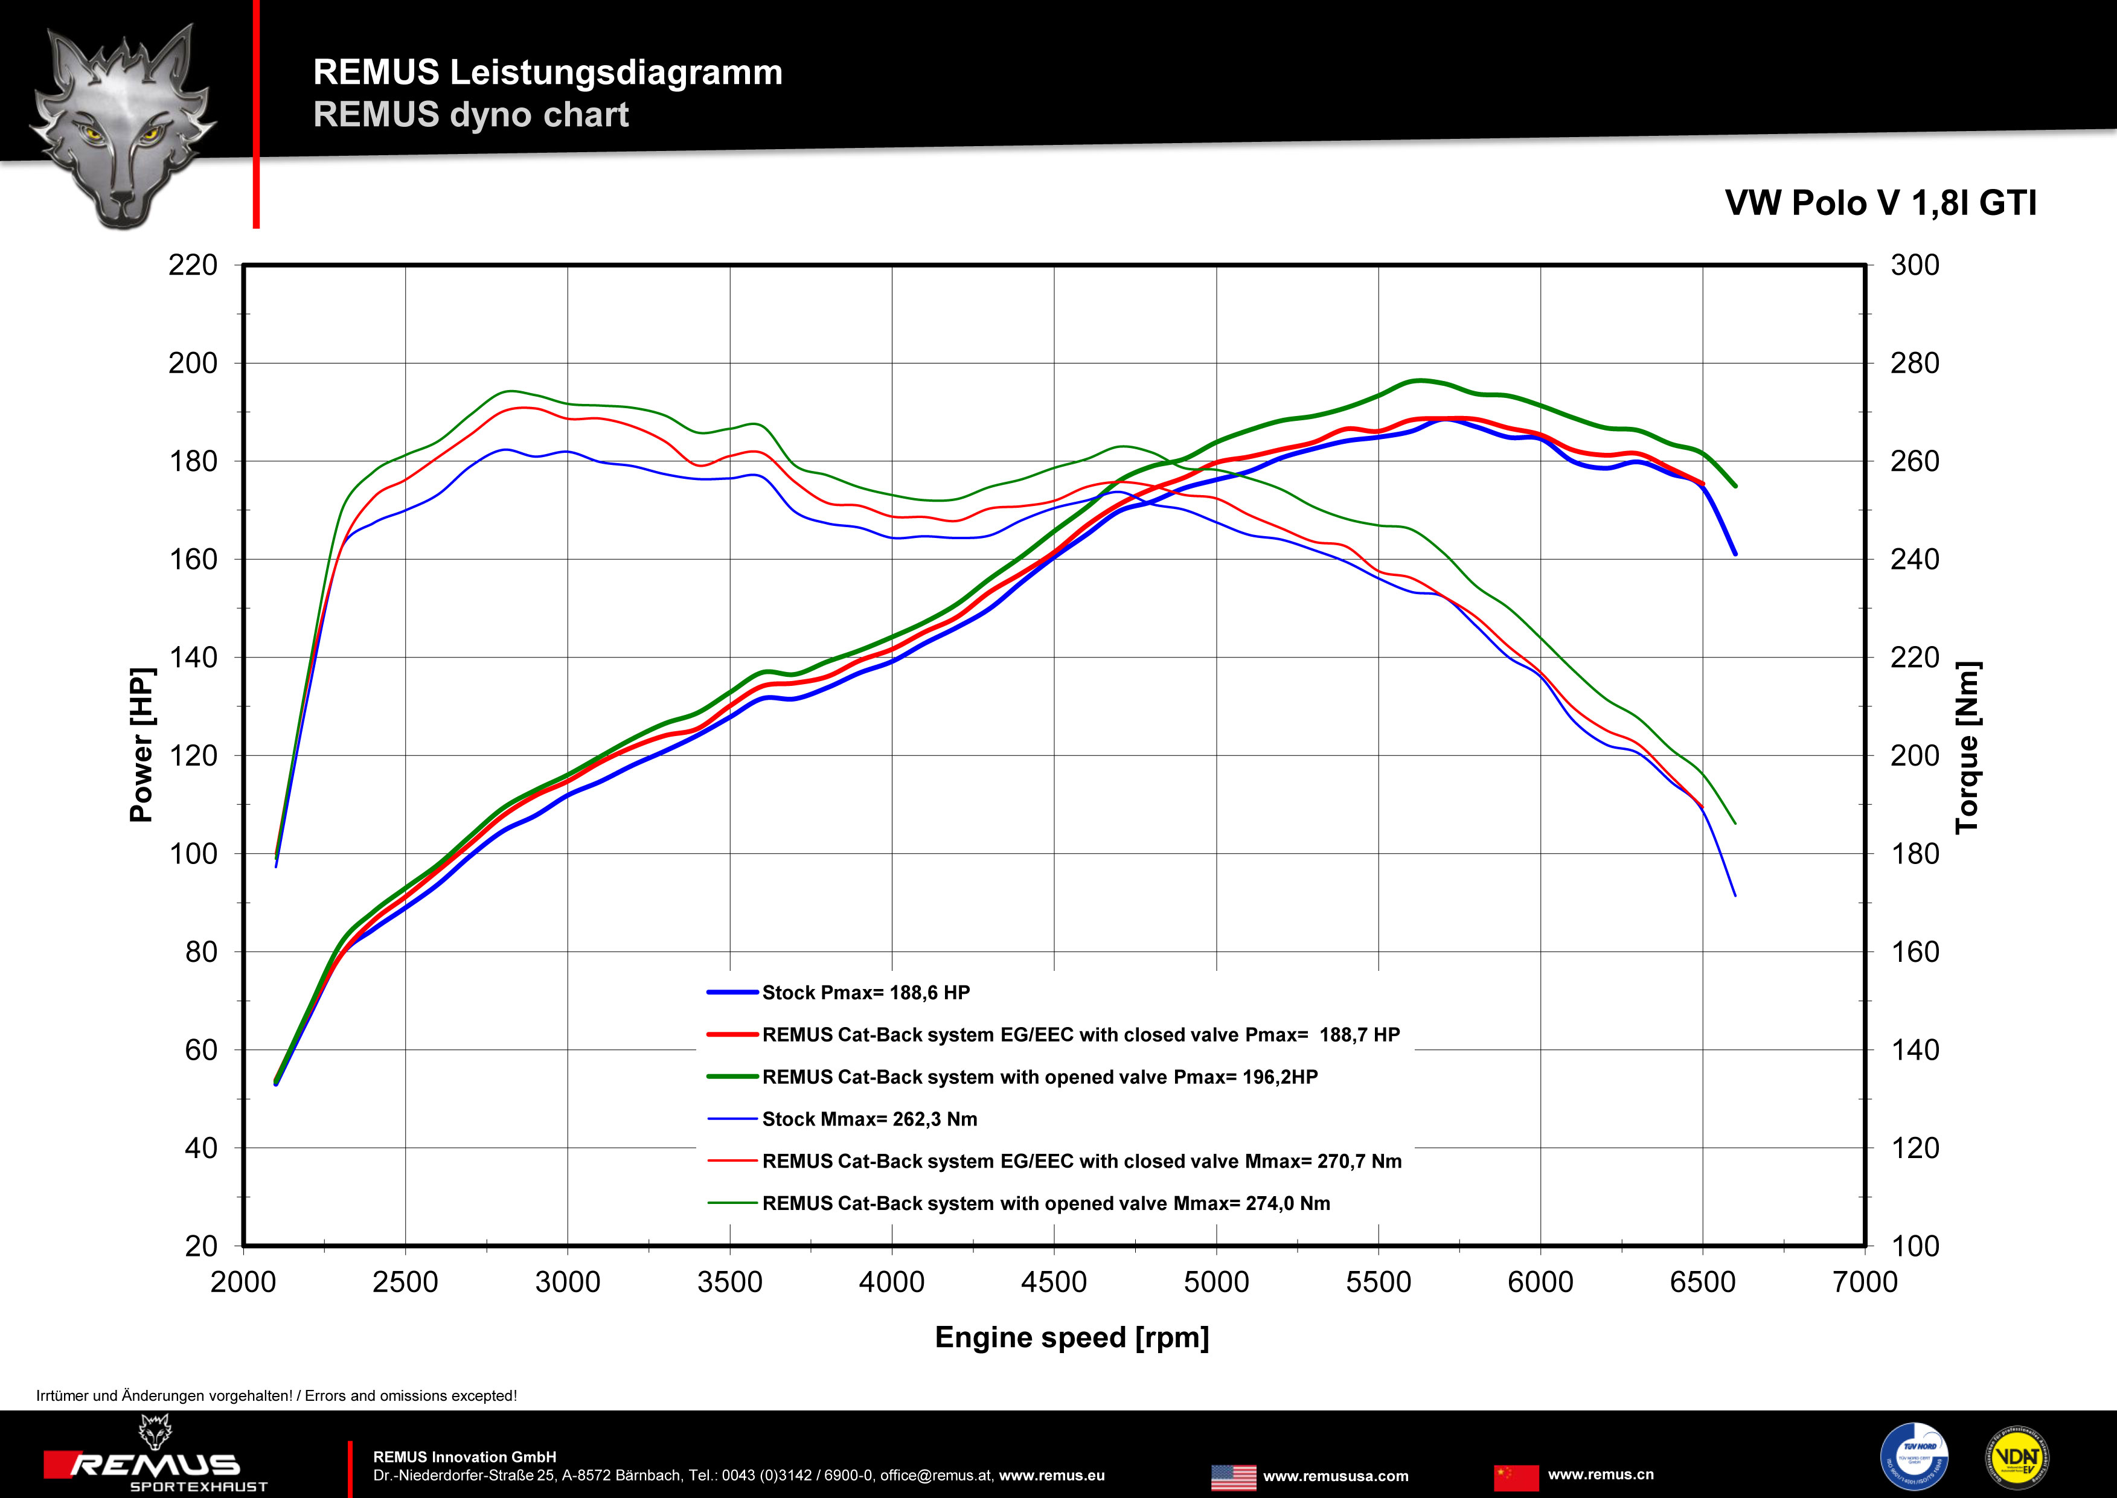
#83CTS: Carbon-tail pipes Ø 84 mm angled, Titanium internals
#83CB: tail pipes Ø 84 mm
Street Race Black Chrome
#83CS: tail pipes Ø 84 mm
Carbon Race, polished

Car and engine specification
VW Polo V GTI Facelift, type 6R, 2014=>
1.8l TSI 141 kW
Part no. | Description | € RRP price excl. VAT
REMUS cat-back system consisting of:
954513 0300 | Stainless steel resonated cat-back front section, with EEC homologation  Original tube Ø 55 mm  REMUS tube Ø 60 mm | 190,--
954513 0000 | Alternative: Stainless steel non resonated cat-back front section, without homologation  Original tube Ø 55 mm  REMUS tube Ø 60 mm | 95,--
954513 0500 | Stainless steel sport exhaust left (without tail pipes), with integrated electronic valve, with EEC homologation  Original tube Ø 55 mm  REMUS tube Ø 60 mm  A remote control unit is included for special applications in order to operate the valve in 4 different positions. | 710,--
choose from following tail pipe package:
0026 05 | Stainless steel tail pipe set 2 tail pipes Ø 90 mm, chromed, with adjustable spherical clamp connection | 150,--
0026 55S | Stainless steel tail pipe set 2 tail pipes Ø 84 mm angled, chromed, with adjustable spherical clamp connection | 150,--
0026 83C | Stainless steel tail pipe set 2 tail pipes Ø 84 mm Street Race, with adjustable spherical clamp connection | 170,--
0026 83CS | Stainless steel tail pipe set 2 tail pipes Ø 84 mm Carbon Race, with adjustable spherical clamp connection | 180,--
0026 83CB | Stainless steel tail pipe set 2 tail pipes Ø 84 mm Street Race Black Chrome, with adjustable spherical clamp connection | 194,--
0026 83CTS | Stainless steel tail pipe set 2 Carbon tail pipes Ø 84 mm angled, Titanium internals, with adjustable spherical clamp connection | 340,--
INFOBOX:
- Cat-back-system 954513 0300 respectively 954513 0000 + 954513 0500 + tail pipe set only fits as a complete set.
- No rear skirt modifications required!

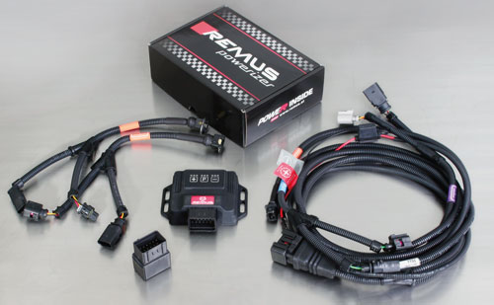

Under http://www.remus.eu/powerizer/ and http://www.remus.eu/remusresponder you will find the entire product range, prices and installation instructions.

REMUS Powerizer: More power, more economy and more fun.
- Up to 25 % more power
- Up to 20 % more torque
- Up to 1l/100 km fuel saving
- Fully adjustable power increase
- Simple DIY installation (Plug & Play)
REMUS POWERIZER: The performance figures represent the maximum achievable values. The actual performance output depends on the original tolerances of each engine. REMUS delivers the POWERIZER with the best possible setting for your vehicle type. You can adjust the performance according to your requirements as per the POWERIZER instructions

Legal references

1. Completion and registration of chip tuning in the car documents
Due to chip tuning, the operating license of the vehicle will terminate if the installation and registration of the POWERIZER is not carried out or immediately reported to an official approved testing facility. Please consider that driving a vehicle without the required operating license will cause legal penalties.

2. Vehicle insurance must be informed upon installing a POWERIZER
The installation of the POWERIZER can have influence on the insurance policy of your vehicle. You must inform the insurance company if you install a POWERIZER in your vehicle.

3. Effect of chip tuning on warranty and guarantee claims
a) When installing a POWERIZER, you will lose all guarantee claims regarding the engine against the vehicle manufacturer.
b) Installing a POWERIZER, can have influence on warranty claims against the seller of the vehicle.
c) REMUS excludes any claims regarding compensation for damages on the engine and drivetrain.

Under http://www.remus.eu/powerizer/ and http://www.remus.eu/remusresponder you will find the entire product range, prices and installation instructions.

REMUS RESPONDER:
Improved throttle response, more dynamic!
The REMUS Responder improves throttle response by means of modifying the accelerator pedal output signal. No more throttle delay and reduced lag during automatic shifting makes driving with the REMUS Responder more fun. The Responder attaches between the OEM pedal sensor and the OEM connector, ready to use in seconds due to plug & play technology. Sophisticated adjustable programming profiles can lead to improved fuel consumption and more efficiency. The 4 individual user selectable and adjustable performance settings allow drivers to select according to their own preferences.
The REMUS Responder totally eliminates the delay in modern electronic accelerator pedals!
