REMUS product information 13-2016

HYUNDAI Tucson, type TL, 2015=>

KIA Sportage, type QL, 2015=> and KIA Sportage GT-Line, type QLE, 2015=>

Dear REMUS Partner,

We are pleased to inform you that we have completed our next development:
REMUS sport exhaust left/right with selectable tail pipes for
HYUNDAI Tucson, type TL, 2015=>
KIA Sportage, type QL, 2015=> and KIA Sportage GT-Line, type QLE, 2015=>.

It would be a pleasure for us to receive your order.

Stay tuned!
Your REMUS Team
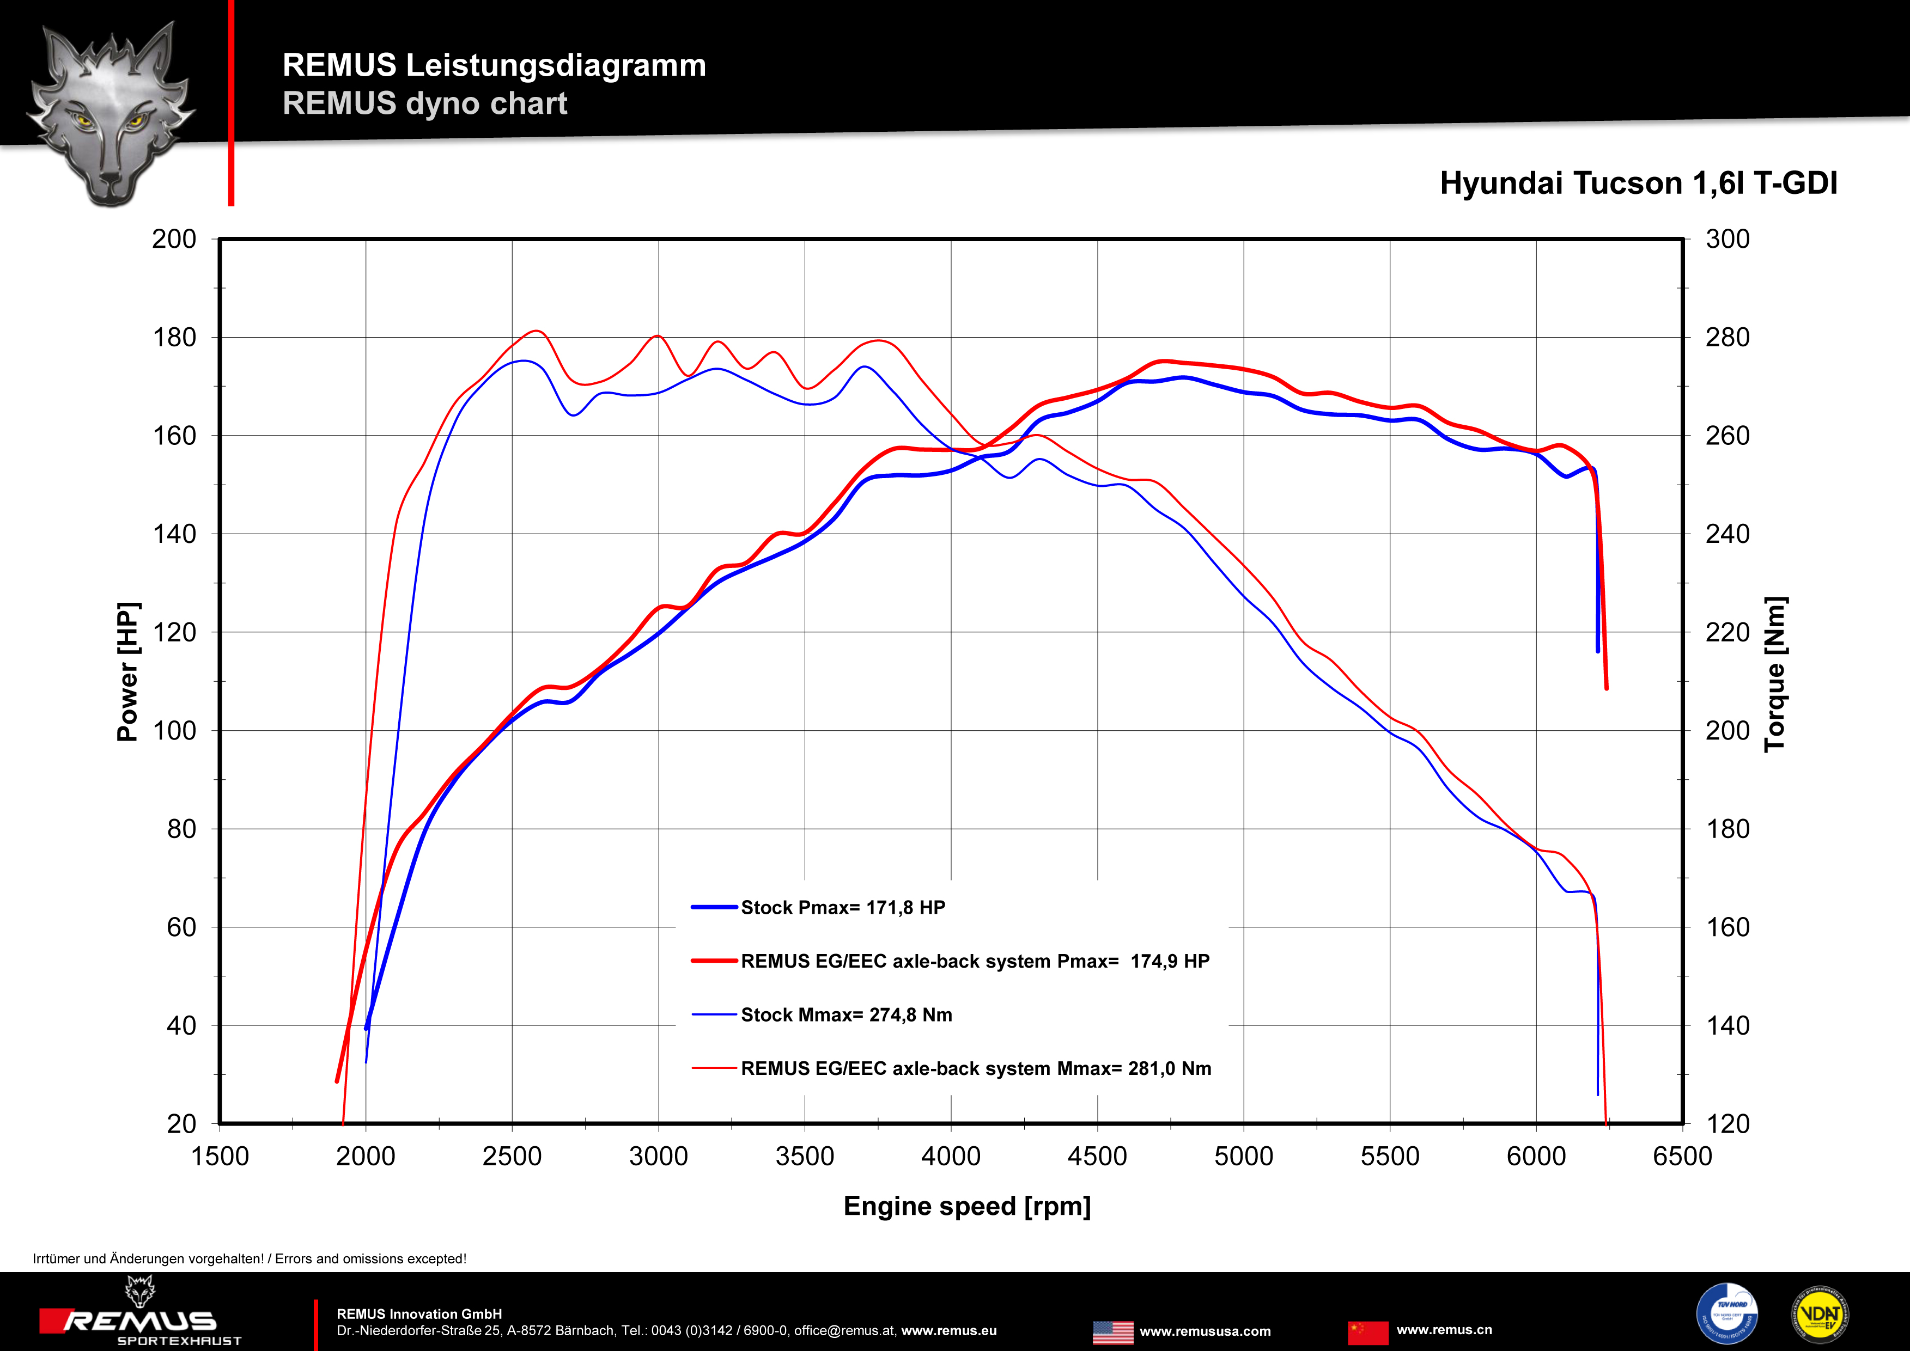
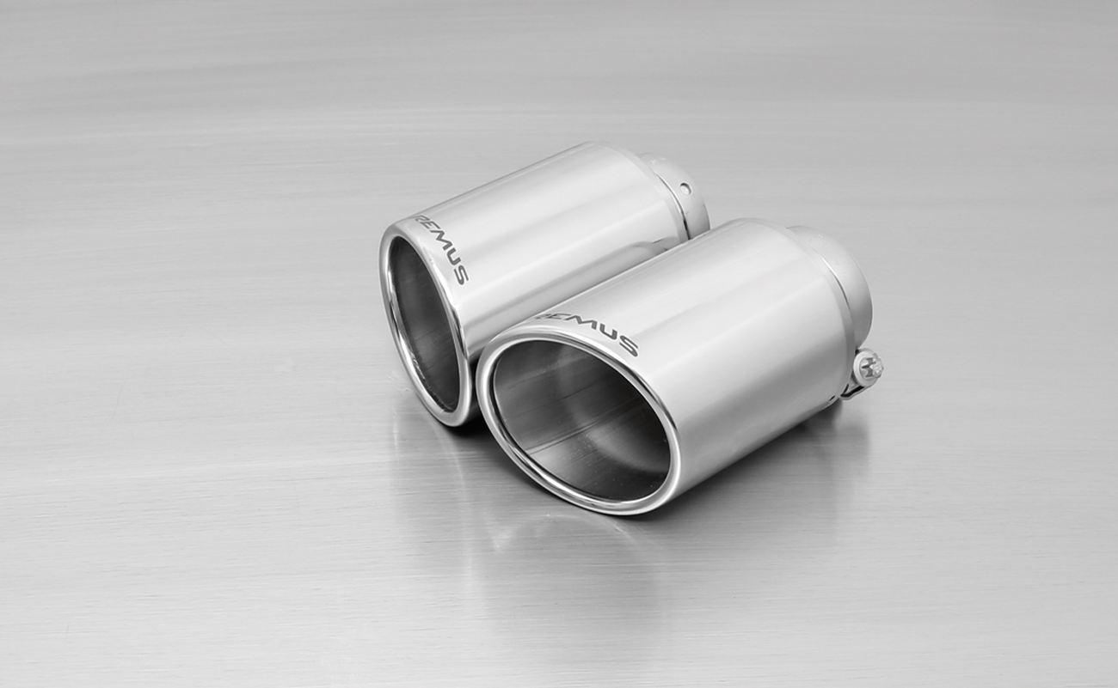
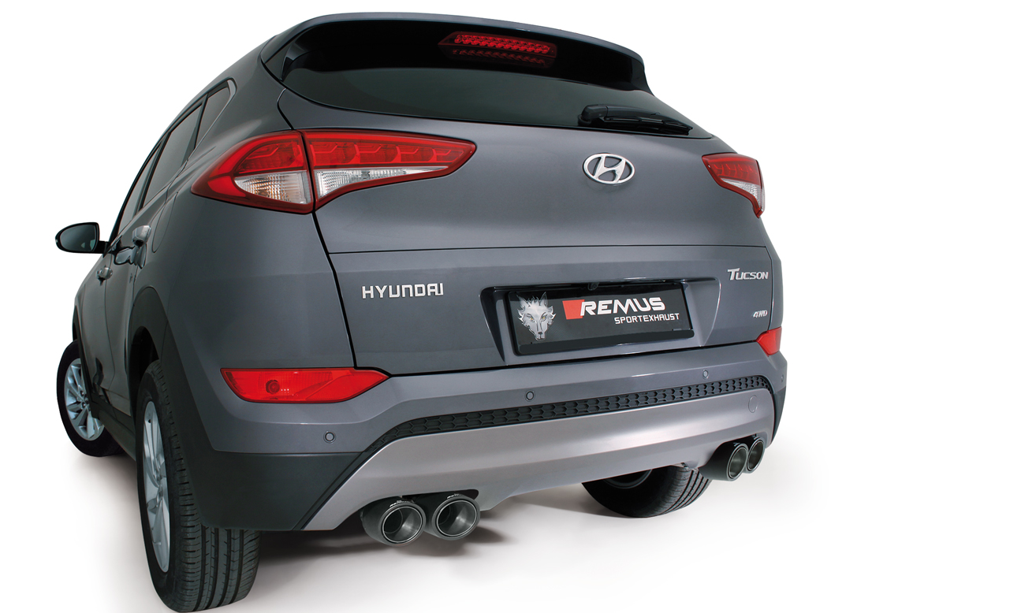

#70SS: tail pipes Ø 102 mm
angled/angled, chromed

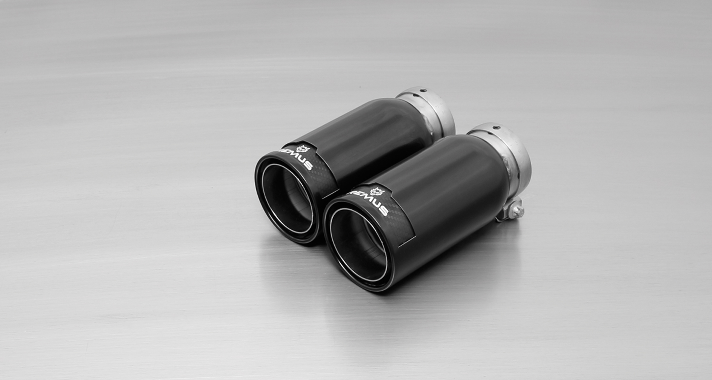

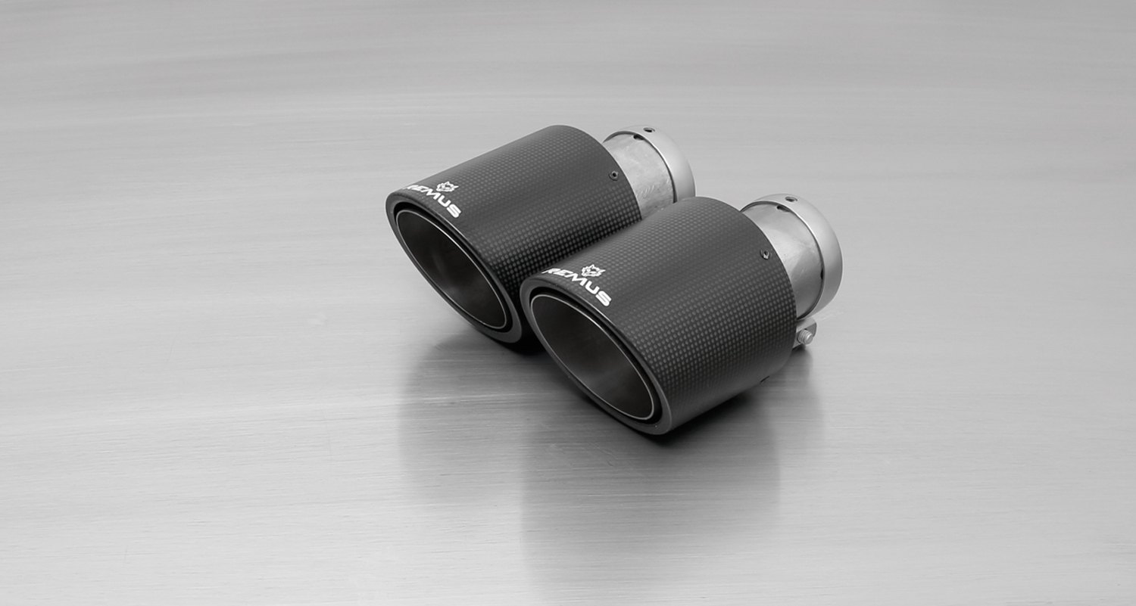

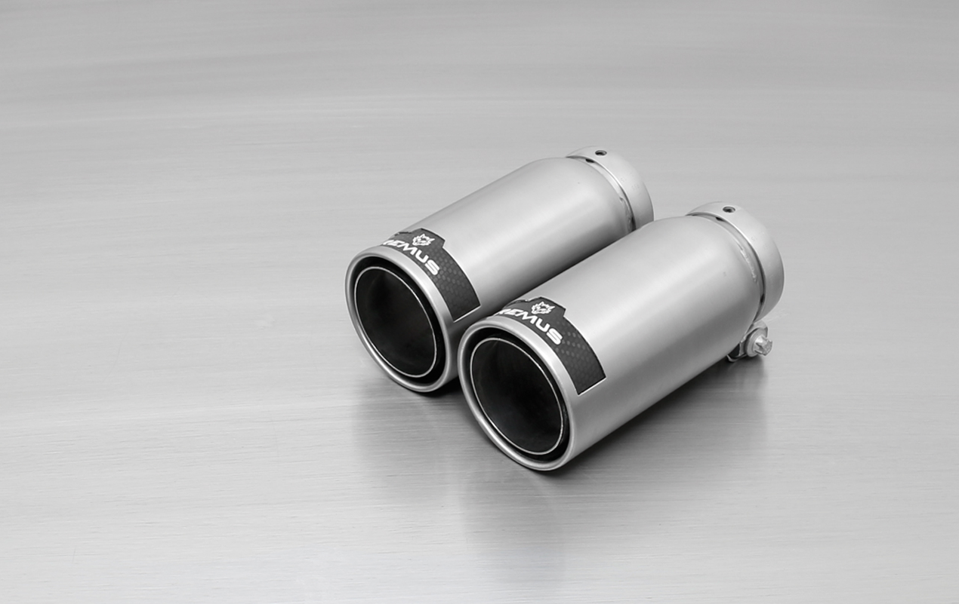
#98CB: tail pipes Ø 98 mm
Street Race Black Chrome

#70CSS: Carbon-tail pipes Ø 102 mm angled/angled, Titanium internals
#98C: tail pipes Ø 98 mm
Street Race, polished

Car and engine specification
HYUNDAI Tucson, type TL, 2015=>
1.6l GDI 97 kW 2WD; 1.6l T-GDI 130 kW 4WD; 1.7l CRDI 85 kW 2WD; 2.0l CRDI 100 2WD/4WD; 2.0l CRDI 136 kW 2WD & 4WD
KIA Sportage, type QL, 2015=>
1.6l GDI 97 kW 2WD; 1.6l T-GDI 130 kW 4WD; 1.7l CRDI 85 kW 2WD; 2.0l CRDI 100 2WD/4WD; 2.0l CRDI 136 kW 2WD & 4WD
Part no. | Description | € RRP price excl. VAT
286015 1500 | Stainless steel sport exhaust centered for L/R system (without tail pipes)  Original tube Ø 54 mm / REMUS tube Ø 60 mm | 330,--
choose from following tail pipe package:
0046 70SS | Stainless steel tail pipe set L/R consisting of 4 tail pipes Ø 102 mm angled/angled, chromed, with adjustable spherical clamp connection | 320,--
0046 70CSS | Stainless steel tail pipe set L/R consisting of 4 Carbon tail pipe Ø 102 mm angled/angled, Titanium internals, with adjustable spherical clamp | 740,--
0046 98C | Stainless steel tail pipe set L/R consisting of 4 tail pipes Ø 98 mm Street Race, with adjustable spherical clamp connection | 392,--
0046 98CB | Stainless steel tail pipe set L/R consisting of 4 tail pipes Ø 98 mm Street Race Black Chrome, with adjustable spherical clamp connection | 440,--
INFOBOX:
- The rear skirt must be trimmed as per the supplied template!
- Sport exhaust and tail pipe set only fit as a complete system!
- Bolt-on Axle-back system, except for the rear skirt, no other vehicle modifications are required!
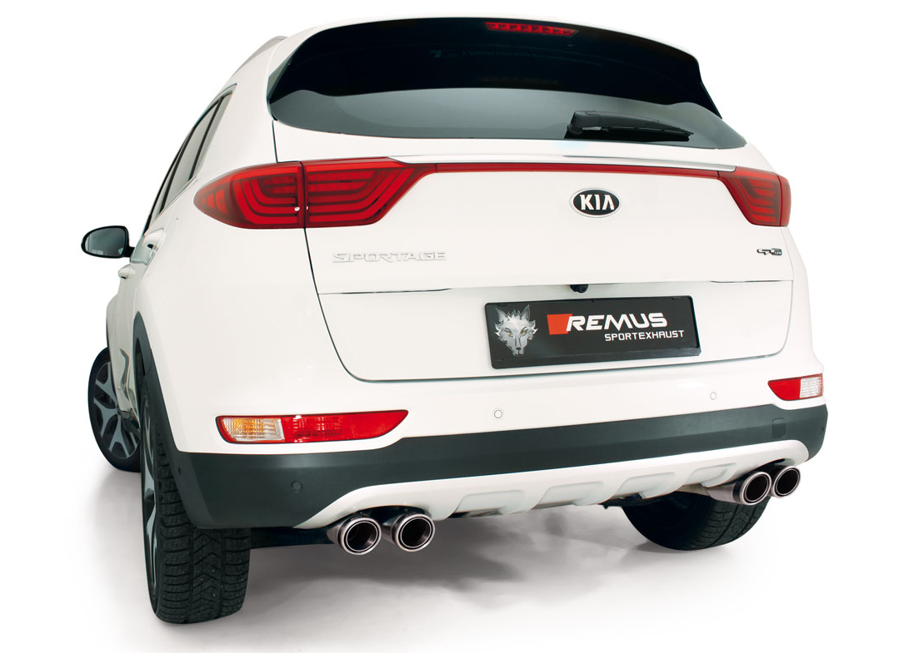

#83CTS: Carbon-tail pipes Ø 84 mm angled, Titanium internals

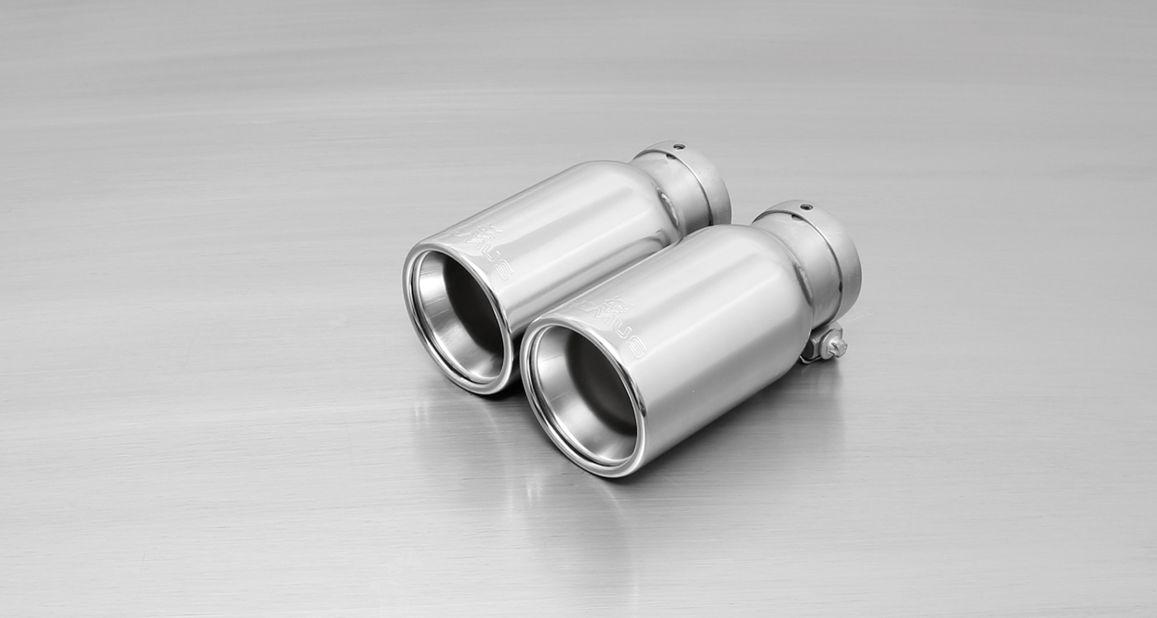

#05: tail pipes Ø 90 mm, chromed
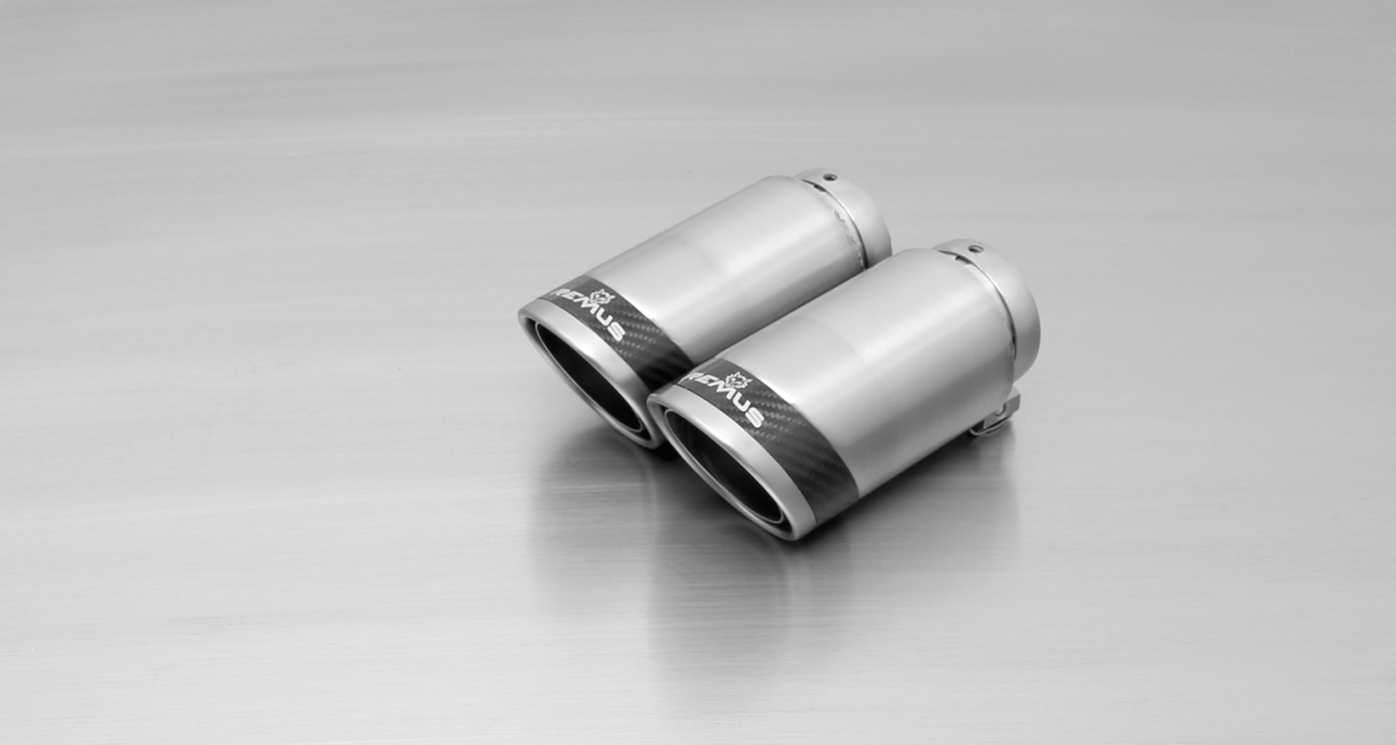
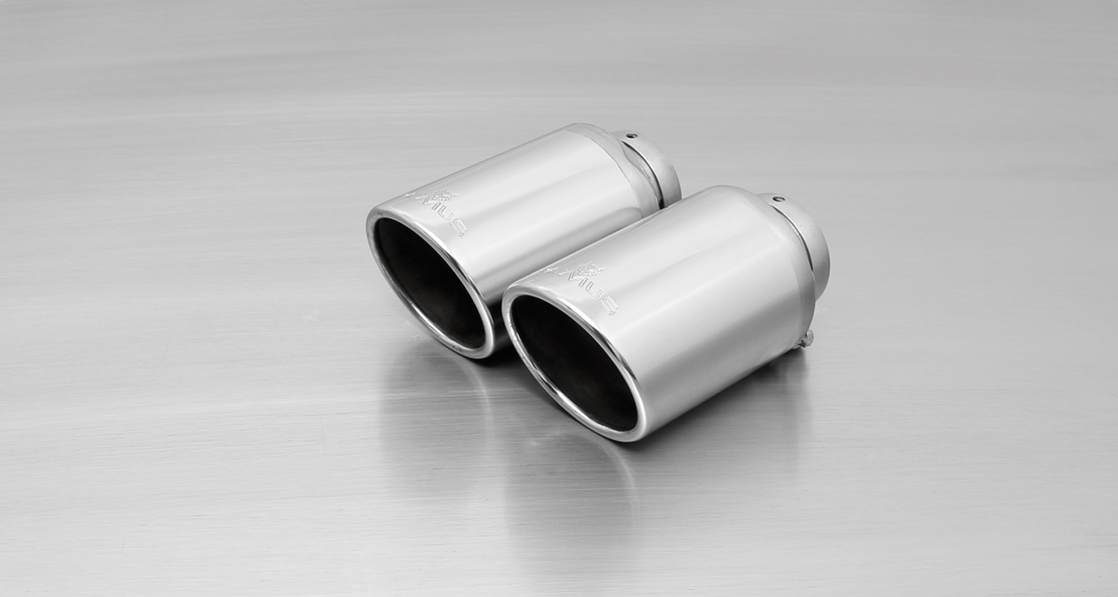

#83CS: tail pipes Ø 98 mm
Carbon Race, polished

#83CB: tail pipes Ø 84 mm
Street Race Black Chrome
#55S: tail pipes Ø 84 mm
angled, chromed

Car and engine specification
KIA Sportage GT-Line, type QLE, 2015=>
1.6l T-GDI 130 kW 4WD; 2.0l CRDI 100 2WD/4WD; 2.0l CRDI 136 kW 4WD
Part no. | Description | € RRP price excl. VAT
286015 1500 | Stainless steel sport exhaust centered for L/R system (without tail pipes)  Original tube Ø 54 mm / REMUS tube Ø 60 mm | 330,--
choose from following tail pipe package:
0046 05 | Stainless steel tail pipe set, 4 x Ø 90 mm, chromed, with adjustable spherical clamp connection | 300,--
0046 55S | Stainless steel tail pipe set, 4 x Ø 84 mm angled, chromed, with adjustable spherical clamp connection | 300,--
0046 83C | Stainless steel tail pipe set, 4 x Ø 84 mm Street Race, with adjustable spherical clamp connection | 340,--
0046 83CS | Stainless steel tail pipe set, 4 x Ø 84 mm Carbon Race, with adjustable spherical clamp connection | 360,--
0046 83CB | Stainless steel tail pipe set, 4 x Ø 84 mm Street Race Black Chrome, with adjustable spherical clamp connection | 388,--
0046 83CTS | Carbon tail pipe set 4 x Ø 84 mm angled, Titanium internals, with adjustable spherical clamp connection | 680,--
INFOBOX:
- Sport exhaust and tail pipe set only fit as a complete system!
- Bolt-on Axle-back system - no other vehicle modifications are required for the GT-Line!

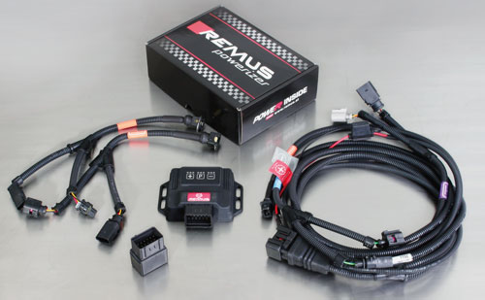

Under http://www.remus.eu/powerizer/ and http://www.remus.eu/remusresponder you will find the entire product range, prices and installation instructions.

REMUS Powerizer: More power, more economy and more fun.
- Up to 25 % more power
- Up to 20 % more torque
- Up to 1l/100 km fuel saving
- Fully adjustable power increase
- Simple DIY installation (Plug & Play)
REMUS POWERIZER: The performance figures represent the maximum achievable values. The actual performance output depends on the original tolerances of each engine. REMUS delivers the POWERIZER with the best possible setting for your vehicle type. You can adjust the performance according to your requirements as per the POWERIZER instructions

Legal references

1. Completion and registration of chip tuning in the car documents
Due to chip tuning, the operating license of the vehicle will terminate if the installation and registration of the POWERIZER is not carried out or immediately reported to an official approved testing facility. Please consider that driving a vehicle without the required operating license will cause legal penalties.

2. Vehicle insurance must be informed upon installing a POWERIZER
The installation of the POWERIZER can have influence on the insurance policy of your vehicle. You must inform the insurance company if you install a POWERIZER in your vehicle.

3. Effect of chip tuning on warranty and guarantee claims
a) When installing a POWERIZER, you will lose all guarantee claims regarding the engine against the vehicle manufacturer.
b) Installing a POWERIZER, can have influence on warranty claims against the seller of the vehicle.
c) REMUS excludes any claims regarding compensation for damages on the engine and drivetrain.

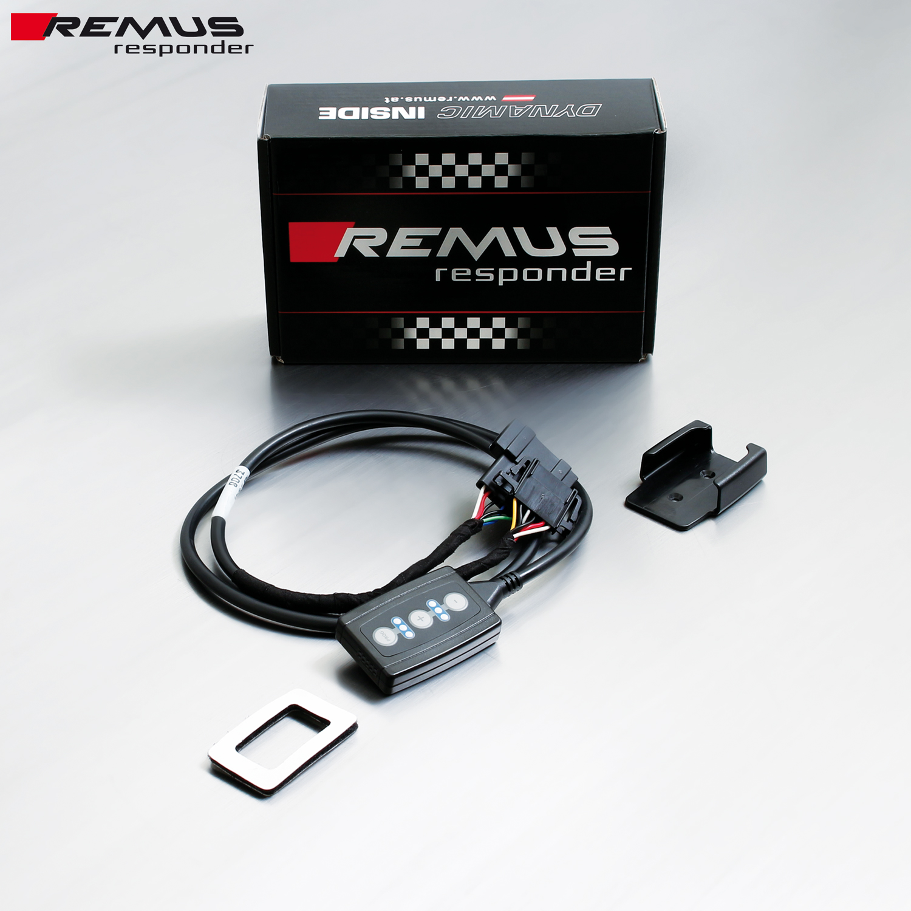

Under http://www.remus.eu/powerizer/ and http://www.remus.eu/remusresponder you will find the entire product range, prices and installation instructions.

REMUS RESPONDER:
Improved throttle response, more dynamic!
The REMUS Responder improves throttle response by means of modifying the accelerator pedal output signal. No more throttle delay and reduced lag during automatic shifting makes driving with the REMUS Responder more fun. The Responder attaches between the OEM pedal sensor and the OEM connector, ready to use in seconds due to plug & play technology. Sophisticated adjustable programming profiles can lead to improved fuel consumption and more efficiency. The 4 individual user selectable and adjustable performance settings allow drivers to select according to their own preferences.
The REMUS Responder totally eliminates the delay in modern electronic accelerator pedals!
