REMUS product information 09-2016

VW Golf VII GTI / GTI Performance, type AU, 2013=>

Dear REMUS-Partner,

We are pleased to inform you that we have completed our next development:
REMUS sport exhaust left/right and non-resonated RACING section left/right with selectable tail pipes, both suitable for the original rear skirt for the
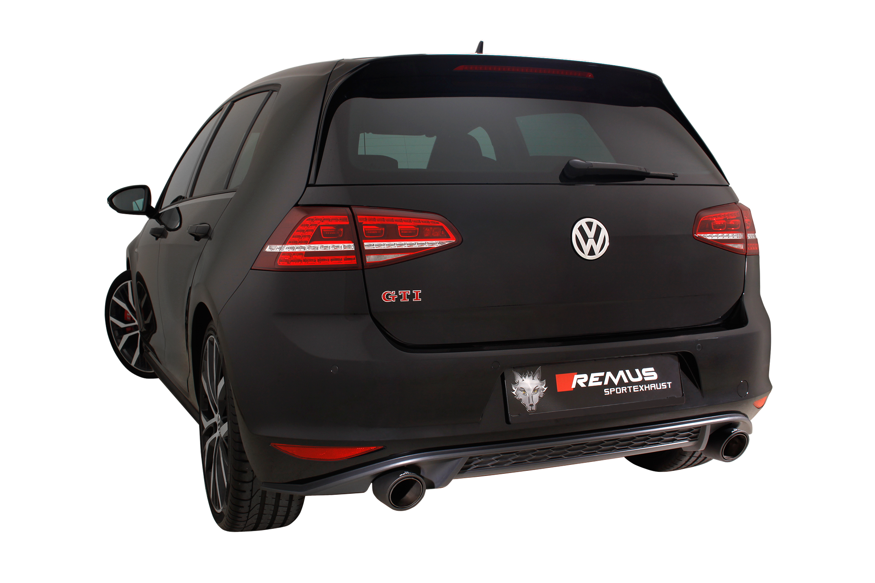
VW Golf VII GTI / GTI Performance, type AU, 2013=>.

It would be a pleasure for us to receive your order.

Stay tuned!
Your REMUS Team

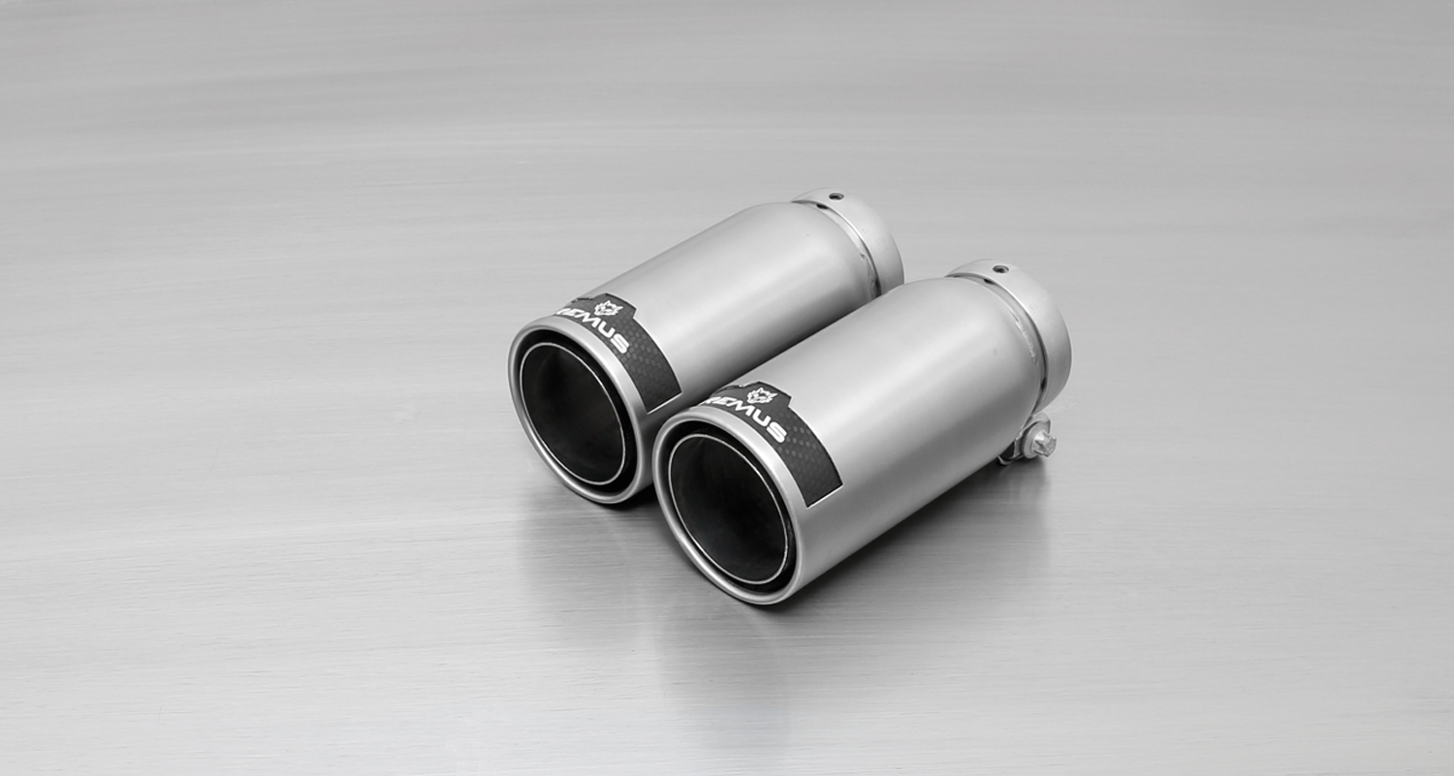
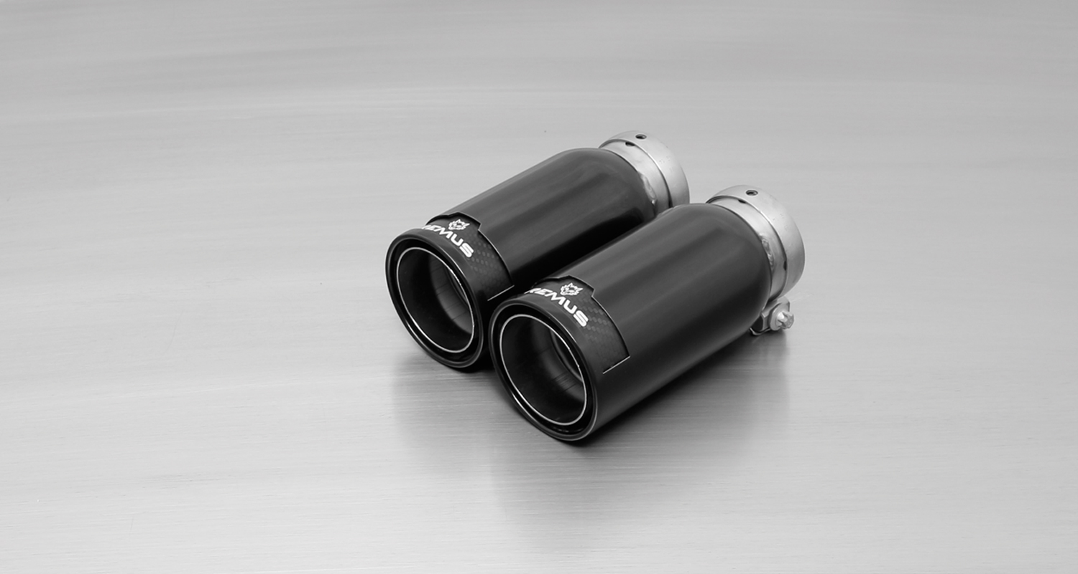
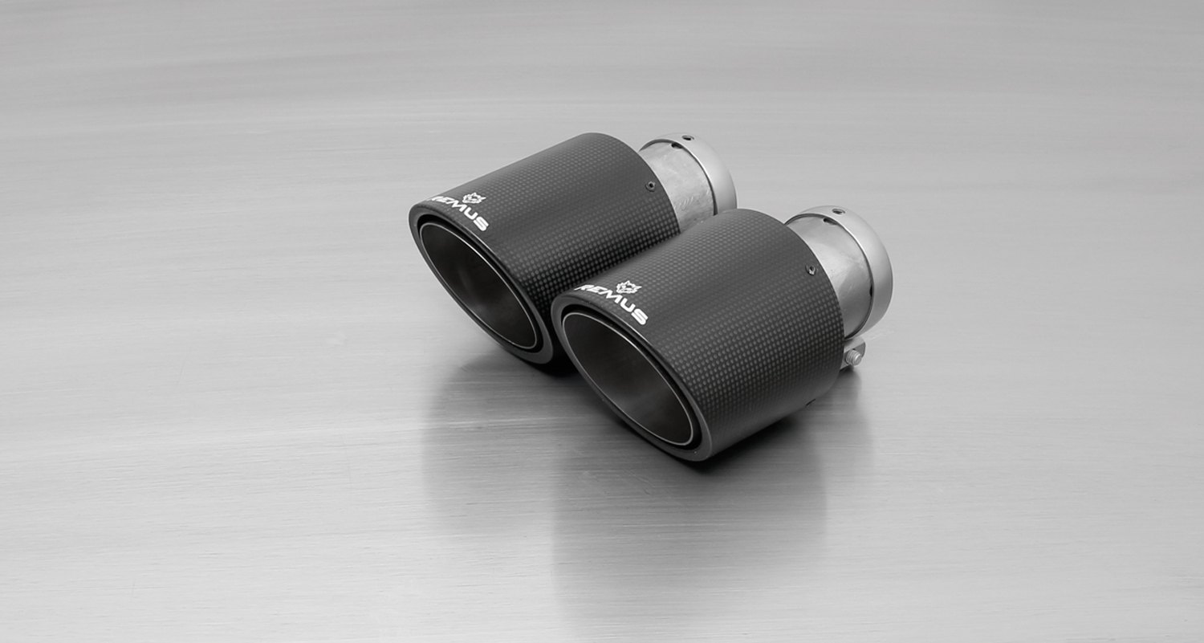
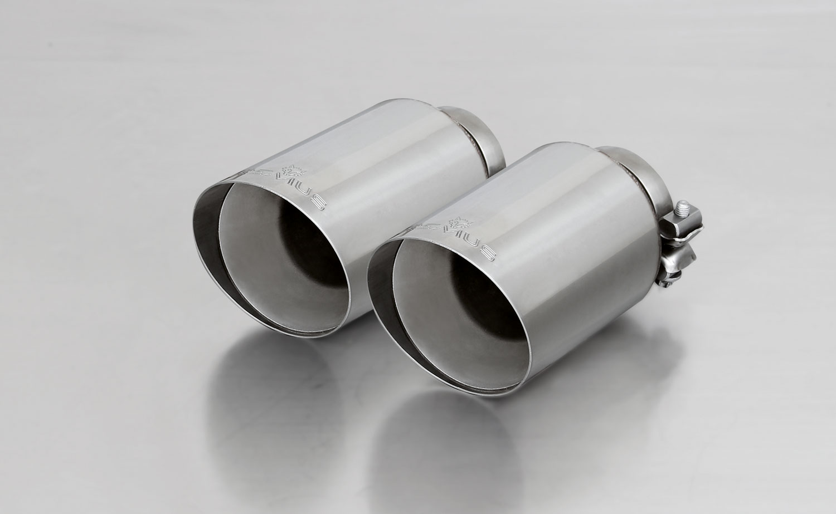
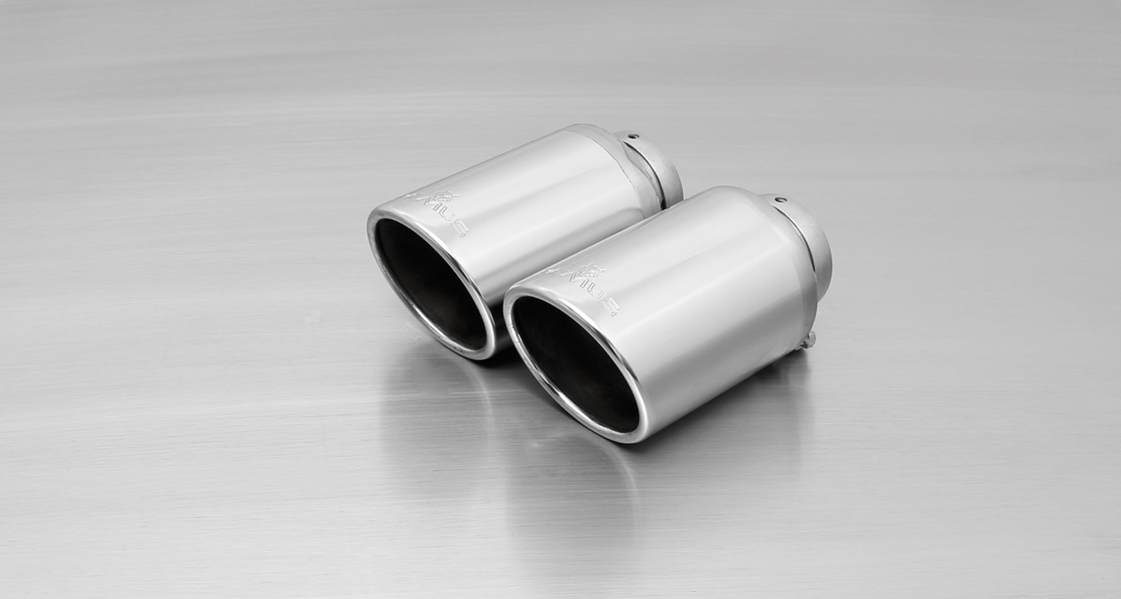
#70S: tail pipes Ø 102 mm
angled, chromed

#98C: tail pipes Ø 98 mm
Street Race, polished
#98CB: tail pipes Ø 98 mm
Street Race Black Chrome
#70SG: tail pipes Ø 102 mm
angled, straight cut, chromed
#70CS: Carbon tail pipes Ø 84 mm angled, Titanium internals
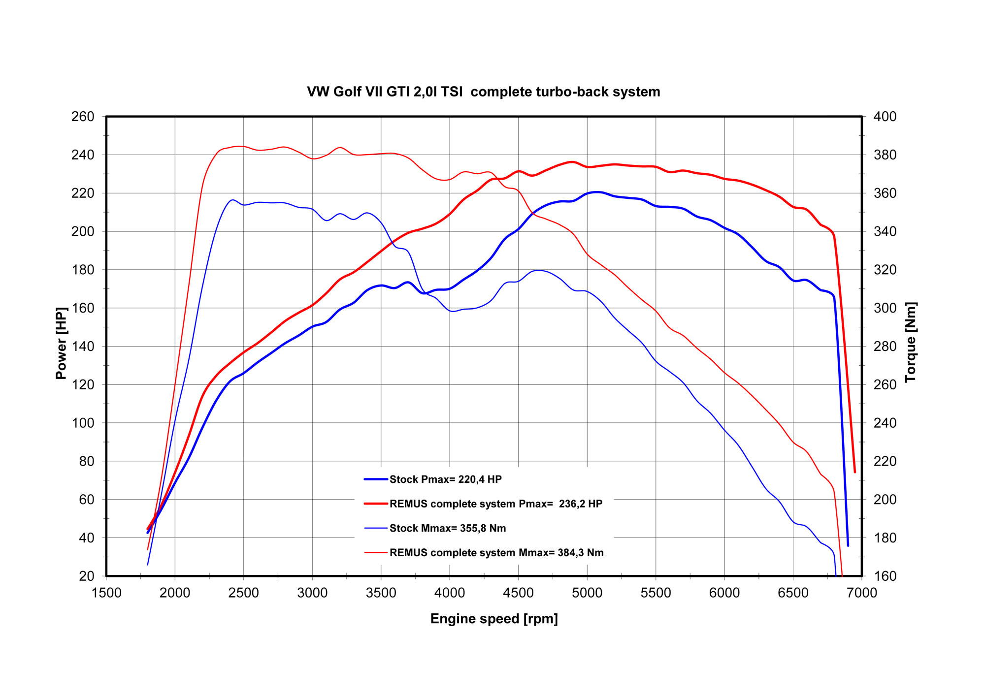

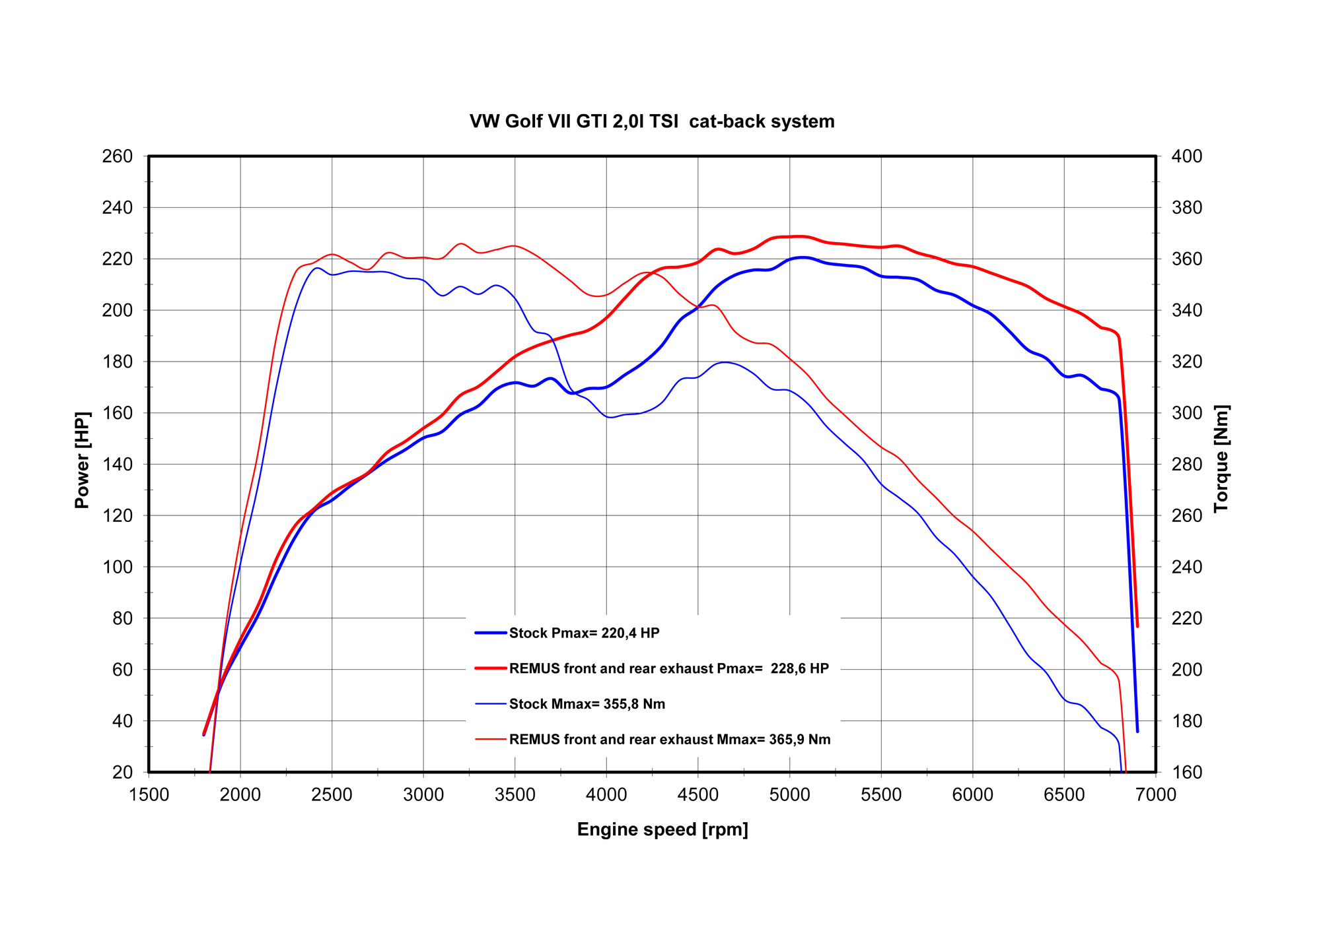
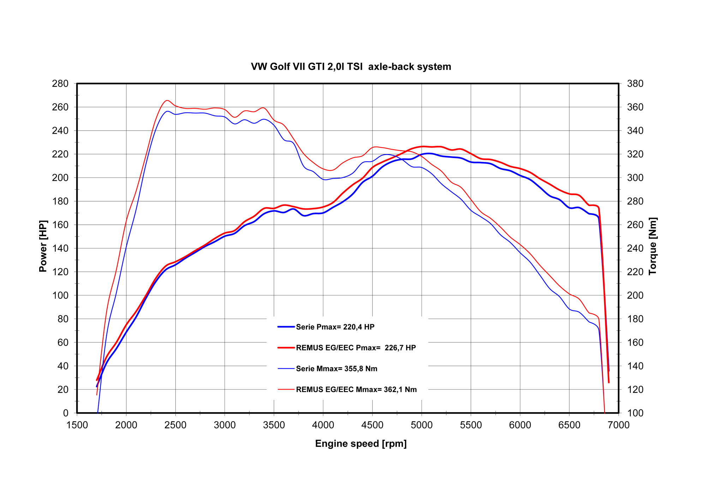

Car and engine specification
VW Golf VII GTI / GTI Performance, type AU, 2013=>
2.0l TSI 162 kW (CHH); 2.0l TSI 169 kW (CHH)
Part no. | Description | € RRP price excl. VAT
955113 1100 | Stainless steel RACING downpipe, with sport catalytic convertor (200 CPSI), without homologation, can only be fitted in combination with the REMUS front resonated cat-back section.  Original tube Ø 65 mm / REMUS tube Ø 70 mm | 874,--
955113 0300 | Stainless steel resonated front and non-resonated middle cat-back section, with EEC homologation for VW Golf VII GTI/GTI Performance type AU only.  Original tube Ø 65 mm / REMUS tube Ø 70 mm | 263,--
955213 0000 | Stainless steel connection tube for mounting the L/R sport exhaust or the non-resonated L/R RACING axle-back systems. | 56,--
Sport exhaust L/R centered axle-back system, with selectable tail pipes, incl. EEC homologation:
796014 1500 | Stainless steel L/R sport exhaust system (without tail pipes, without connecting tube), suitable for the original rear skirt, with EEC homologation  Original tube Ø 65 mm / REMUS tube Ø 70 mm | 240,--
alternative: Non-resonated RACING centered L/R axle-back system, with selectable tail pipes, without homologation:
796014 1600 | Stainless steel non resonated L/R axle-back system (without tail pipes, without connecting tube), suitable for the original rear skirt, without homologation  Original tube Ø 65 mm / REMUS tube Ø 70 mm | 105,--
choose from following tail pipe package:
0026 70SG | Tail pipe set L/R consisting of 2 tail pipes Ø 102 mm angled, straight cut, chromed, with adjustable spherical clamp connection | 140,--
0026 70S | Tail pipe set L/R consisting of 2 tail pipes Ø 102 mm angled, chromed, with adjustable spherical clamp connection | 160,--
0026 70CS | Tail pipe set L/R consisting of 2 Carbon tail pipes Ø 102 mm angled, Titanium internals, with adjustable spherical clamp connection | 370,--
0026 98C | Tail pipe set L/R consisting of 2 tail pipes Ø 98 mm Street Race, with adjustable spherical clamp connection | 196,--
0026 98CB | Tail pipe set L/R consisting of 2 tail pipes Ø 98 mm Street Race Black Chrome, with adjustable spherical clamp connection | 220,--
INFOBOX:
- Axle-Back: When installing sport exhaust 796014 1500 or non-resonated RACING system 796014 1600, in combination with the required connection tube 955213 0000, the original exhaust must be cut!
- Cat-Back-system: When installing sport exhaust 796014 1500 or non-resonated RACING system 796014 1600, in combination with the required connection tube 955213 0000 and 955113 0300 cat-back sections, no vehicle modifications are required.
- Turbo-Back-system: When installing sport exhaust 796014 1500 or non-resonated RACING system 796014 1600, in combination with the required connection tube 955213 0000 and 955113 0300 cat-back sections and Racing downpipe 955113 1100, no vehicle modifications are required.
- Suitable for the original rear skirt – no modification required!
- When installing REMUS down-pipes with and without the racing catalytic convertors, which are only suitable for closed road driving, it is important to note that ECU tuning is required to ensure that the engine runs and performs efficiently and to ensure that the CEL does not come on.

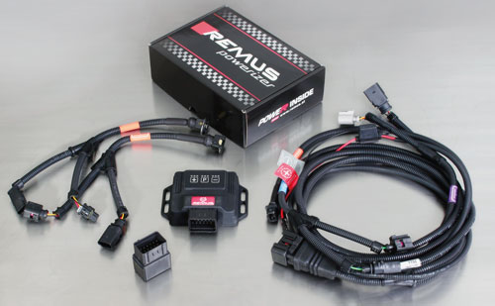

Under http://www.remus.eu/powerizer/ and http://www.remus.eu/remusresponder you will find the entire product range, prices and installation instructions.

REMUS Powerizer: More power, more economy and more fun.
- Up to 25 % more power
- Up to 20 % more torque
- Up to 1l/100 km fuel saving
- Fully adjustable power increase
- Simple DIY installation (Plug & Play)
REMUS POWERIZER: The performance figures represent the maximum achievable values. The actual performance output depends on the original tolerances of each engine. REMUS delivers the POWERIZER with the best possible setting for your vehicle type. You can adjust the performance according to your requirements as per the POWERIZER instructions

Legal references

1. Completion and registration of chip tuning in the car documents
Due to chip tuning, the operating license of the vehicle will terminate if the installation and registration of the POWERIZER is not carried out or immediately reported to an official approved testing facility. Please consider that driving a vehicle without the required operating license will cause legal penalties.

2. Vehicle insurance must be informed upon installing a POWERIZER
The installation of the POWERIZER can have influence on the insurance policy of your vehicle. You must inform the insurance company if you install a POWERIZER in your vehicle.

3. Effect of chip tuning on warranty and guarantee claims
a) When installing a POWERIZER, you will lose all guarantee claims regarding the engine against the vehicle manufacturer.
b) Installing a POWERIZER, can have influence on warranty claims against the seller of the vehicle.
c) REMUS excludes any claims regarding compensation for damages on the engine and drivetrain.

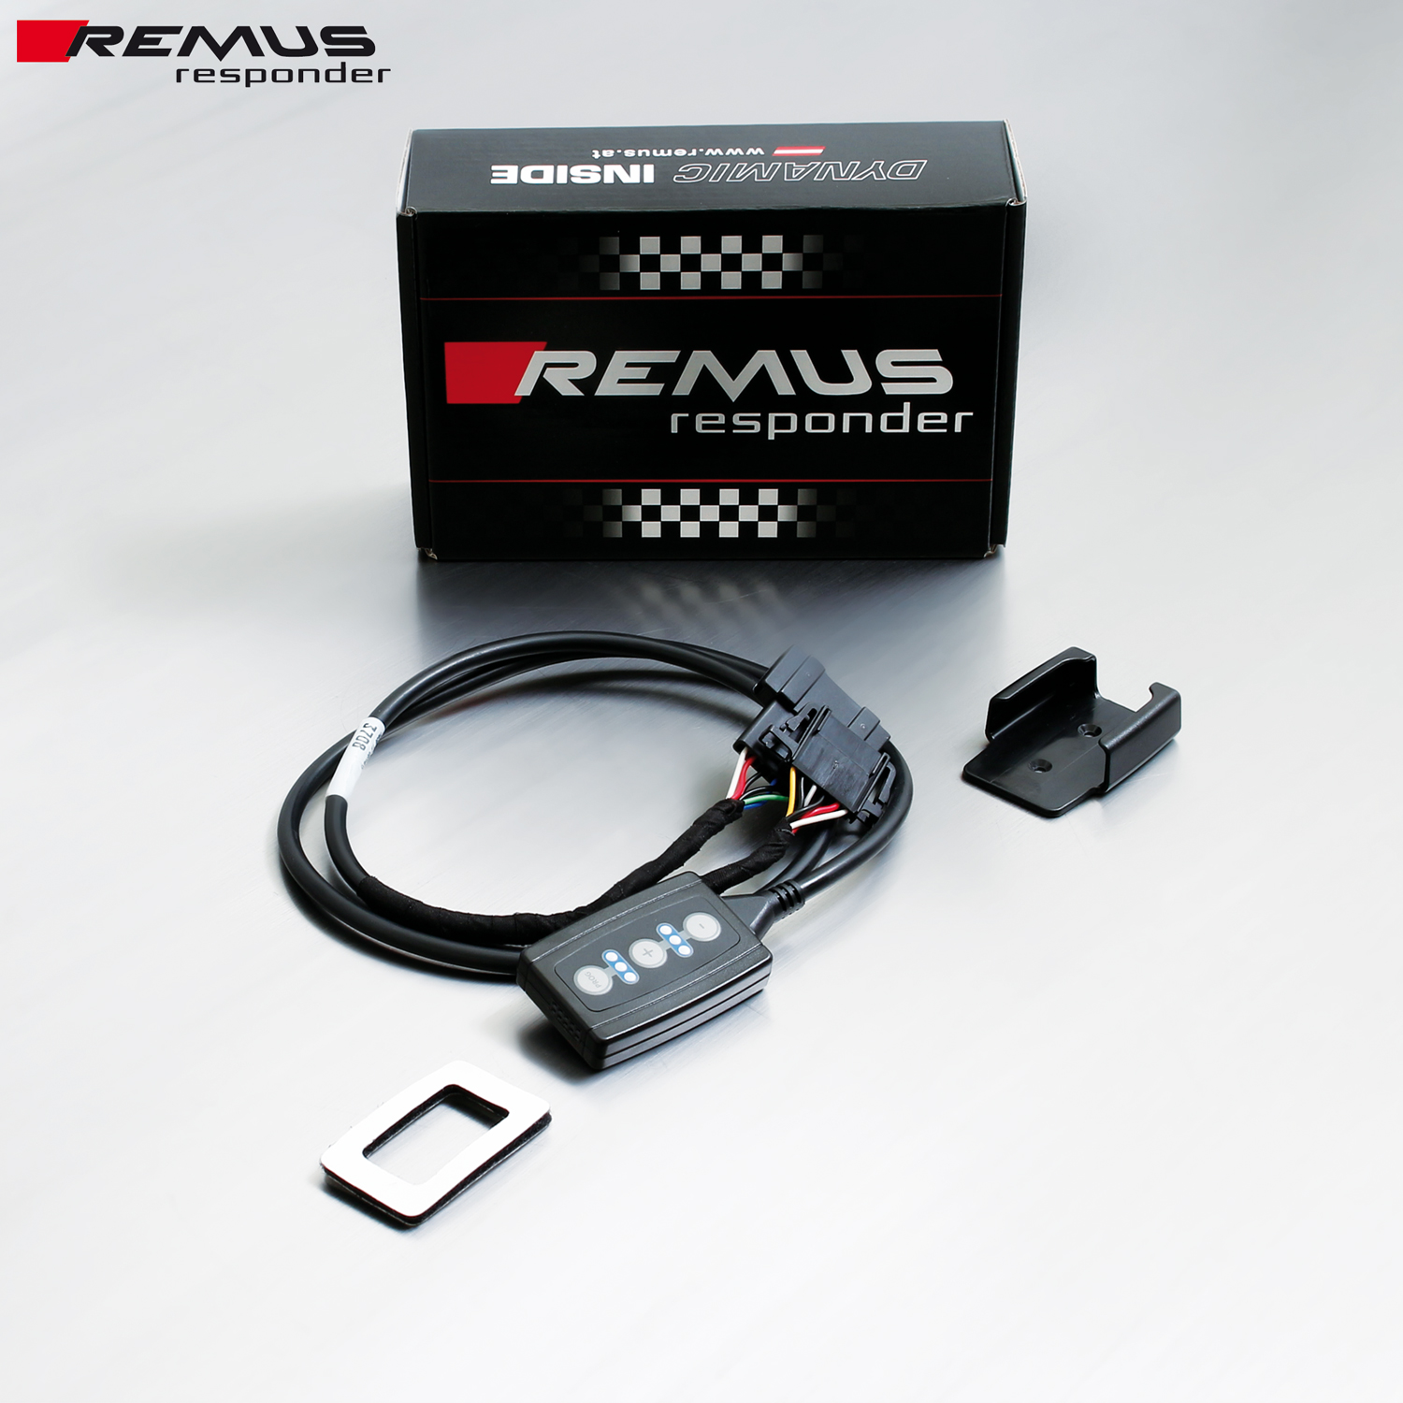

Under http://www.remus.eu/powerizer/ and http://www.remus.eu/remusresponder you will find the entire product range, prices and installation instructions.

REMUS RESPONDER:
Improved throttle response, more dynamic!
The REMUS Responder improves throttle response by means of modifying the accelerator pedal output signal. No more throttle delay and reduced lag during automatic shifting makes driving with the REMUS Responder more fun. The Responder attaches between the OEM pedal sensor and the OEM connector, ready to use in seconds due to plug & play technology. Sophisticated adjustable programming profiles can lead to improved fuel consumption and more efficiency. The 4 individual user selectable and adjustable performance settings allow drivers to select according to their own preferences.
The REMUS Responder totally eliminates the delay in modern electronic accelerator pedals!
