Product information 08/2017

HONDA Civic Type-R
HONDA Civic Type-R, type FK2, 5 door, from 2015
REMUS Cat-back-system
- 100% stainless steel
- Powerful sound
- Performance and torque increase
- EC homologation

+ 9,2 HP
+ 12,2 Nm

2.0l VTEC Turbo/Turbo GT 228 kW (K20C1)

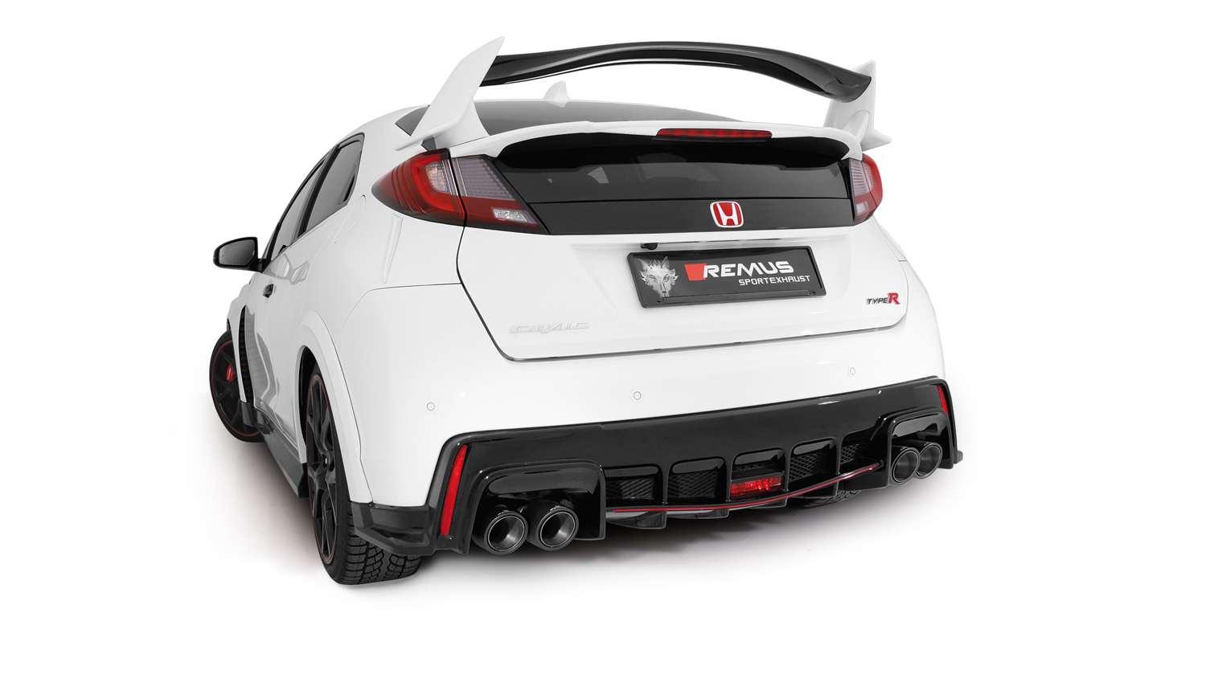

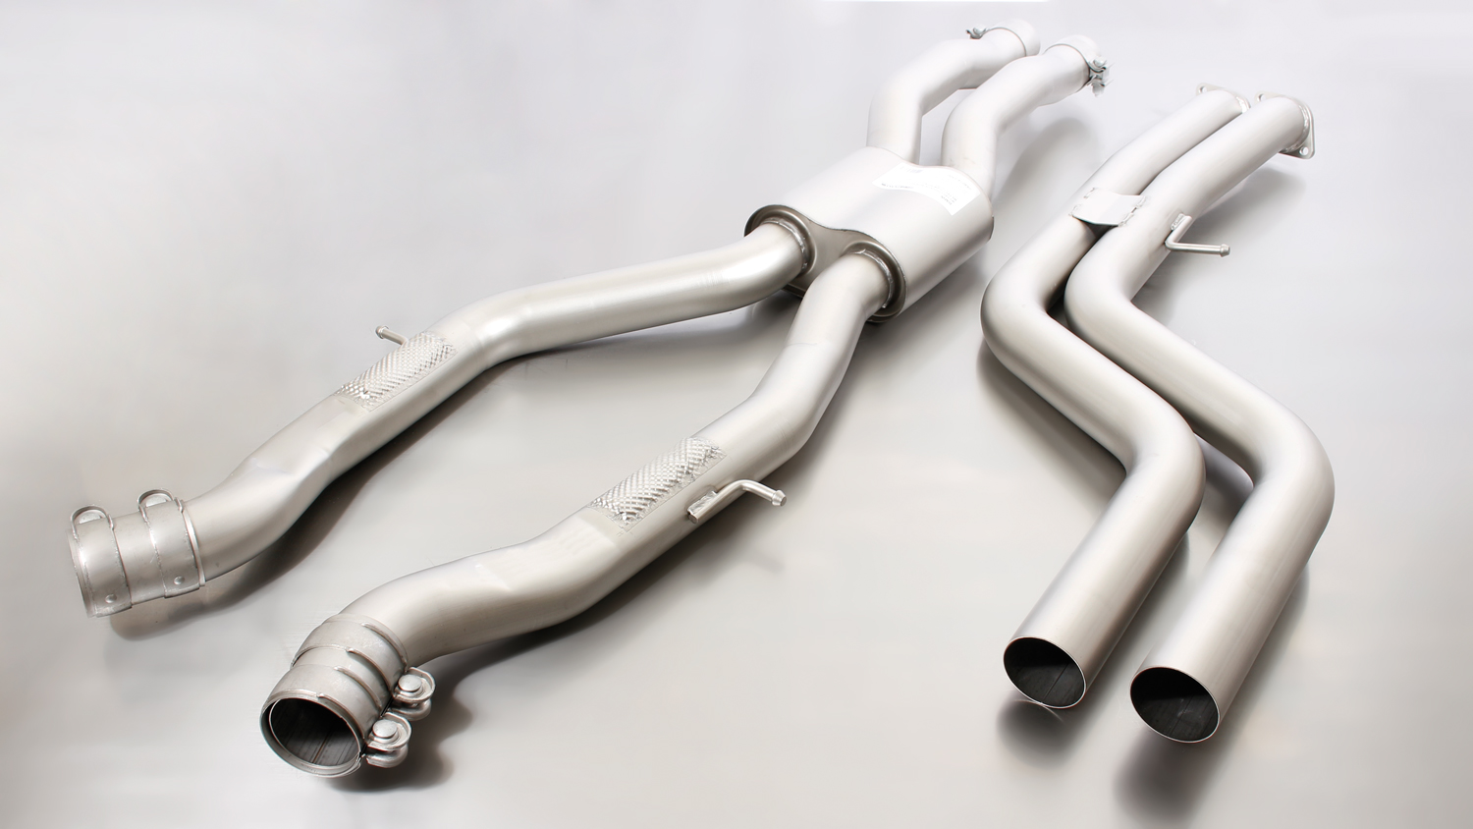

Car and engine specification
HONDA Civic Type-R, type FK2, 5 door, 2015=>
2.0l VTEC Turbo/Turbo GT 228 kW (K20C1)
INFOBOX:
- Cat-back-system LHD: 256315 0300 + 256515 1500 + tail pipe set + optional STE 0005BT! No vehicle modifications are required! Only for left hand drive! NOT SUITABLE FOR RHD MODELS IN FOLLOWING COUNTRIES: Australia, Cyprus, Japan, Hong Kong, India, Isle of Man, Ireland, Malaysia, New Zealand, South Africa, Singapore, Thailand, UK
- Cat-back-system RHD: 256215 0300 + 256515 1500 + tail pipe set + optional STE 0005BT! No vehicle modifications are required! Only for right hand drive! ONLY SUITABLE FOR RHD MODELS IN FOLLOWING COUNTRIES: Australia, Cyprus, Japan, Hong Kong, India, Isle of Man, Ireland, Malaysia, New Zealand, South Africa, Singapore, Thailand, UK
Part no. | Description | € RRP price excl. VAT
256215 0300 | Stainless steel resonated cat-back section RHD, incl. EC homologation  Original tube Ø 60 mm, REMUS tube Ø 70 mm | 360,--
256315 0300 | Stainless steel resonated cat-back section LHD, incl. EC homologation  Original tube Ø 60 mm, REMUS tube Ø 70 mm | 360,--
256515 1500 | Stainless steel sport exhaust centered for left/right system (without tail pipes)  with integrated valves, incl. EC homologation  Original tube Ø 60 mm, REMUS tube Ø 70 mm  It is not permissible to activate the valve on public roads as per the EU transport authority.  The activation of the valve can be carried out using the separate available REMUS sound controller and the REMUS sound control app. The sound controller and electrical actuator allows the valve to be operated in different positions. | 678,--
Optional: REMUS Sound Controller and electrical actuator
STE 0005BT | The REMUS Sound Controller consisting of the electronic module, the OBDII plug, the remote control button as well as the electrical actuator including the cables. Without EC homologation. | 480,--
Choose from following tail pipe package:
0446 70SG | Stainless steel tail pipe set 4 tail pipes Ø 102 mm angled (shorter length 145 mm), straight cut, chromed, with adjustable spherical clamp connection | 296,--
0446 70CS | Carbon tail pipe set 4 tail pipes Ø 102 mm angled (shorter length 145 mm), Titanium internals, with adjustable spherical clamp connection | 840,--

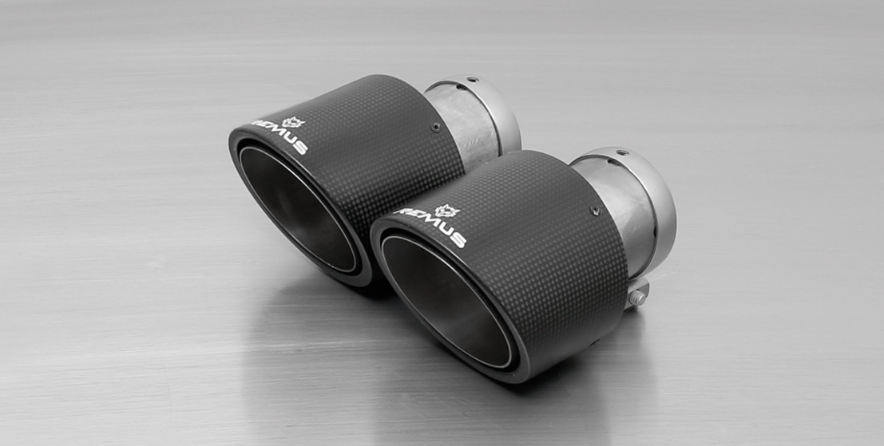
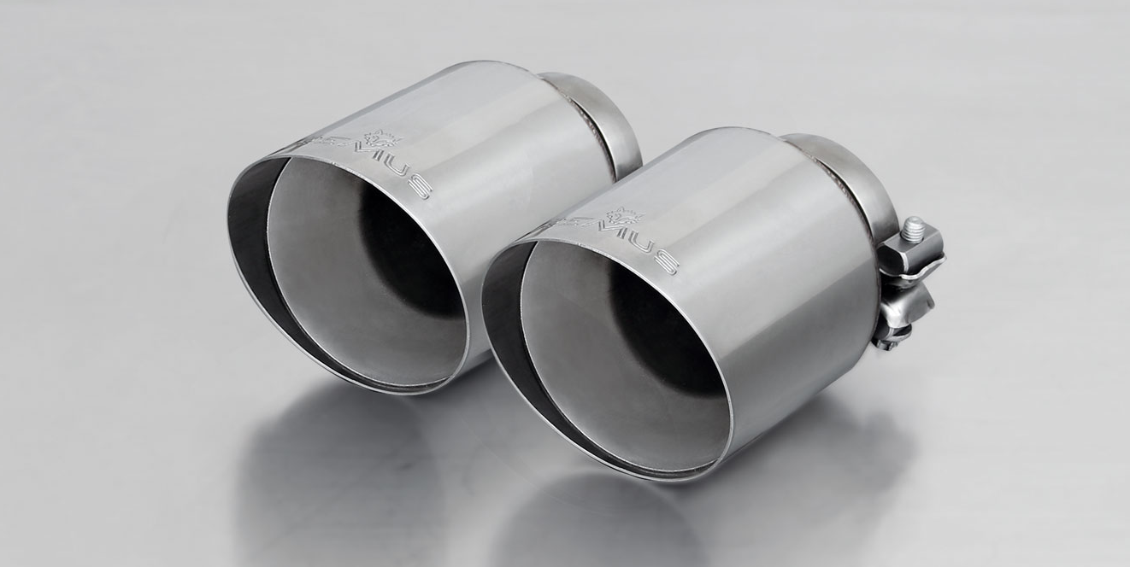
0446 70SG

0446 70CS

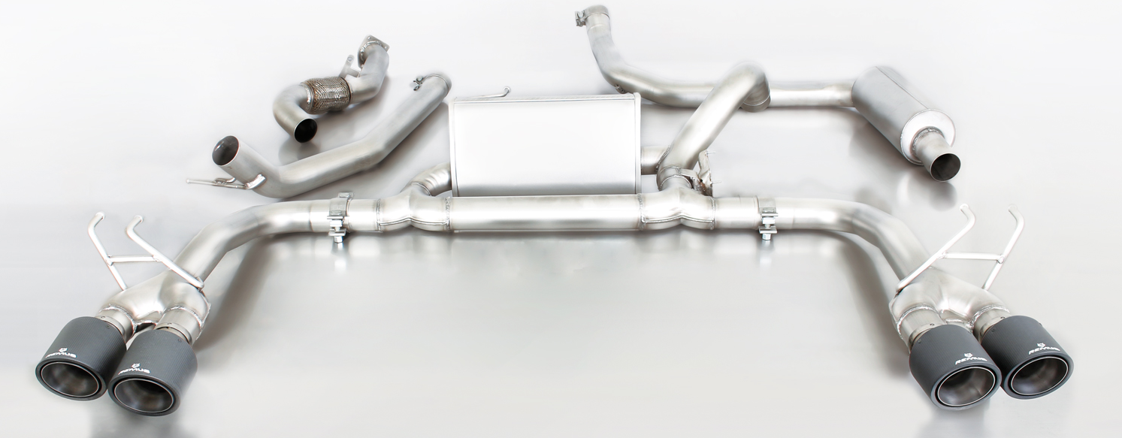
256515 1500 + 256315 0300 + 0446 70CS
256215 0300
256515 1500
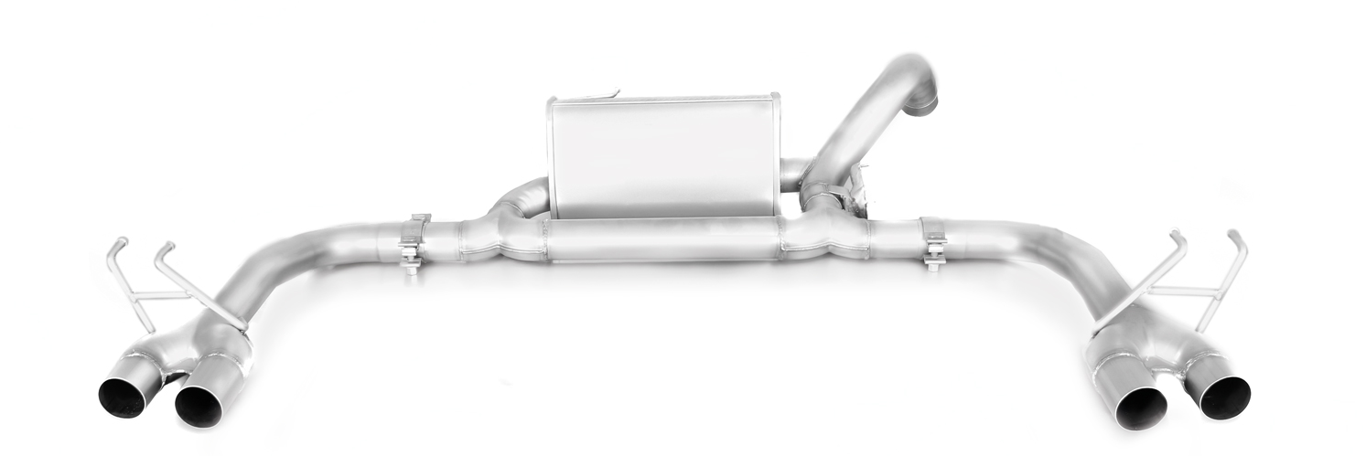

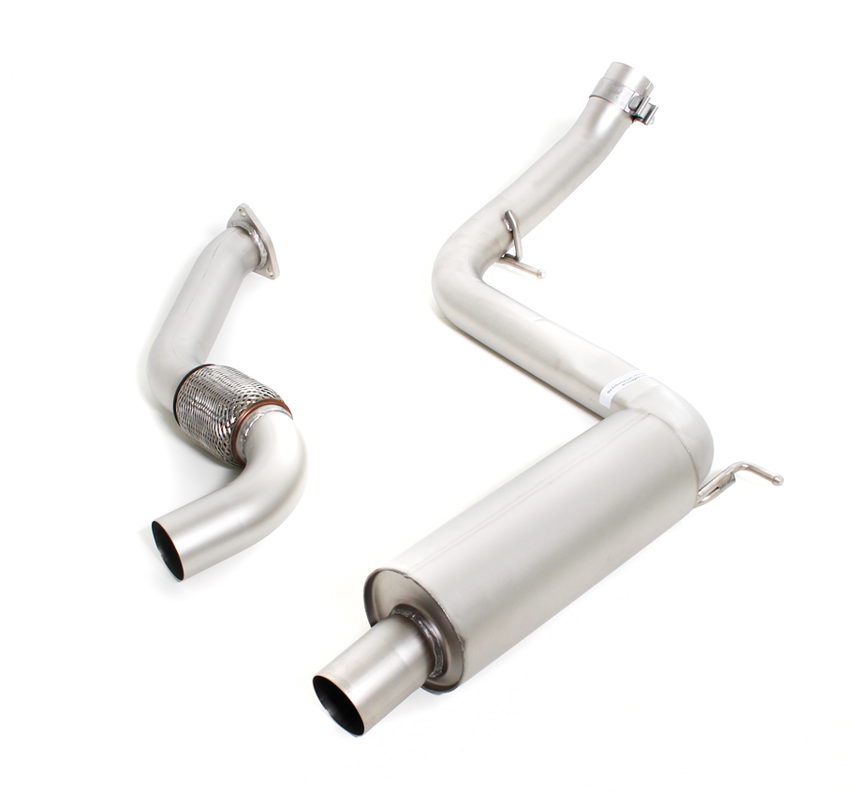
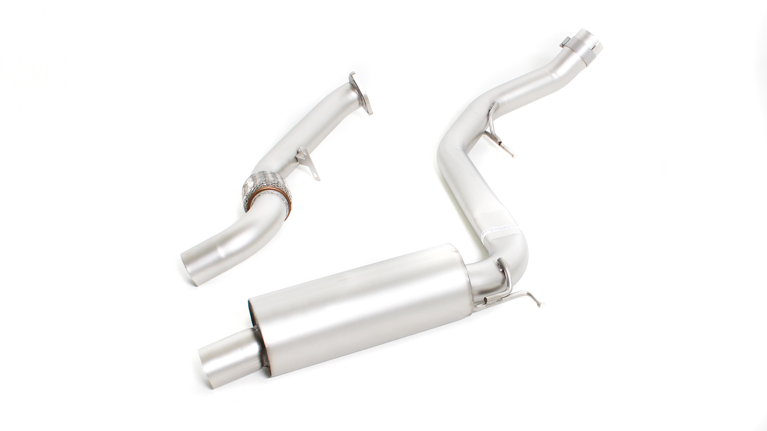

256315 0300

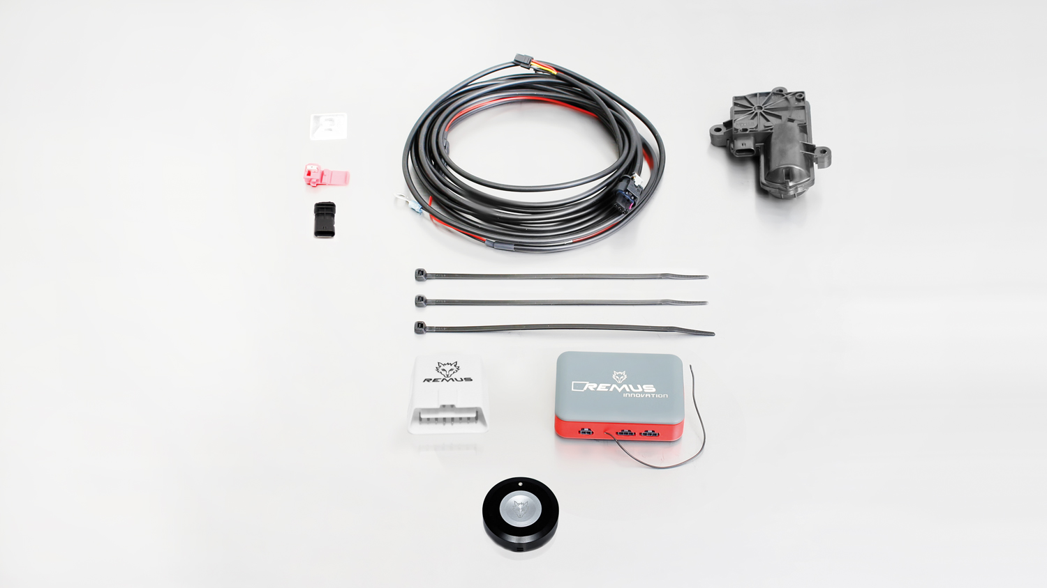
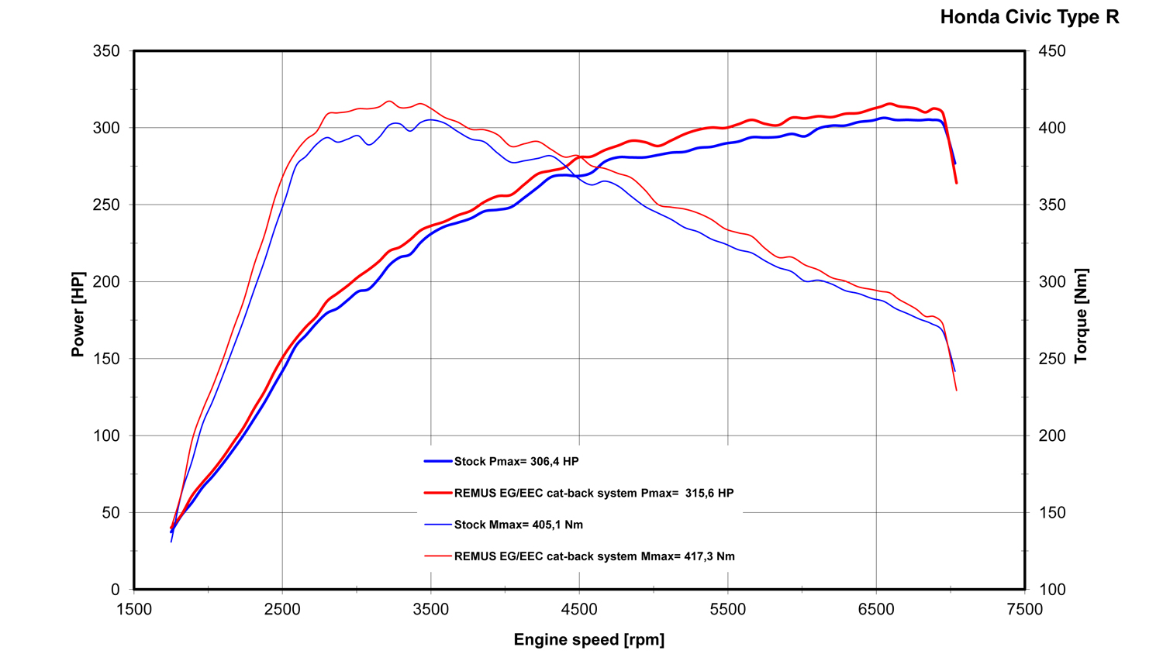

STE 0005BT

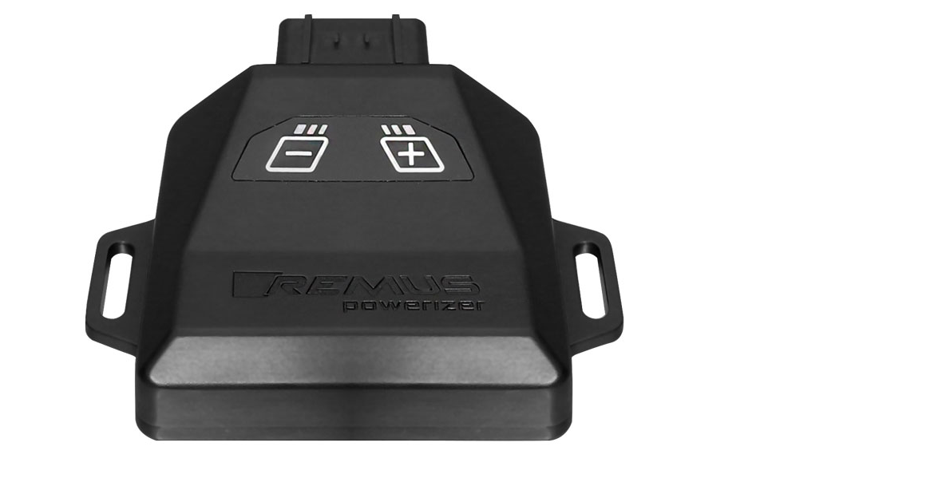
REMUS Powerizer
More power, more torque means more fun!
The perfectly matched electronics and advanced technology of the
REMUS Powerizer enhances Engine ECU mapping is optimized in
excess of 1000 times per second and ensures for a considerable and
noticeable power increase. The engine safety parameters (Check engine light) and engine management remains totally untouched to ensure that individual engine components are not overstrained.
Because of the plug & play concept, the REMUS Powerizer is installed in the engine compartment and connected to sensors such as intake manifold pressure sensor, boost pressure sensor, camshaft position sensor or fuel injection sensor. In real time, the incoming signals are processed, optimized and transmitted to the additional control unit. The Powerizer can be easily removed or decommissioned at any time using the supplied blind connector.
Due to the torque increase, the engine has more power at lower RPM which can lead to a reduction in fuel consumption. The power increase of the engine can easily be fine-tuned by means of seven preset levels via the keypad. The REMUS Powerizer is available for over 3300 petrol and diesel powered cars.
Furthermore, the latest Powerizer is also available for all vehicle engines with SENT technology. This newly developed multi-protocol technology combines analog and digital motor control the same time captures important analog signals of the engine management system which leads to increased engine performance. The capability to tune vehicles with SENT technology is an absolute highlight of the latest Powerizer.

- Up to 30% more power
- Up to 20% more torque
- Easy installation and removal (plug & play)
- Up to 1l/100 km fuel saving
- No vehicle modifications required
- 7 preset power levels

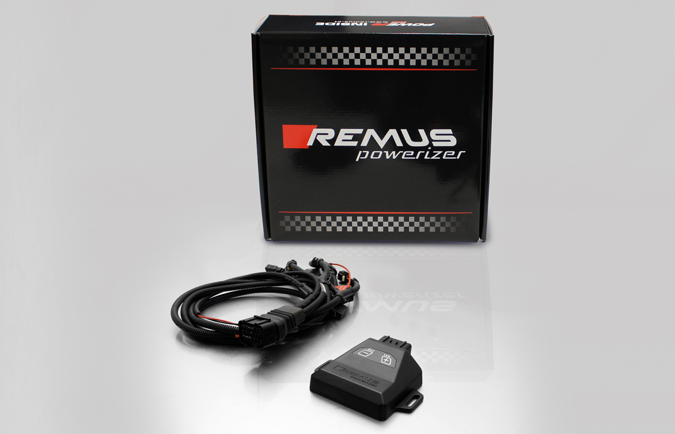

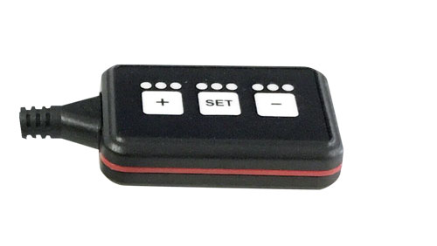
REMUS Responder

Improved throttle response for more driving dynamic!

The REMUS Responder improves throttle response and is the best power boost for
many electronically managed gas pedals. Results of up to 10% better acceleration are not uncommon and no annoying throttle delay and lag during take-off or in between manual / automatic shifts makes driving with the REMUS Responder much more dynamic.

The REMUS Responder attaches between the OEM gas pedal sensor and the OEM wiring loom and is ready to use in minutes due to plug & play technology.

The fully adjustable Responder settings can be adjusted in 20 different stages. The individual user-selectable and adjustable performance settings allow drivers to select according to their own preferences & road conditions.

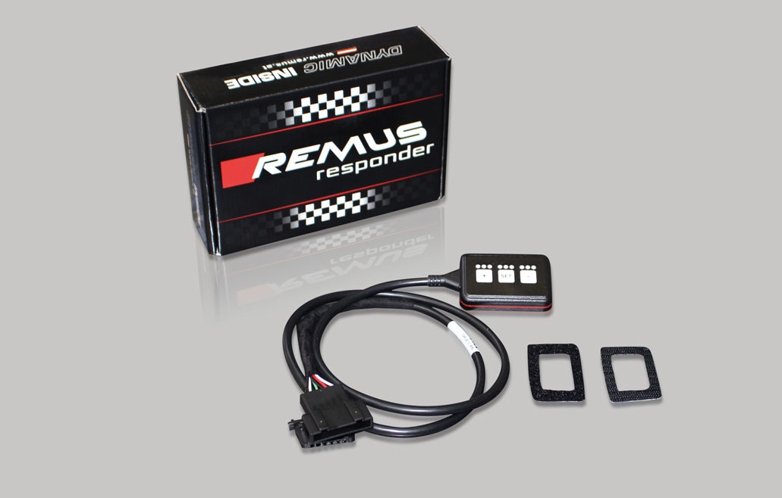

- Improves throttle response and lag during take-off and gear changes
- Quicker reaction times, more driving dynamic
- 20 individual user selectable performance settings
- Vehicle specific programming using OEM quality connectors
- Simple plug & play installation and removal without leaving traces

