REMUS product information 07-2015

SMART ForFour, type C453, 2014=>
RENAULT Twingo III, type AH, 2014=>

Dear REMUS-Partner,

We are pleased to inform you that we have completed our next development
REMUS sport exhaust for
smart ForFour, type C453, 2014=> and Renault Twingo III, type AH, 2014=>.

It would be a pleasure for us to receive your order.

Stay tuned!
Your REMUS Team

Car and engine specification
Smart ForFour, type C453, 2014=>
0.9l 66 kW; 1.0l 52 kW
RENAULT Twingo III, type AH, 2014=>
0.9l 66 kW; 1.0l 52 kW
Part no. | Description | € RRP price excl. VAT
731014 5504 | Stainless steel sport exhaust with 2 tail pipes Ø 76 mm centered, with EEC homologation | 495,--
ATTENTION:
- The rear skirt must be trimmed according to the enclosed template!
- Not for ForFour with sport package – will fit if original rear skirt (part no A4538800240) is purchased and installed / trimmed according to enclosed template!

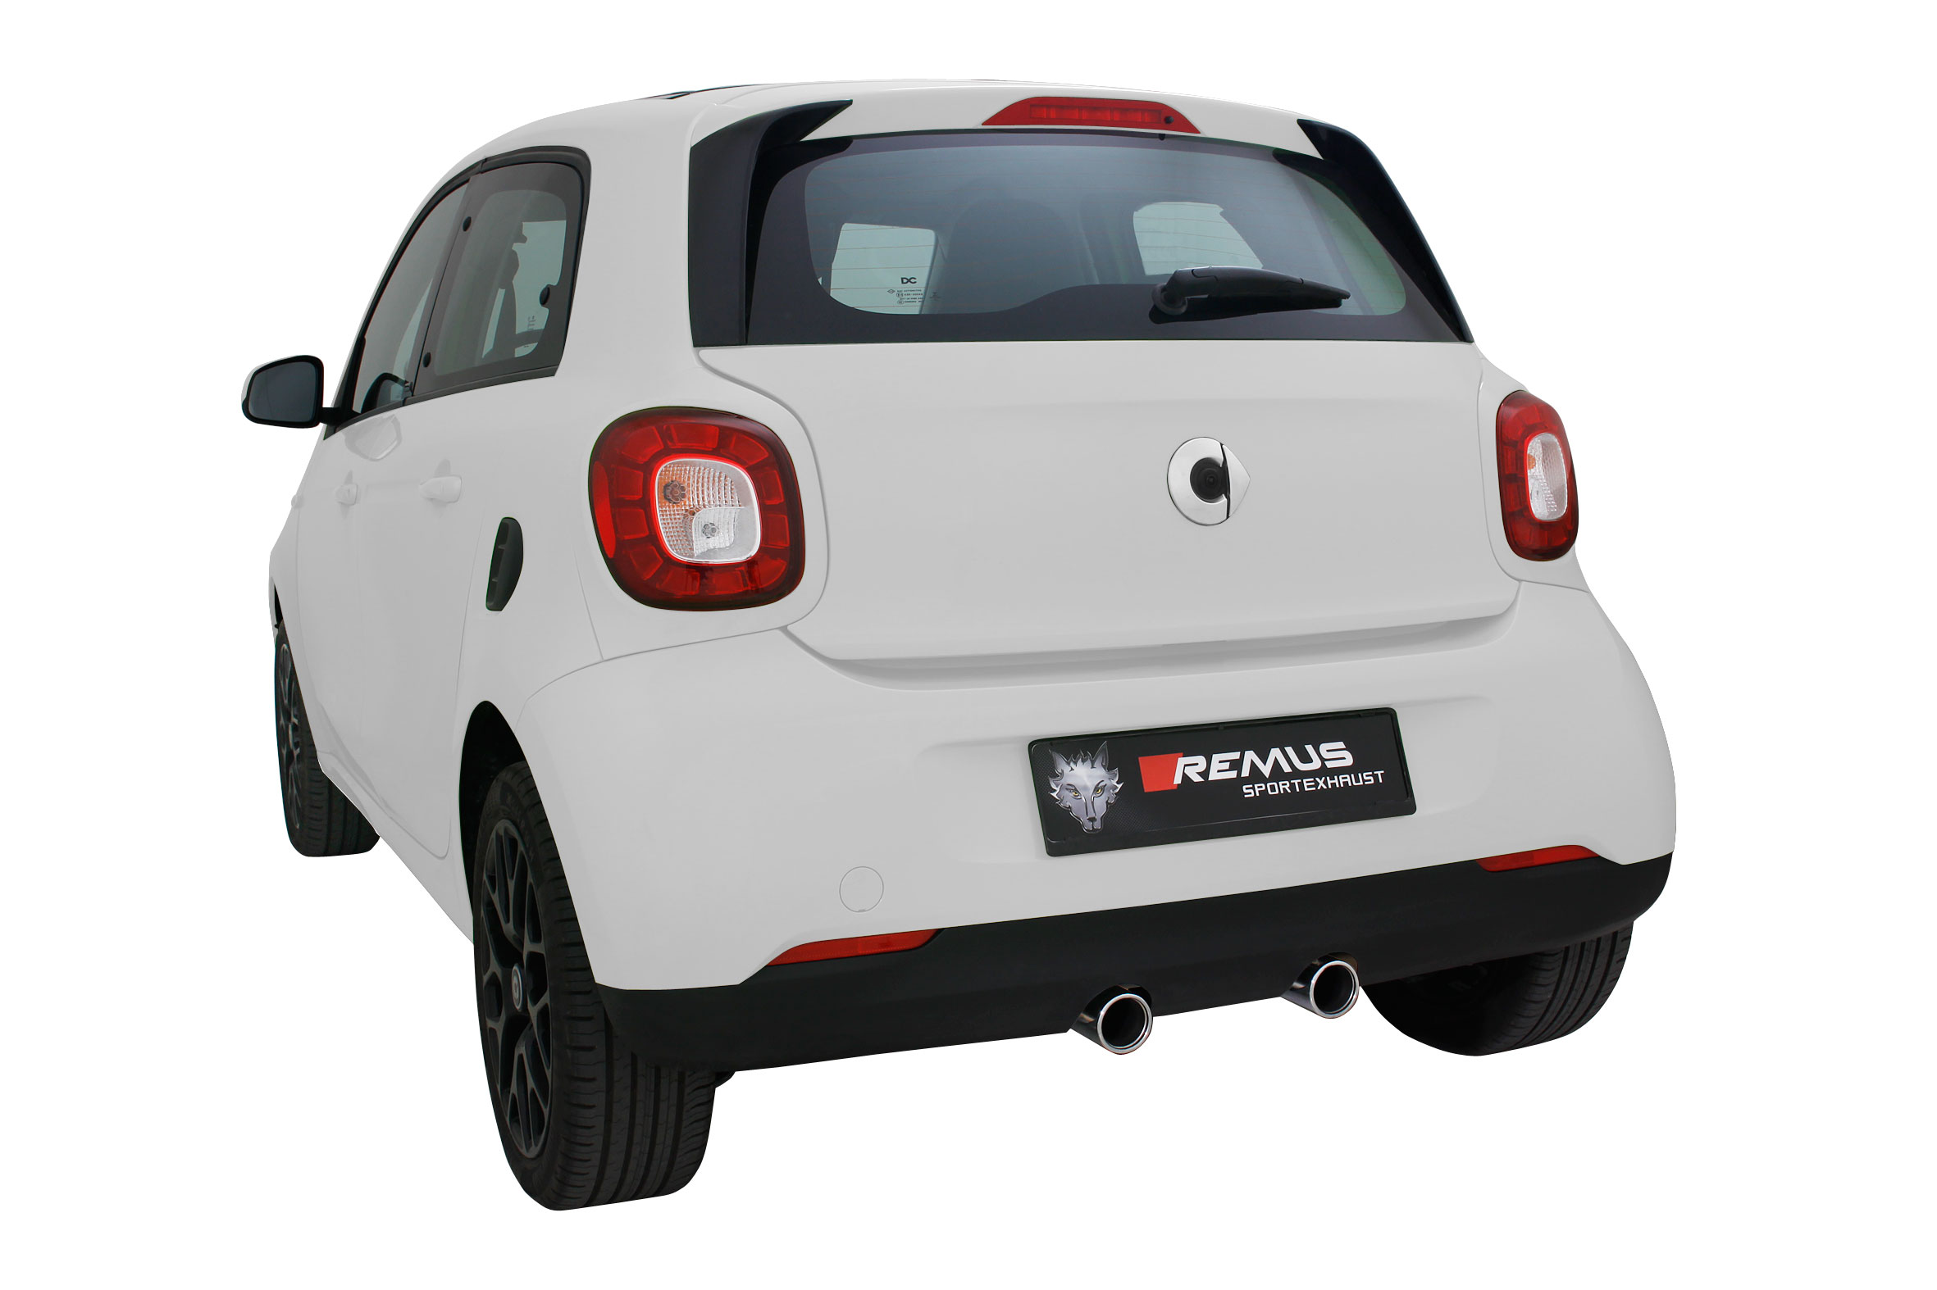
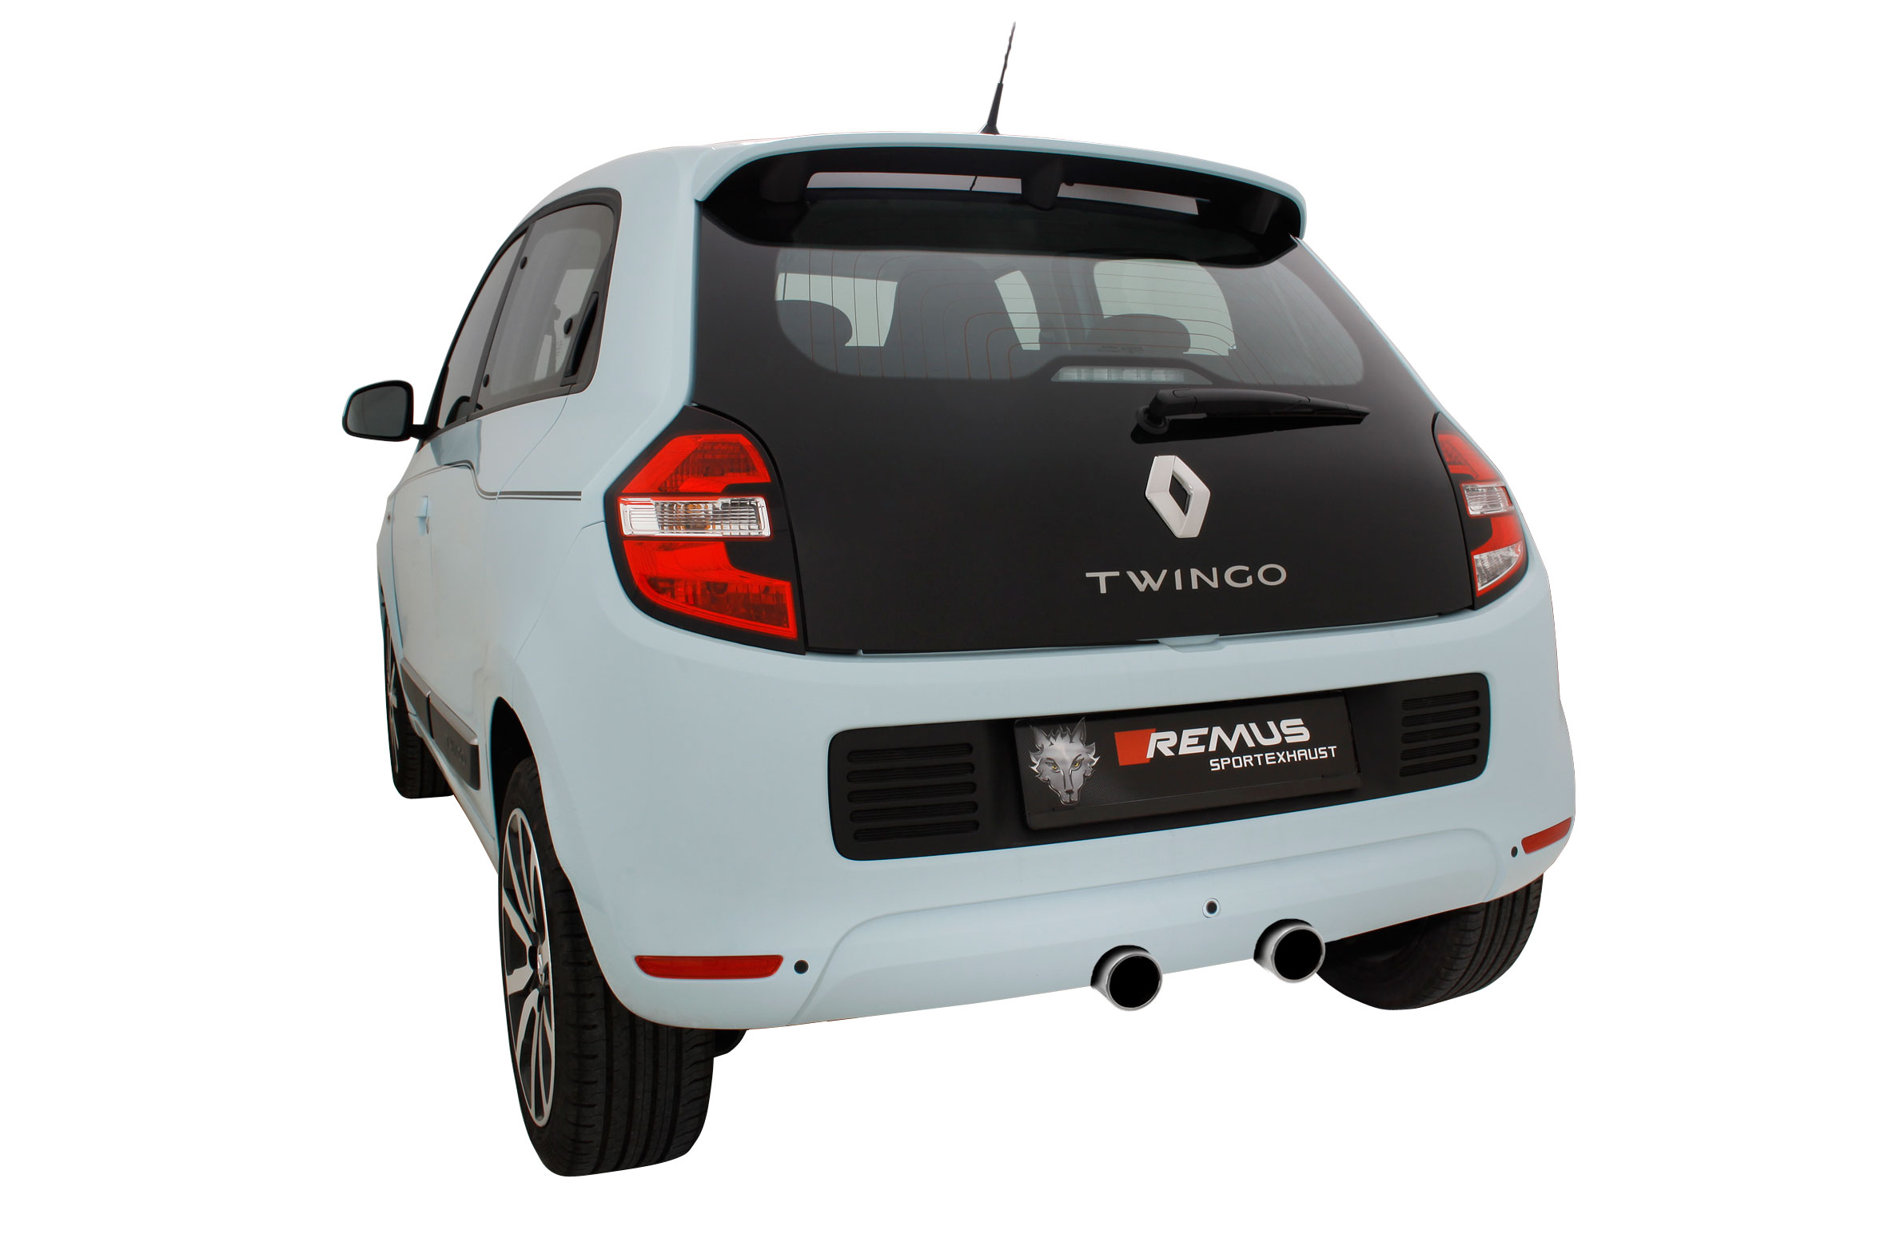
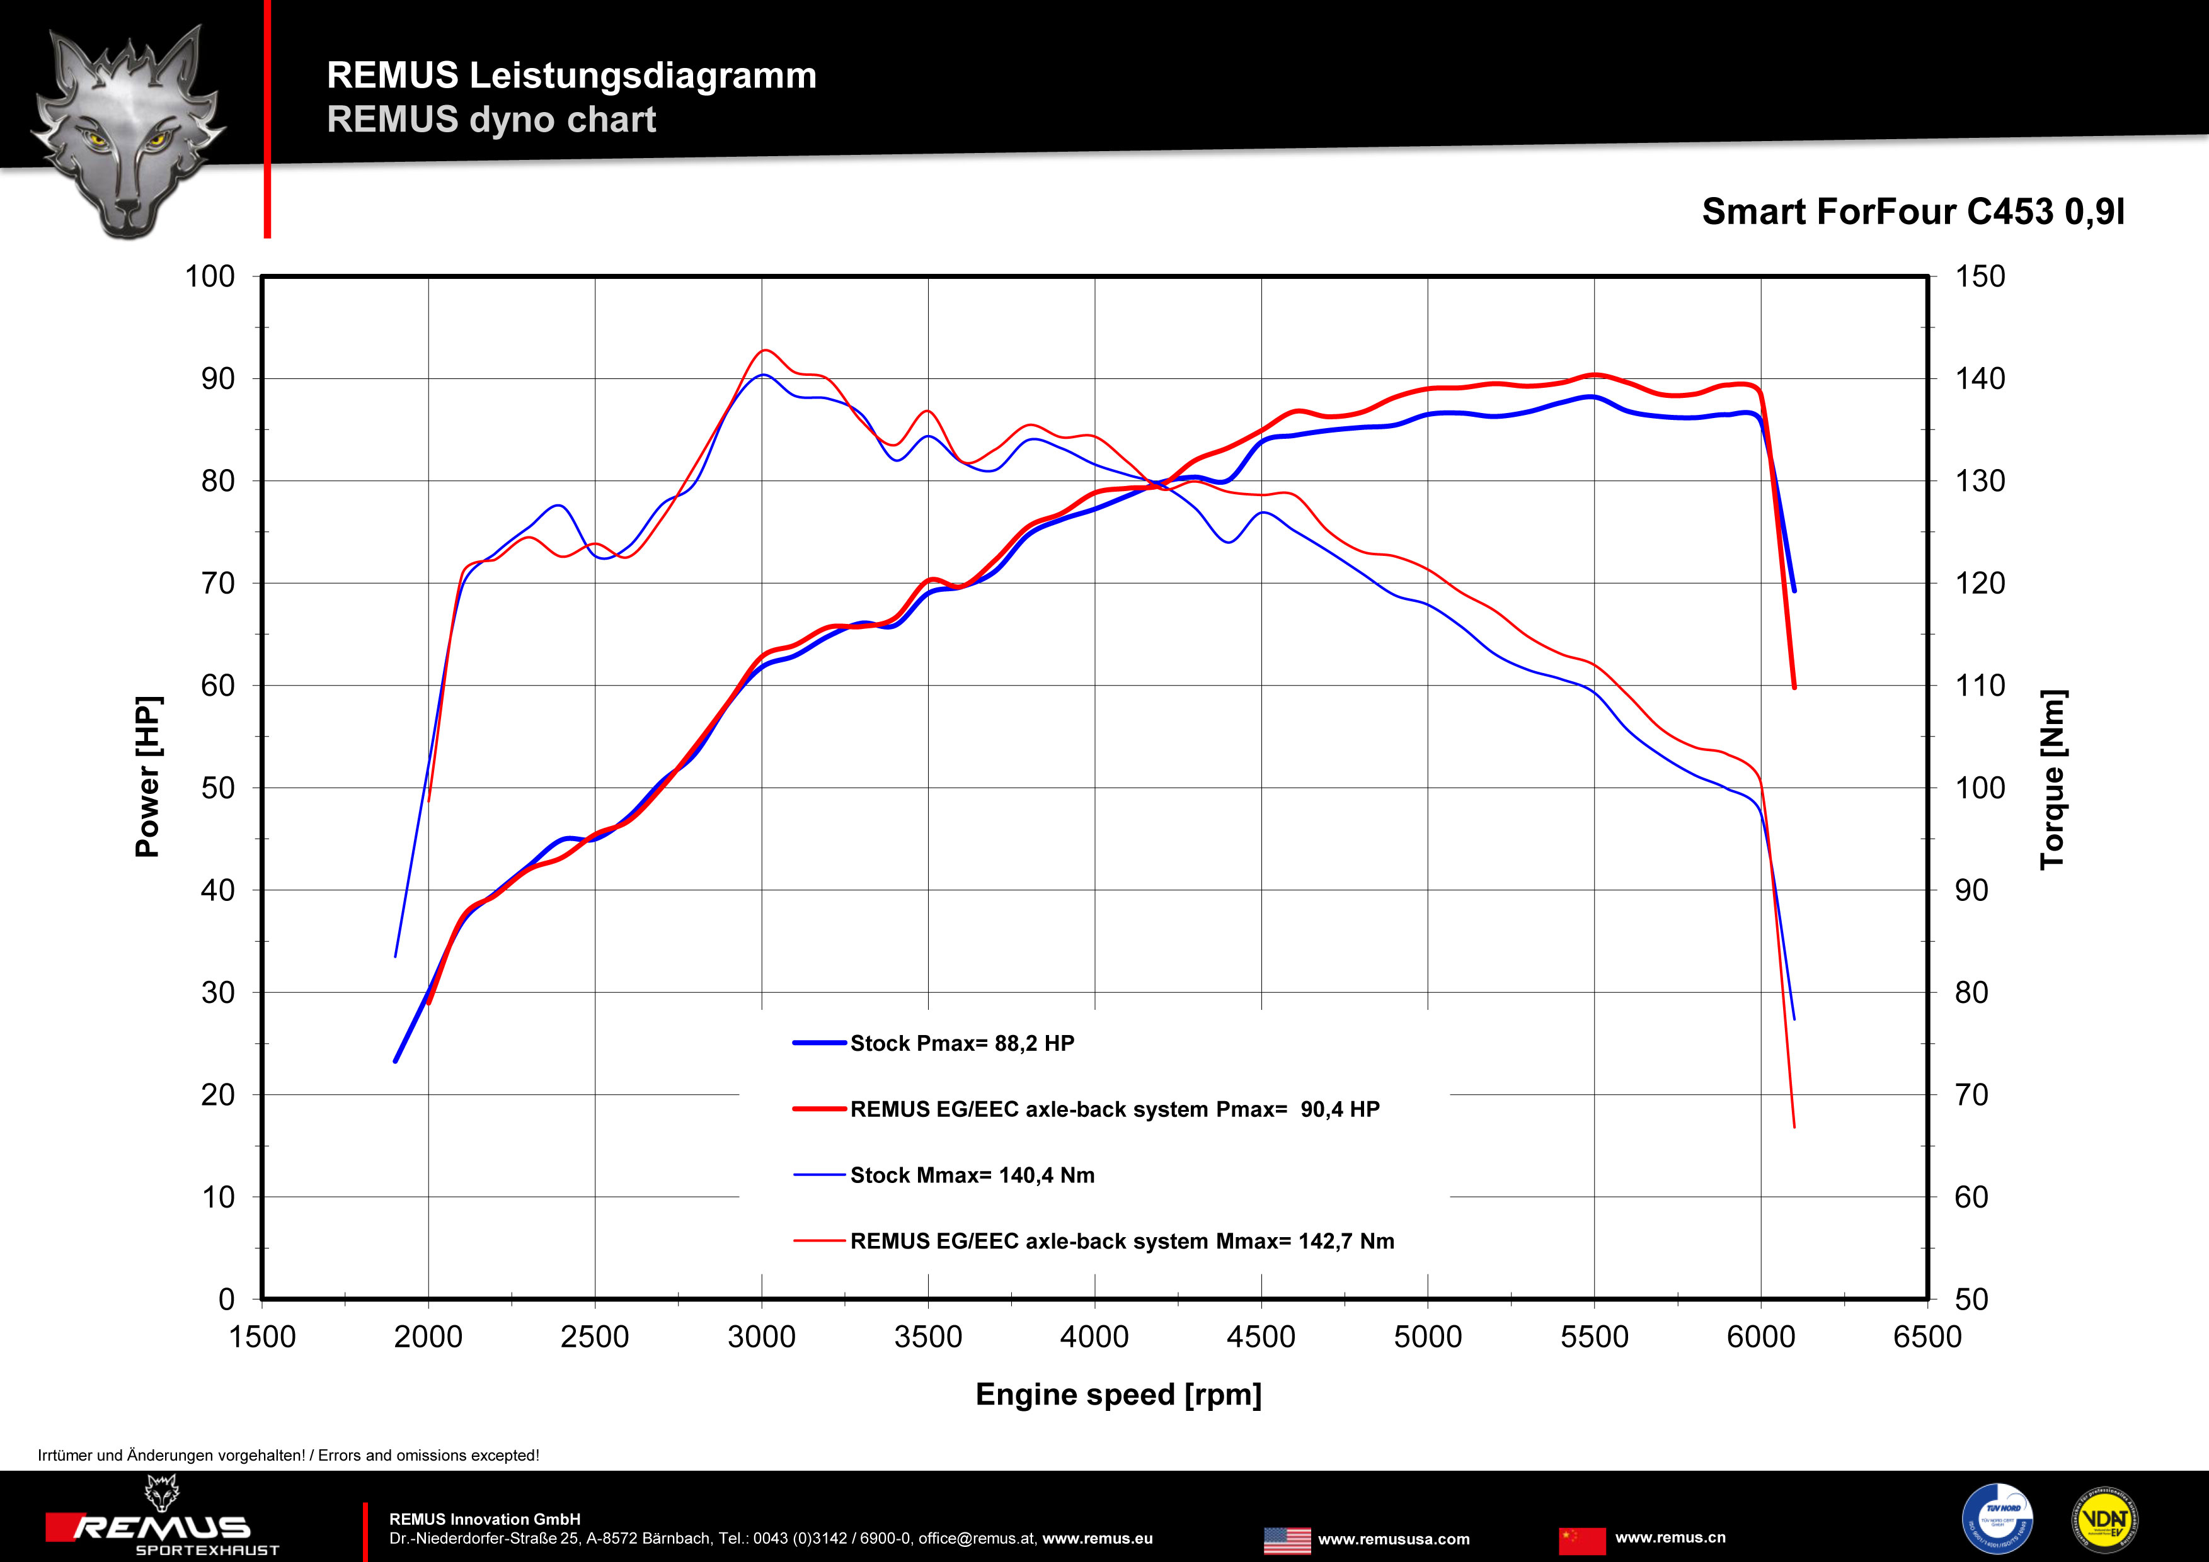
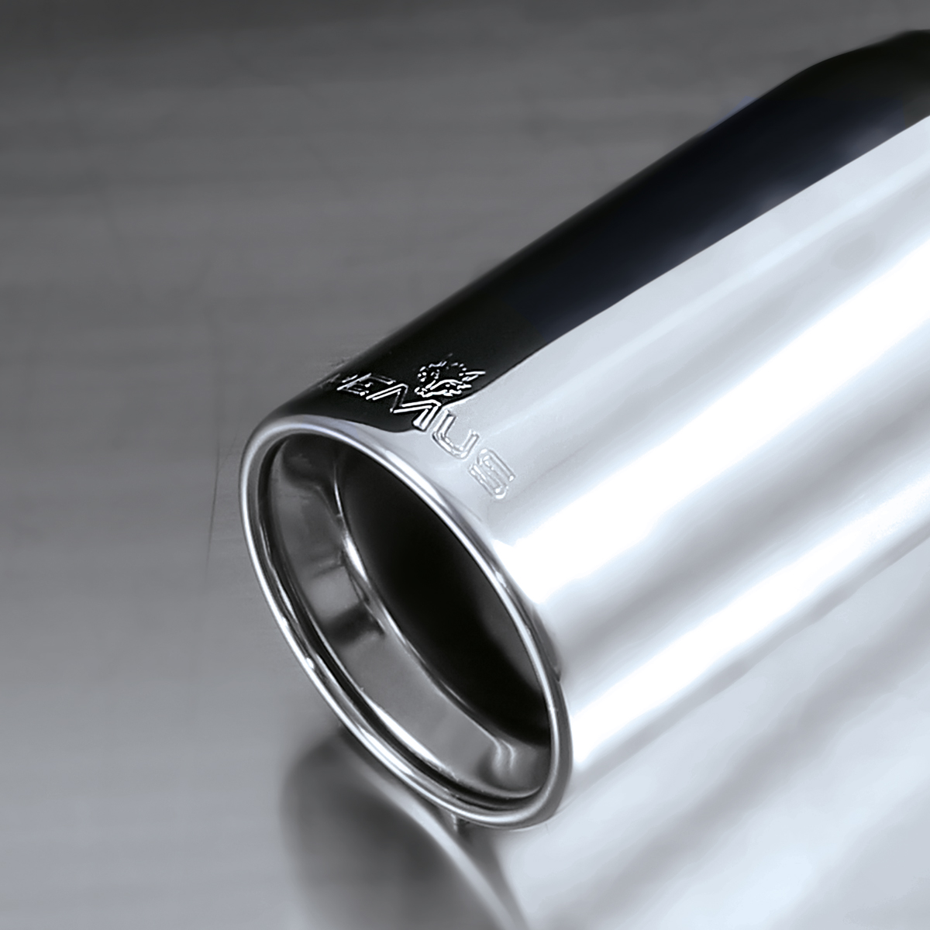
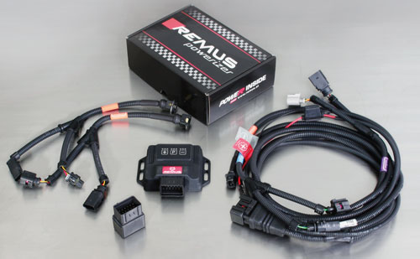

Part no. | Description | € RRP price excl. VAT
D911125 | REMUS POWERIZER for  Renault Twingo (NO) (2007-...)1.5 dCi 64 HP  Original: 47 kW / 64 HP / 160 Nm  TUNED: 59 kW / 80 HP / 200 Nm / Vmax + 4 kmH | 499,--
D916807 | REMUS POWERIZER for  Renault Twingo (NO) (2007-...)1.5 dCi 75 HP  Original: 55 kW / 75 HP / 180 Nm  TUNED: 65 kW / 88 HP / 210 Nm / Vmax + 6 kmH | 499,--
D914310 | REMUS POWERIZER for  Renault Twingo (NO) (2007-...)1.5 dCi 84 HP  Original: 62 kW / 84 HP / 200 Nm  TUNED: 76 kW / 103 HP / 220 Nm / Vmax + 4 kmH | 499,--
D916808 | REMUS POWERIZER for  Renault Twingo (NO) (2007-...)1.5 dCi 85 HP  Original: 63 kW / 85 HP / 200 Nm  TUNED: 75 kW / 102 HP / 230 Nm / Vmax + 5 kmH | 499,--
REMUS Powerizer: More power, more economy and more fun.
- Up to 25 % more power
- Up to 20 % more torque
- Up to 1l/100 km fuel saving
- Fully adjustable power increase
- Simple DIY installation (Plug & Play)
REMUS POWERIZER: The performance figures represent the maximum achievable values. The actual performance output depends on the original tolerances of each engine. REMUS delivers the POWERIZER with the best possible setting for your vehicle type. You can adjust the performance according to your requirements as per the POWERIZER instructions

Legal references

1. Completion and registration of chip tuning in the car documents
Due to chip tuning, the operating license of the vehicle will terminate if the installation and registration of the POWERIZER is not carried out or immediately reported to an official approved testing facility. Please consider that driving a vehicle without the required operating license will cause legal penalties.

2. Vehicle insurance must be informed upon installing a POWERIZER
The installation of the POWERIZER can have influence on the insurance policy of your vehicle. You must inform the insurance company if you install a POWERIZER in your vehicle.

3. Effect of chip tuning on warranty and guarantee claims
a) When installing a POWERIZER, you will lose all guarantee claims regarding the engine against the vehicle manufacturer.
b) Installing a POWERIZER, can have influence on warranty claims against the seller of the vehicle.
c) REMUS excludes any claims regarding compensation for damages on the engine and drivetrain.
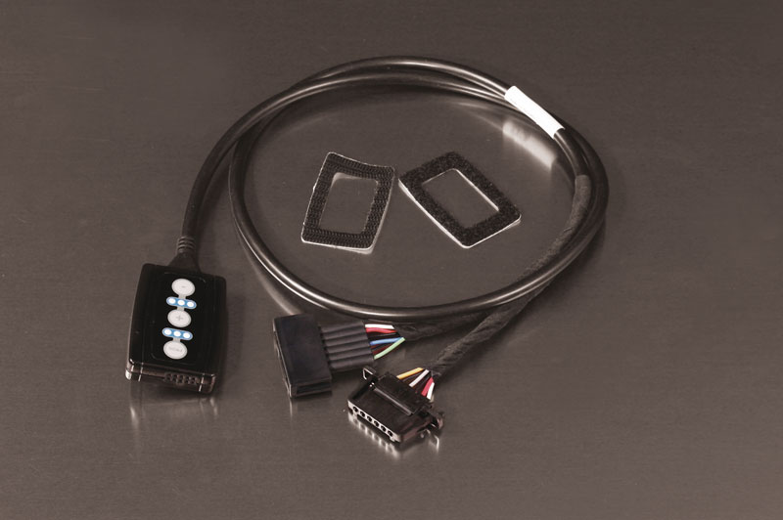

Part no. | Description | € RRP price excl. VAT
R903793 | REMUS Responder  Renault Twingo II (2007-...); 1.2L 56 kW  Renault Twingo II (2007-...); 1.2L 45 kW  Renault Twingo II (2007-...); 1.2L Turbo 74 kW  Renault Twingo II (2007-...); 1.5L dCi 49 kW  Renault Twingo II (2007-...); 1.6L RS 99 kW | 167,--
REMUS RESPONDER:
Improved throttle response, more dynamic!
The REMUS Responder improves throttle response by means of modifying the accelerator pedal output signal. No more throttle delay and reduced lag during automatic shifting makes driving with the REMUS Responder more fun. The Responder attaches between the OEM pedal sensor and the OEM connector, ready to use in seconds due to plug & play technology. Sophisticated adjustable programming profiles can lead to improved fuel consumption and more efficiency. The 4 individual user selectable and adjustable performance settings allow drivers to select according to their own preferences.
The REMUS Responder totally eliminates the delay in modern electronic accelerator pedals!
