Produktinformation 04/2017
AUDI RS4
AUDI RS4 Avant Quattro, type 8T (B8), from 06/2012
4.2l 331 kW (CFS)
REMUS Cat-back-system
- 100% stainless steel
- Powerful sound
- Performance and torque increase
- Light weight construction
+ 14,4 HP
+ 7,8 Nm

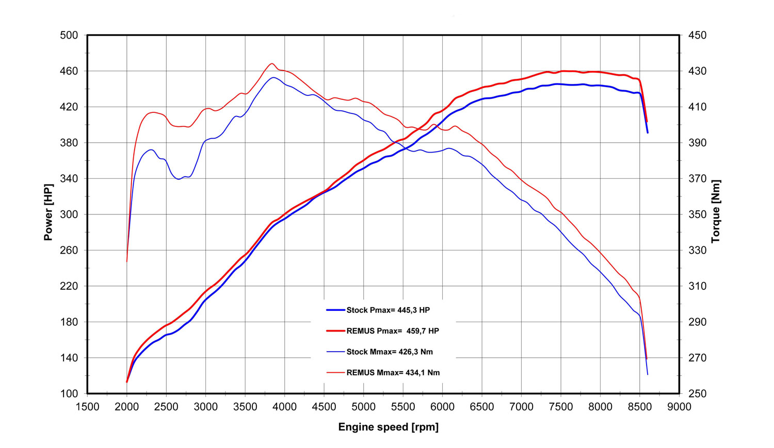

Car and engine specification
AUDI RS4 Avant Quattro, type 8T (B8), 06/2012=>
4.2l 331 kW (CFS)
INFOBOX:
- Axle-back-system L/R: 049010 0500LR (Racing)!
- Cat-back-system L/R: 049010 0100 (Racing) + 049010 0000 (Racing) resp. 049010 0400 (Racing) + 049010 0500LR (Racing)!
Part no. | Description | € RRP price excl. VAT
049010 0100 | Stainless steel RACING tube without homologation, instead of front silencer | 249,--
049010 0400 | Stainless steel RACING secondary silencer, without homologation | 417,--
049010 0000 | Stainless steel RACING tube without homologation, instead of secondary silencer | 282,--
049010 0500LR | Stainless steel RACING sport exhaust left and RACING sport exhaust right (without tail pipes)  with vacuum operated valves, without homologation  fits into the original skirt using integrated tail pipes  The valve position is vacuum controlled via the onboard electronics. | 1.355,--

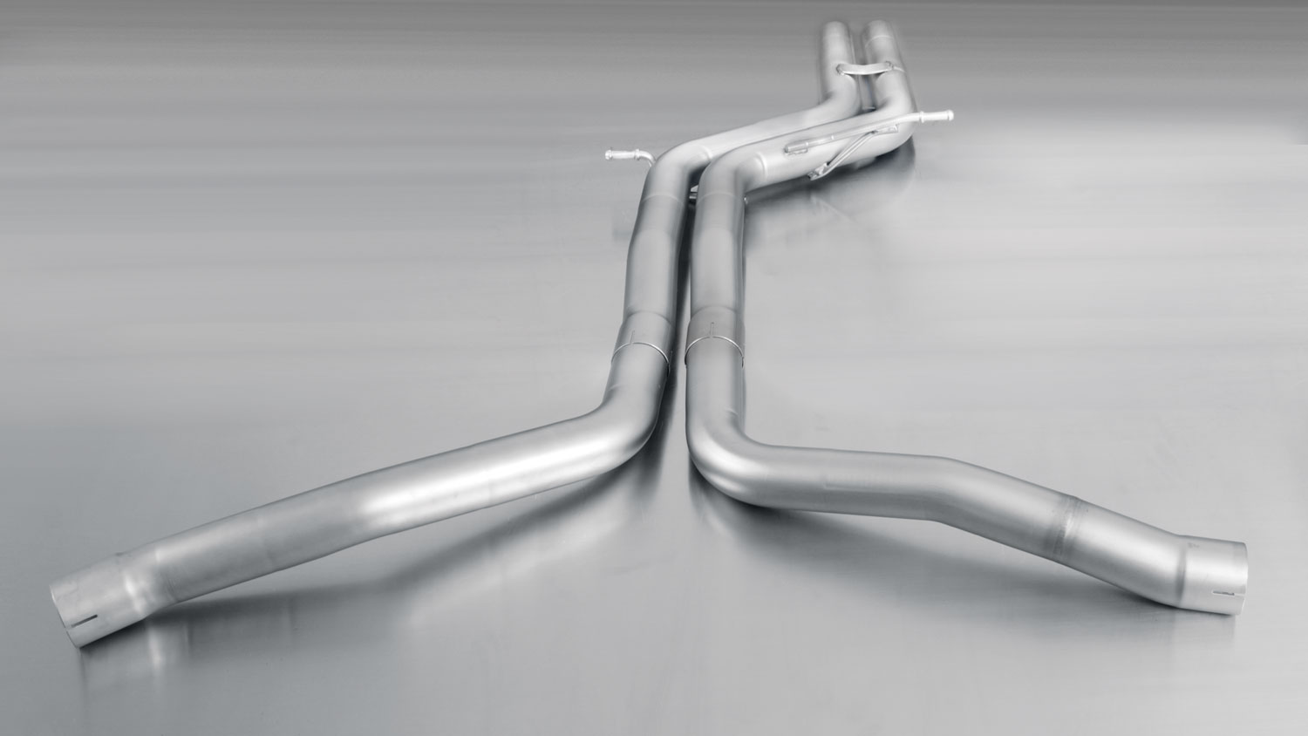

049010 0000
086514 1604G

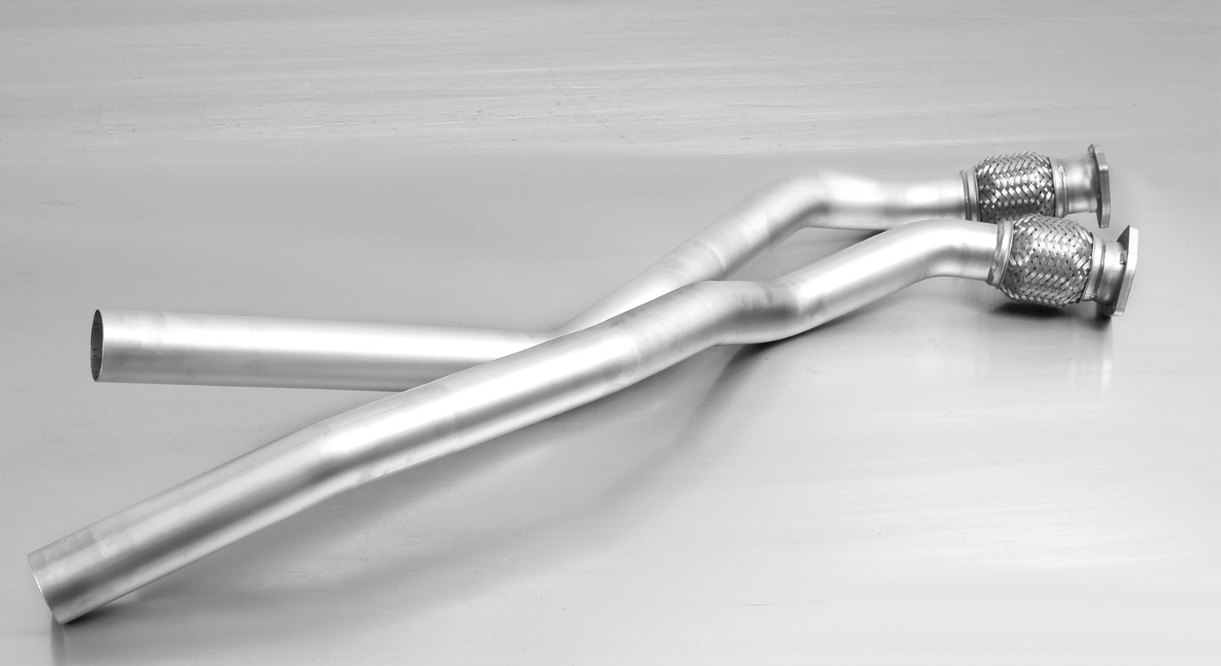

049010 0100

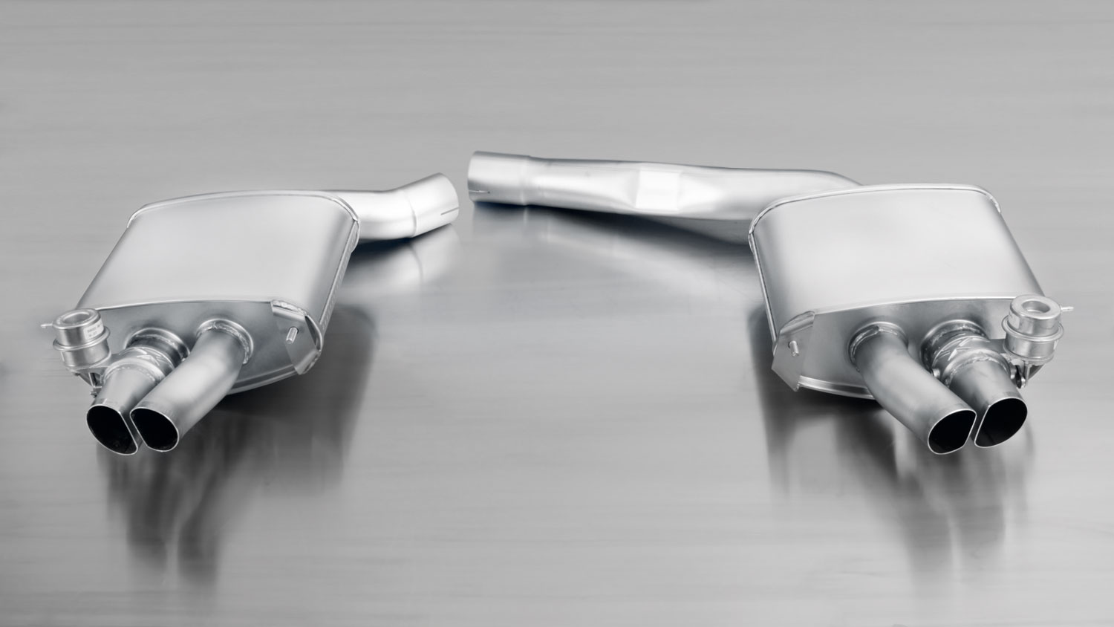

049010 0500LR

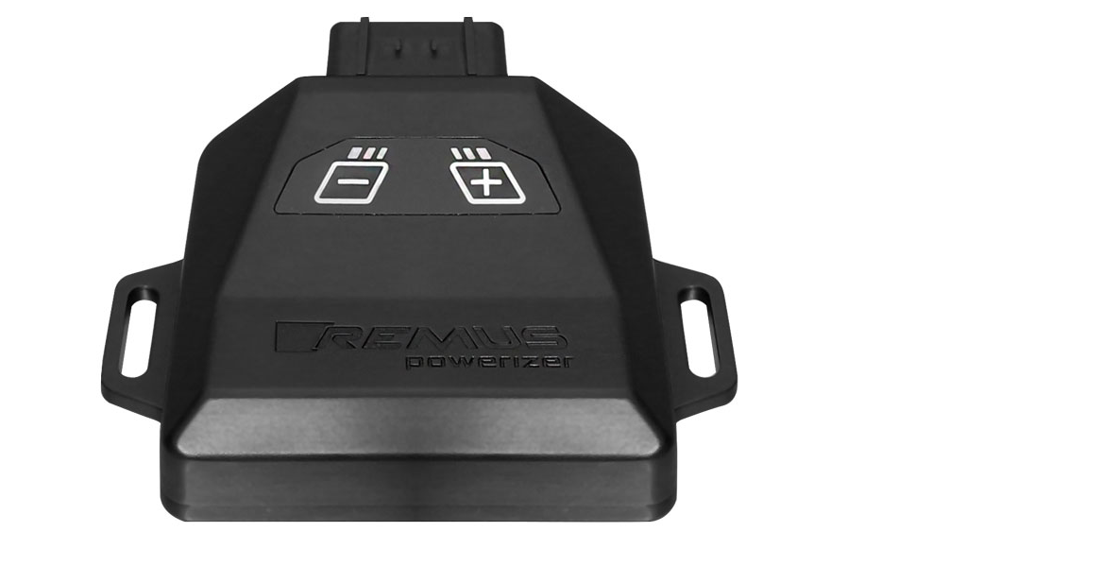
REMUS Powerizer
More power, more economy and more fun!
The electronics of the REMUS Powerizer enhances in real time
the engine management parameters. The engine mapping
is optimized in excess of 1000 times per second and ensures for a
considerable and noticeable power increase. The engine safety parameters and management remains totally original to ensure that individual engine components are not overstrained. Furthermore, the original mapping software remains totally untouched.
Due to the plug & play concept, the REMUS Powerizer is simple to install and can be easily removed or decommissioned using the supplied blind connector. Due to the torque increase, the engine has more power at lower RPM which leads to a reduction in fuel consumption. The power increase of the engine can be fine-tuned by means of seven preset levels. The REMUS Powerizer is available for over 3000 petrol and diesel powered cars.

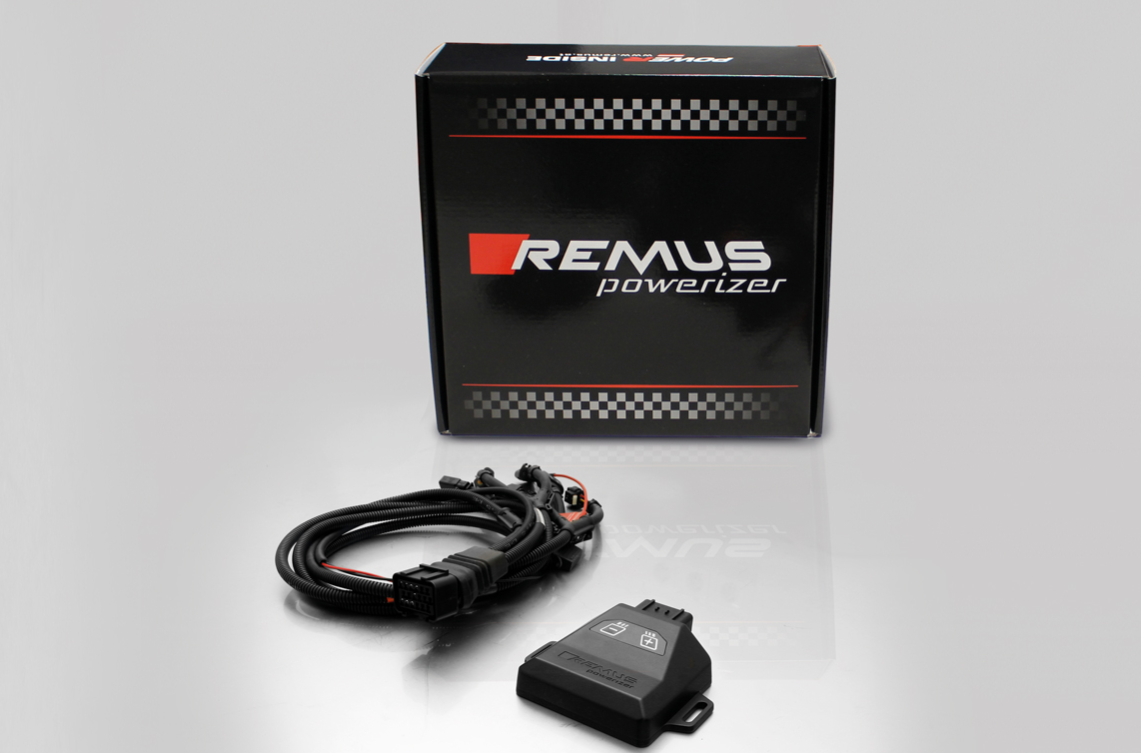

- Up to 25% more power
- Up to 20% more torque
- Easy installation and removal (plug & play)
- Up to 1l/100 km fuel saving
- No modifications on the ECU
- 7 preset power levels

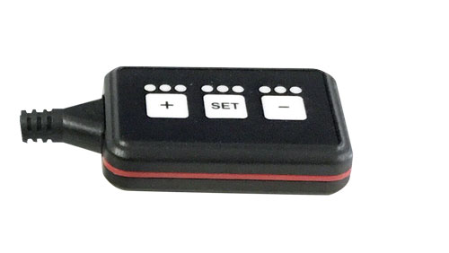
REMUS Responder

Improved throttle response, more dynamic!

The REMUS Responder improves throttle response by means
of modifying the accelerator pedal output signal.

No more throttle delay and reduced lag during automatic shifting makes driving
with the REMUS Responder more fun. The Responder attaches between the
OEM pedal sensor and the OEM connector, ready to use in seconds due to plug & play technology.

Sophisticated adjustable programming profiles can lead to improved fuel consumption and
more efficiency. The four individual user selectable and adjustable performance settings
allow drivers to select according to their own preferences. The REMUS Responder totally eliminates the delay in modern electronic accelerator pedals!

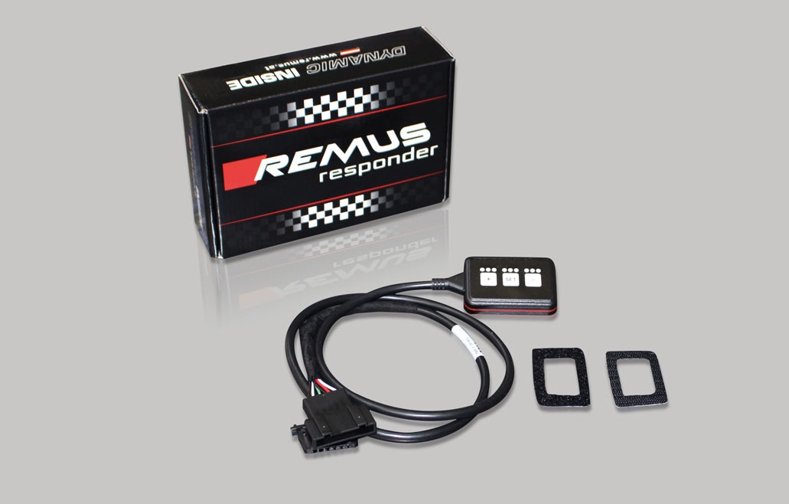

- Improved throttle response, reduced lag during gear changes
- Quicker reaction times, more dynamic without changing engine parameters
- 4 individual user selectable and adjustable performance settings
- Vehicle specific programming using OEM quality connectors
- Simple plug & play installation and easily removed without leaving traces

