REMUS product information 04-2016

MINI Cooper / One, F55, 2014=>
MINI Cooper / One, F56, 2014=>
MINI Cooper S, F55 and F56, 2014=>

Dear REMUS Partner,

We are pleased to inform you that due to continued demand, we will again produce the following parts:
REMUS Racing tube and front resonated section for
MINI Cooper / One, F55 und F56, 2014=>
MINI Cooper S, F55 und F56, 2014=>.

It would be a pleasure for us to receive your order.
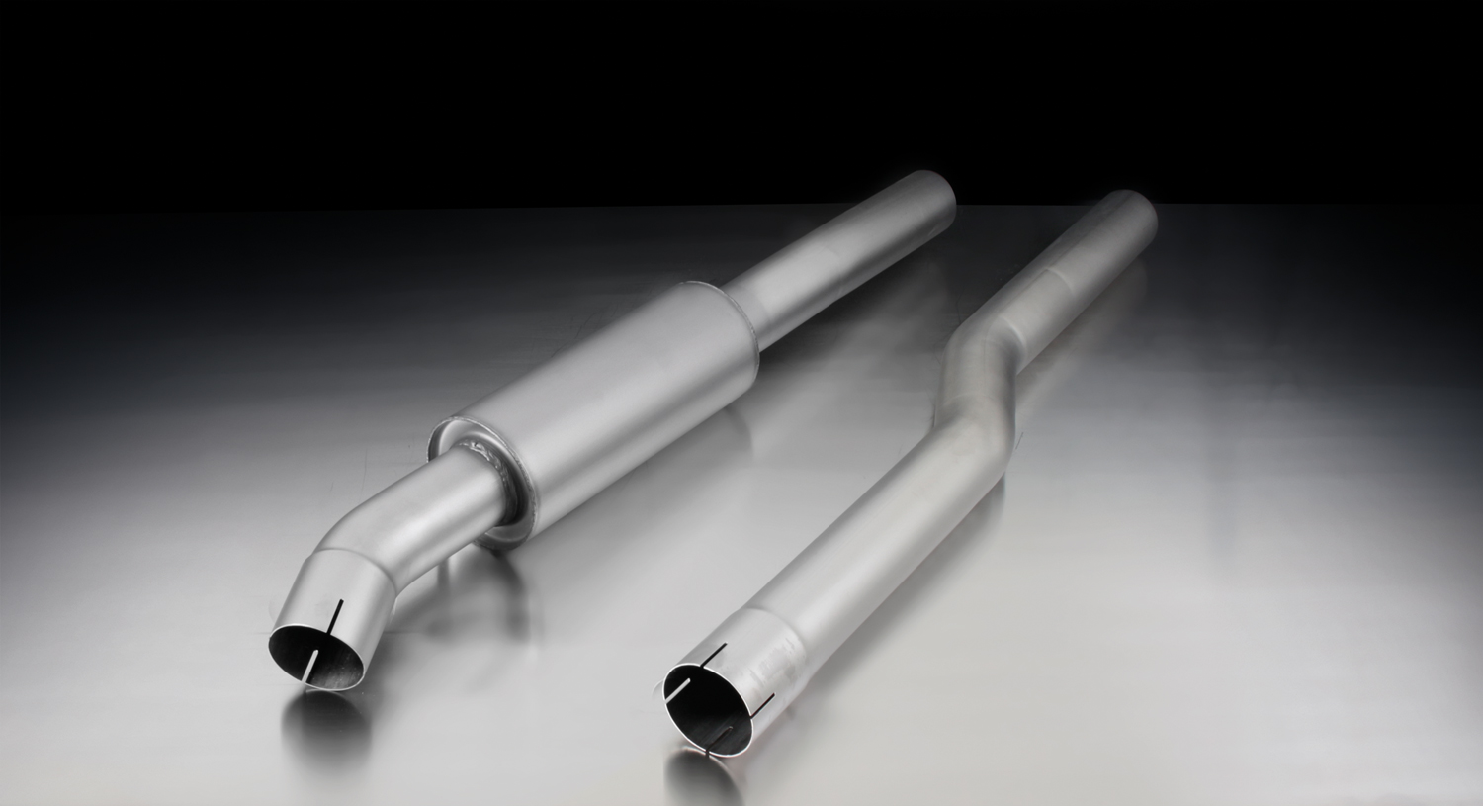
Stay tuned!
755014 0300:
Front resonated section, Ø 70 mm pipe

Your REMUS Team

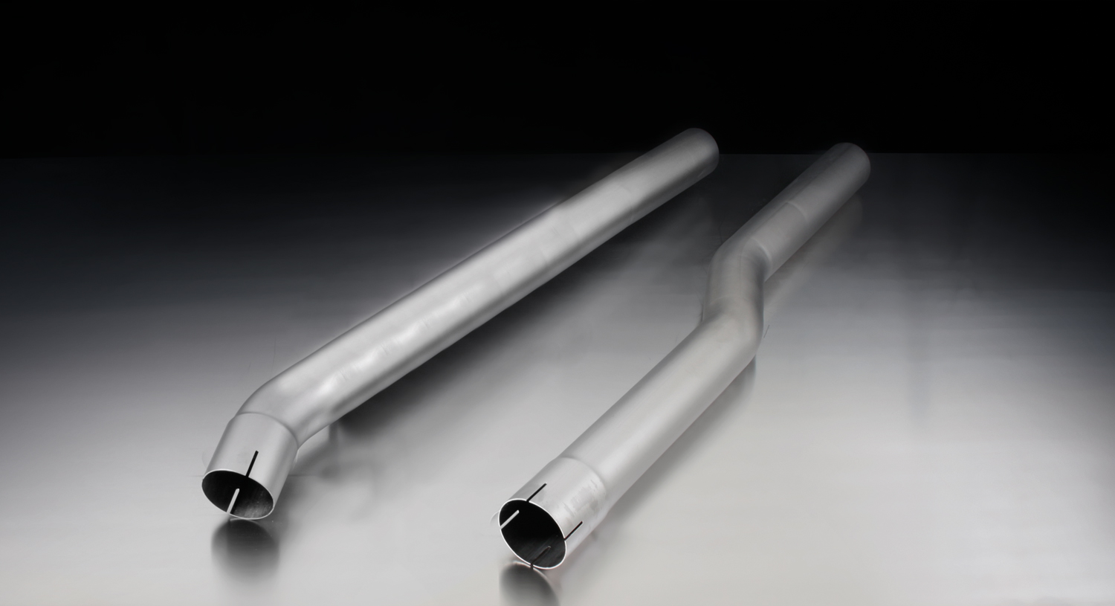
755014 0000:
Front racing section, Ø 70 mm pipe

Car and engine specification
MINI One F55 (5 door), 2014=>
1.2l 75 kW
MINI Cooper F55 (5 door), 2014=>
1.5l 100 kW
Part no. | Description | € RRP price excl. VAT
AD0190 | Distance tube A8 for mounting of 755014 0000/755014 0300 onto the original catalytic converter | 22,--
AD0194 | Distance tube (length compensation) for mounting of 755014 0000 respectively 755014 0300 onto F55 (5 door) models | 18,--
755014 0000 | Stainless steel Racing section without homologation, instead of front silencer, pipe Ø 70 mm | 153,--
755014 0300 | Stainless steel resonated section, with EEC homologation, pipe Ø 70 mm | 245,--
754514 0500 | Stainless steel sport exhaust for left-system (without tail pipes), with EEC homologation, pipe Ø 70 mm | 353,--
choose from following tail pipe package:
0006 70S | 1 tail pipe Ø 102 mm angled, chromed, with adjustable spherical clamp connection | 80,--
0006 70SG | 1 tail pipe Ø 102 mm angled, straight cut, chromed, with adjustable spherical clamp connection | 70,--
0006 70CS | 1 Carbon tail pipe Ø 102 mm angled, Titanium internals, with adjustable spherical clamp connection | 185,--
0006 98C | 1 tail pipe Ø 98 mm Street Race, with adjustable spherical clamp connection | 98,--
0006 98CB | 1 tail pipe Ø 98 mm Street Race Black Chrome, with adjustable spherical clamp connection | 110,--
ATTENTION:
- Sport exhaust and tail pipe set only fit as a complete system!
- Axle-back: when installing 754514 0500, the original exhaust must be cut!
- Cat-back system: sport exhaust 754514 0500 in connection with resonated section 755014 0300 respectively Racing section 755014 0000 and adaptor AD0190 with length compensation AD0194 (Only for F55) can be installed without any vehicle modifications.

Car and engine specification
MINI One F56 (3 door), 2014=>
1.2l 75 kW
MINI Cooper F56 (3 door), 2014=>
1.5l 100 kW
Part no. | Description | € RRP price excl. VAT
AD0190 | Distance tube A8 for mounting of 755014 0000/755014 0300 onto the original catalytic converter | 22,--
755014 0000 | Stainless steel Racing section without homologation, instead of front silencer, pipe Ø 70 mm | 153,--
755014 0300 | Stainless steel resonated section, with EEC homologation, pipe Ø 70 mm | 245,--
754014 0500 | Stainless steel sport exhaust for left-system (without tail pipes), with EEC homologation, pipe Ø 70 mm | 353,--
choose from following tail pipe package:
0006 70S | 1 tail pipe Ø 102 mm angled, chromed, with adjustable spherical clamp connection | 80,--
0006 70SG | 1 tail pipe Ø 102 mm angled, straight cut, chromed, with adjustable spherical clamp connection | 70,--
0006 70CS | 1 Carbon tail pipe Ø 102 mm angled, Titanium internals, with adjustable spherical clamp connection | 185,--
0006 98C | 1 tail pipe Ø 98 mm Street Race, with adjustable spherical clamp connection | 98,--
0006 98CB | 1 tail pipe Ø 98 mm Street Race Black Chrome, with adjustable spherical clamp connection | 110,--
ATTENTION:
- Sport exhaust and tail pipe set only fit as a complete system!
- Axle-back: when installing 754014 0500, the original exhaust must be cut!
- Cat-back system: sport exhaust 754014 0500 in connection with resonated section 755014 0300 respectively Racing section 755014 0000 and adaptor AD0190 can be installed without any vehicle modifications.

Car and engine specification
MINI Cooper S F55 (5 door), 2014=>
2.0l Turbo 141 kW
Part no. | Description | € RRP price excl. VAT
AD0181 | Distance tube U7 for mounting of 755014 0000/755014 0300 on China/USA/Korean models | 15,--
AD0194 | Distance tube (length compensation) for mounting of 755014 0000 respectively 755014 0300 onto F55 (5 door) models | 18,--
755014 0000 | Stainless steel Racing section without homologation, instead of front silencer, pipe Ø 70 mm | 153,--
755014 0300 | Stainless steel resonated section, with EEC homologation, pipe Ø 70 mm | 245,--
755514 097 | Stainless steel sport exhaust centered with integrated valve (without tail pipes) and EEC homologation, pipe Ø 70 mm  For the valve, a remote controlled unit is supplied for special applications. | 675,--
choose from following tail pipe package:
0026 70S | Tail pipe set 2 tail pipes Ø 102 mm angled, chromed, with adjustable spherical clamp connection | 160,--
0026 70SG | Tail pipe set 2 tail pipes Ø 102 mm angled, straight cut, chromed, with adjustable spherical clamp connection | 140,--
0026 70CS | Tail pipe set 2 Carbon tail pipes Ø 102 mm angled, Titanium internals, with adjustable spherical clamp connection | 370,--
0026 98C | Tail pipe set 2 tail pipes Ø 98 mm Street Race, with adjustable spherical clamp connection | 196,--
0026 98CB | Tail pipe set 2 tail pipes Ø 98 mm Street Race Black Chrome, with adjustable spherical clamp connection | 220,--
ATTENTION:
- Sport exhaust and tail pipe set only fit as a complete system!
- Axle-back: when installing 755514 097, the original exhaust must be cut!
- Cat-back system: sport exhaust 755514 097 in connection with length compensation AD0194 (Only for F55) and resonated section 755014 0300 respectively Racing section 755014 0000 and optional adaptor AD0181 can be installed without any vehicle modifications.

Car and engine specification
MINI Cooper S F56 (3 door), 2014=>
2.0l Turbo 141 kW
Part no. | Description | € RRP price excl. VAT
AD0181 | Distance tube U7 for mounting of 755014 0000/755014 0300 on China/USA/Korean models | 15,--
755014 0000 | Stainless steel Racing section without homologation, instead of front silencer, pipe Ø 70 mm | 153,--
755014 0300 | Stainless steel resonated section, with EEC homologation, pipe Ø 70 mm | 245,--
755014 097 | Stainless steel sport exhaust centered with integrated valve (without tail pipes) and EEC homologation, pipe Ø 70 mm  For the valve, a remote controlled unit is supplied for special applications. | 675,--
choose from following tail pipe package:
0026 70S | Tail pipe set 2 tail pipes Ø 102 mm angled, chromed, with adjustable spherical clamp connection | 160,--
0026 70SG | Tail pipe set 2 tail pipes Ø 102 mm angled, straight cut, chromed, with adjustable spherical clamp connection | 140,--
0026 70CS | Tail pipe set 2 Carbon tail pipes Ø 102 mm angled, Titanium internals, with adjustable spherical clamp connection | 370,--
0026 98C | Tail pipe set 2 tail pipes Ø 98 mm Street Race, with adjustable spherical clamp connection | 196,--
0026 98CB | Tail pipe set 2 tail pipes Ø 98 mm Street Race Black Chrome, with adjustable spherical clamp connection | 220,--
ATTENTION:
- Sport exhaust and tail pipe set only fit as a complete system!
- Axle-back: when installing 755014 097, the original exhaust must be cut!
- Cat-back system: sport exhaust 755014 097 in connection with resonated section 755014 0300 respectively Racing section 755014 0000 and optional adaptor AD0181 can be installed without any vehicle modifications.

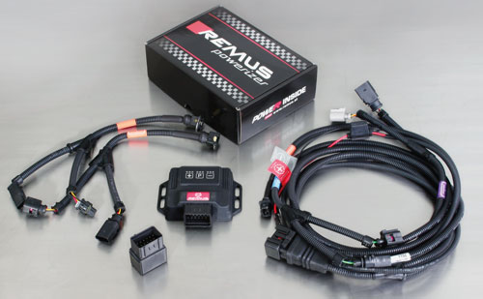

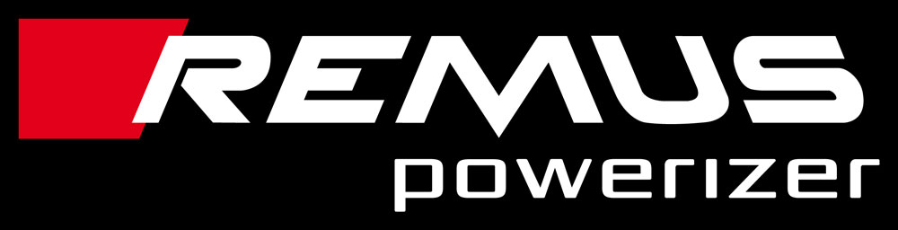

Under http://www.remus.eu/powerizer/ and http://www.remus.eu/remusresponder you will find the entire product range, prices and installation instructions.

REMUS Powerizer: More power, more economy and more fun.
- Up to 25 % more power
- Up to 20 % more torque
- Up to 1l/100 km fuel saving
- Fully adjustable power increase
- Simple DIY installation (Plug & Play)
REMUS POWERIZER: The performance figures represent the maximum achievable values. The actual performance output depends on the original tolerances of each engine. REMUS delivers the POWERIZER with the best possible setting for your vehicle type. You can adjust the performance according to your requirements as per the POWERIZER instructions

Legal references

1. Completion and registration of chip tuning in the car documents
Due to chip tuning, the operating license of the vehicle will terminate if the installation and registration of the POWERIZER is not carried out or immediately reported to an official approved testing facility. Please consider that driving a vehicle without the required operating license will cause legal penalties.

2. Vehicle insurance must be informed upon installing a POWERIZER
The installation of the POWERIZER can have influence on the insurance policy of your vehicle. You must inform the insurance company if you install a POWERIZER in your vehicle.

3. Effect of chip tuning on warranty and guarantee claims
a) When installing a POWERIZER, you will lose all guarantee claims regarding the engine against the vehicle manufacturer.
b) Installing a POWERIZER, can have influence on warranty claims against the seller of the vehicle.
c) REMUS excludes any claims regarding compensation for damages on the engine and drivetrain.

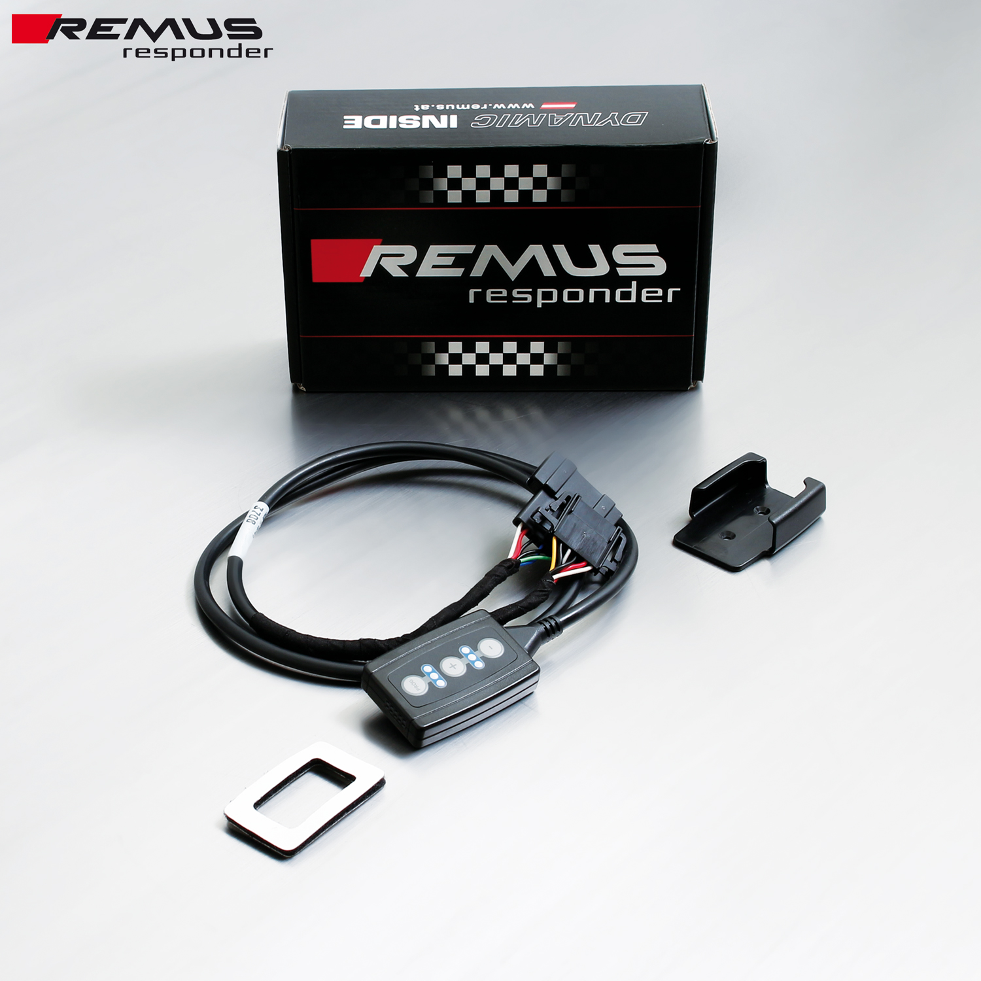

Under http://www.remus.eu/powerizer/ and http://www.remus.eu/remusresponder you will find the entire product range, prices and installation instructions.

REMUS RESPONDER:
Improved throttle response, more dynamic!
The REMUS Responder improves throttle response by means of modifying the accelerator pedal output signal. No more throttle delay and reduced lag during automatic shifting makes driving with the REMUS Responder more fun. The Responder attaches between the OEM pedal sensor and the OEM connector, ready to use in seconds due to plug & play technology. Sophisticated adjustable programming profiles can lead to improved fuel consumption and more efficiency. The 4 individual user selectable and adjustable performance settings allow drivers to select according to their own preferences.
The REMUS Responder totally eliminates the delay in modern electronic accelerator pedals!
